SESAME CHICKEN EGG ROLLS
WITH SWEET & SOUR SAUCE
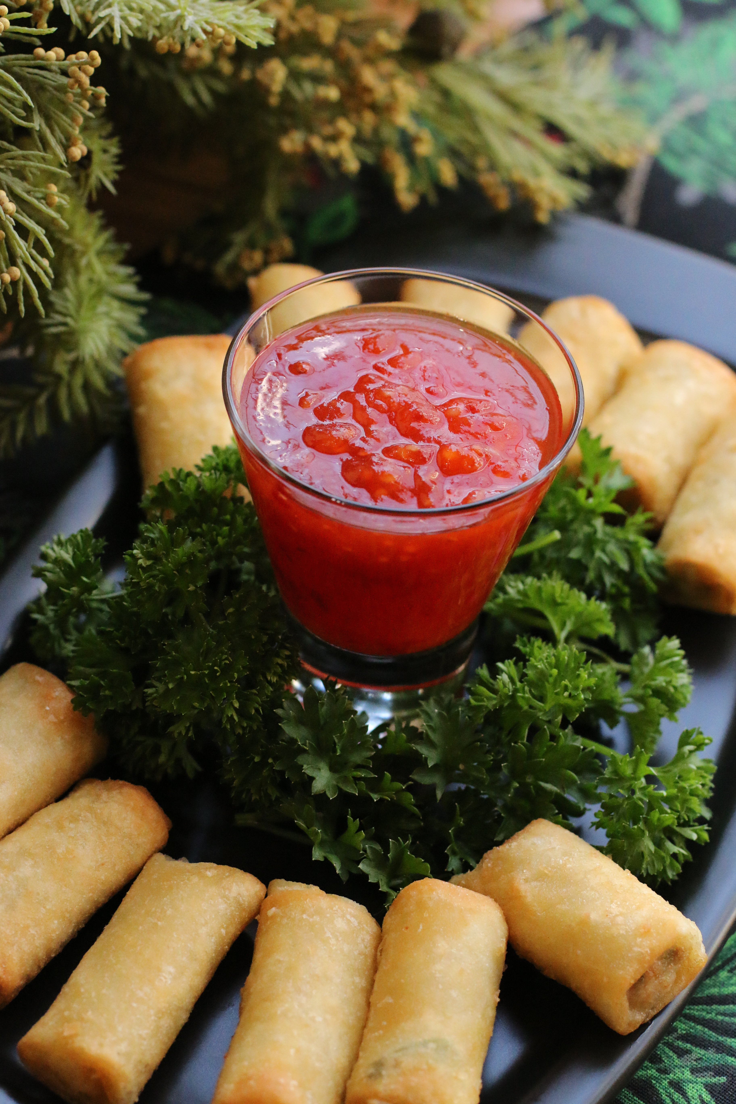

Chinese food is the only way to bring in and celebrate the new year – and these Sesame Chicken Egg Rolls with homemade Sweet & Sour Sauce are absolute perfection! Perfect as an appetizer, or as a dinner, served with hot white rice!

INGREDIENTS:
SWEET & SOUR SAUCE:
1/4 cup natural pineapple juice (from a 20 oz. can of pineapple tidbits – reserve extra)
½ cup red wine vinegar
¾ cup sugar
3 tablespoons ketchup
1 tablespoon soy sauce
½ teaspoon salt
¼ teaspoon ginger powder
½ teaspoon Thai or Asian Sweet Chili Sauce
2 teaspoons cornstarch

CHICKEN EGG ROLLS:
1 lb. chicken breasts (boneless & skinless), cut into thin strips
½ cup onion (chopped)
2 cloves garlic (minced)
1 pkg. (12 oz.) Stir Fry Vegetables (snow peas, carrots, broccoli & bean sprouts)
1 red bell pepper (cored & sliced)
1 cup pineapple tidbits in natural juice (drained well)
1 tablespoon sesame oil
¼ cup Sweet & Sour Sauce

1 pkg. (16) egg roll wrappers
1 quart vegetable oil (for frying)
HOW I MAKE THESE:
- PREPARE SWEET & SOUR SAUCE: Drain pineapple from one 20 oz. can; reserve juice for Sweet & Sour Sauce, save drained pineapple for the Chicken Egg Rolls. Whisk together the pineapple juice and all remaining Sweet & Sour Sauce ingredients in a heavy medium saucepan. Bring to a boil; reduce to a simmer and whisk or stir constantly until slightly thickened. Remove from heat. The sauce will continue to thicken as it cools to room temperature.
- PREPARE CHICKEN EGG ROLLS: In a large skillet, heat sesame oil over high heat. Add chicken and onions and cook about 3 minutes. Add frozen vegetables and pineapple tidbits; stir fry over medium high heat until vegies are crispy tender and chicken is cooked through. Remove from heat.
- Using a slotted spoon (you don’t want any extra moisture), add the stir-fried chicken and vegetables to your food processor and pulse until finely chopped (about 12 pulses). Pour into a bowl and stir in ¼ cup Sweet & Sour Sauce.
- On a cutting board, position an egg roll wrapper diagonally with one point towards you. Place ¼ cup chicken & vegie mixture in the bottom third of the wrapper. Fold the bottom corner over filing, then continue to roll up, firmly folding the sides toward the center over the filling as you roll. Moisten top corner edges with water and press firmly to seal. Repeat with remaining wrappers and filling.
- Heat the vegetable oil in a heavy dutch oven or deep-fat fryer to 350 degrees or medium high heat. Fry the egg rolls 4 at a time until golden brown, turning a few times while frying so that they cook evenly. Remove from hot oil with a slotted spoon and drain on doubled up paper towels.
- Serve warm with reserved Sweet & Sour Sauce. If you need to thin your sauce, use additional reserved pineapple juice.

YIELD: 16 egg rolls, 1 cup Sweet & Sour Sauce
© SnowflakesandCoffeecakes. All images, attachments & content are copyright protected unless otherwise indicated. All rights reserved. Please do not use my images without prior permission. If you want to republish this recipe, please re-write the recipe in your own words, or link back to www.snowflakesandcoffeecakes.com for the recipe.


