spring berry & spinach salad
WITH SWEET BALSAMIC DRESSING
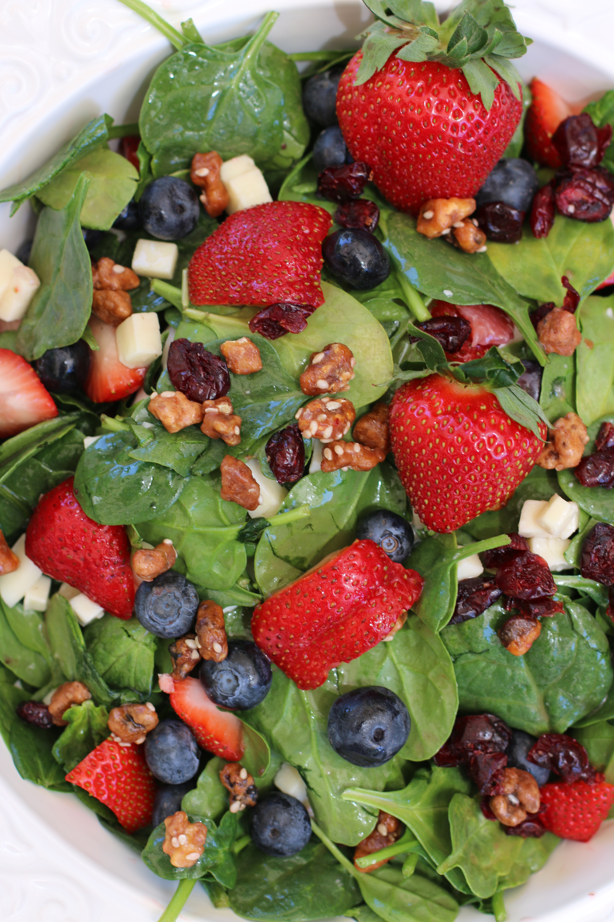

Such a flavorful and beautiful salad – perfect for Spring or Summer when fresh ripe strawberries are in season!

SALAD:
5 to 6 cups Fresh Baby Spinach
2 cups Strawberries (washed, drained and and cut)
5 oz Gorgonzola Cheese
8 Strips Cooked Maple Bacon, chopped (or sliced chicken breast)
1/2 cup dried cranberries
½ cup fresh blueberries
1/2 Cup Caramelized Pecans, chopped

SWEET BALSAMIC DRESSING:
1/2 cup vegetable or canola oil
1/3 cup granulated sugar
3 tablespoons balsamic vinegar
1/8 teaspoon dry mustard (or a little squeeze of yellow mustard)
1/8 tsp fresh ground pepper

HOW I MAKE THIS:
- Clean spinach, place in large bowl and top with ingredients.
- For dressing, whisk all the ingredients together, until sugar and oil are blended. It takes a few minutes for the oil and sugar to blend. Keep whisking....it will blend!
- Add desired amount of dressing to salad, toss and enjoy.

YIELD: 2 servings
© SnowflakesandCoffeecakes. All images, attachments & content are copyright protected unless otherwise indicated. All rights reserved. Please do not use my images without prior permission. If you want to republish this recipe, please re-write the recipe in your own words, or link back to www.snowflakesandcoffeecakes.com for the recipe.

