fresh strawberry rhubarb pie

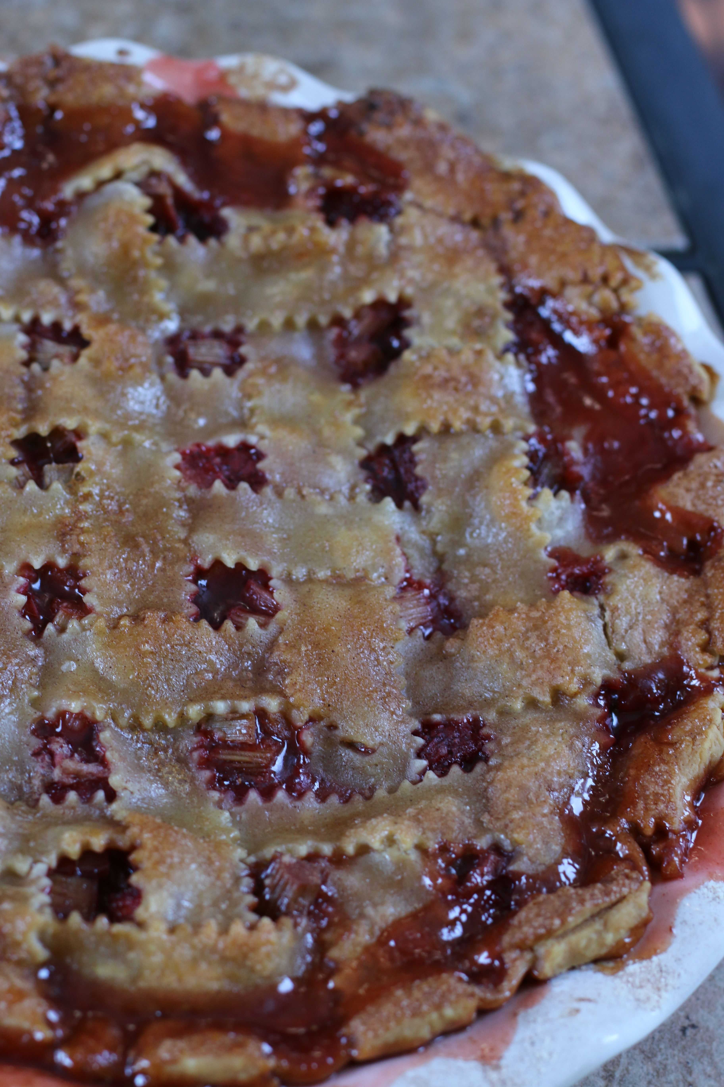

*As a spring rite, as soon as the first tender rhubarb stalks start poking up thru the warm soil we start planning our rhubarb cooking and baking. The season is short, and the list of favorite rhubarb recipes is long – so it is always a battle of the favorites! Rhubarb Jam is always first, but next on the list is two Strawberry Rhubarb pies – one for the family to enjoy, and one for Skipper to have all to himself! The combination of rhubarb with strawberries or raspberries is a fruity match made in heaven. The sweetness of the fruit balances out the tartness of the rhubarb, baking into a beautiful, glorious, sweetly tart pink pie. This is my hubby’s favorite recipe!*

**INGREDIENTS:**

**For the Crust**: (or use one package of pre-made refrigerated pie crusts)  
2¼ cups all-purpose flour  
1 teaspoon salt  
2 tablespoons granulated sugar  
11 tablespoons butter, cut into ¼-inch cubes  
7 tablespoons vegetable shortening (Crisco), chilled  
1/3 cup ice water

**For the Pie Filling**:

3 cups strawberries, hulled and sliced  
4 cups rhubarb, trimmed and cut into ¾-inch pieces  
1 cup granulated sugar

¼ cup cornstarch

1 teaspoon cinnamon

¼ teaspoon ground nutmeg

2 tablespoons unsalted butter, cut into small pieces

1 egg white (room temperature)

Maple cinnamon sugar sprinkles

### **HOW I MAKE THIS**:

1. Clean and cut rhubarb, place in a large mixing bowl. Cover cut rhubarb with boiling water and let stand for five minutes, drain extremely well. (This little trick will keep your rhubarb tender!)
2. **To Make the Crust**: Place the flour, salt and sugar in a food processor and pulse a few times to combine. Scatter the pieces of butter over the flour mixture, using your fingers to toss and coat the butter with some flour. Cut the butter into the flour mixture with five 1-second pulses. Add the shortening and continue to pulse until the flour is pale yellow and resembles coarse cornmeal with butter bits no larger than small peas, about four more 1-second pulses. Turn the mixture into a medium bowl.
3. Sprinkle all but 1 tablespoon of the ice water over the mixture. Use a rubber spatula to fold the water into the flour mixture. Press down on the dough with the spatula until the dough sticks together, adding up to 1 tablespoon of remaining ice water if the dough does not come together. Divide the dough into two balls, one slightly larger than the other. Flatten each into disks, dust lightly with flour, wrap separately in plastic wrap and refrigerate for at least 30 minutes.
4. Remove dough from the refrigerator; let stand at room temperature to soften slightly, about 10 minutes. Preheat oven to 425 degrees.
5. **Make the Filling**: Gently toss the rhubarb and strawberries with sugar, cornstarch, nutmeg and cinnamon; let stand for 15 minutes.
6. **Assemble the Pie**: Roll the larger dough disk on a lightly floured surface into a 12-inch circle, about 1/8-inch thick. Transfer and fit dough into 9-inch pie plate, leaving dough that overhangs the lip in place.
7. Turn the fruit mixture, including juices, into the pie shell. Scatter the butter pieces over the fruit.
8. Roll the smaller disk on a lightly floured surface into a 10-inch circle. Lay over the fruit. Trim the top and bottom dough edges to ½-inch beyond the lip of the pie plate. Tuck this rim of dough underneath itself so that the folded edge is flush with the edge of the pie plate. Flute the dough or press with a fork to seal. Cut four slits at right angles on the top of the dough to allow steam to escape or cut shapes out of pie crust top with small cookie cutters. You can also prepare a lattice top crust if you prefer.
9. Using a pastry brush, brush egg bath over top of pie crust. Sprinkle generously with maple cinnamon sugar.
10. Place in the freezer for 10 minutes before baking.
11. Place the pie on a baking sheet; bake for 15 minutes. Place pie crust saver around pie crust edge. Reduce the oven temperature to 350 degrees and continue to bake until the juices bubble and the crust is golden brown, 40 to 50 minutes longer.
12. Cover the pie crust edges with foil or a pie crust shield to prevent over-browning, if needed.
13. Let the pie cool completely (for at least 4 hours) before cutting (the filling will thicken as it cools).
14. Serve with a scoop of vanilla ice cream or sweetened, whipped cream, if desired!
15. Cover leftover pie tightly with plastic wrap and store in the refrigerator for up to 3 days.

**YIELD**: 8 servings

**RECIPE NOTES**:

* **BEST WAY TO THICKEN A FRUIT PIE FILLING**? I use quick cooking, or "minute," tapioca to thicken the filling for this recipe. Quick cooking tapioca has good jelling power and does an excellent job of absorbing the juice from even the juiciest fruit so that you can still get a fairly clean slice. Once cooked, tapioca becomes clear, so the beautiful pink hue of the pie shines thru!
* Tapioca also works best if you allow it to sit with the fruit for a few minutes to soften and begin absorbing juices before filling the pie or baking, which is why I recommend letting the strawberry and rhubarb filling sit for 10 minutes before filling your pie shell.
* **SUBSTITUTIONS FOR TAPIOCA**? If you don't have access to quick tapioca, you can use cornstarch as a substitute, the same amount.
* **CAN I USE FROZEN RHUBARB**? I’ve made this pie once or twice with frozen rhubarb – it isn’t quite the same, but can be used in a pinch (I recommend thawing and draining before using).

**GRANDMA’S SECRETS FOR THE BEST STRAWBERRY RHUBARB PIE**:

* Pick your rhubarb early in the day - as soon as the sun comes up!
* Clean and cut rhubarb, place in a large mixing bowl. Cover cut rhubarb with boiling water and let stand for five minutes, drain extremely well.  (This little trick will keep your rhubarb tender!)
* Cinnamon and a touch of nutmeg make this Strawberry Rhubarb Pie shine!

*Original recipe created & posted July 2012 by Snowflakes & Coffeecakes; revised and reposted May 2022.*

*© SnowflakesandCoffeecakes. All images, attachments & content are copyright protected. All rights reserved. Please do not use my images without prior permission. If you want to republish this recipe, please re-write the recipe in your own words, or link back to* [*www.snowflakesandcoffeecakes.com*](http://www.snowflakesandcoffeecakes.com) *for the recipe.*

*Tried it and loved it? Snap a picture and share it with me on Instagram*[*@SnowflakesandCoffeecakes*](https://www.instagram.com/snowflakesandcoffeecakes/)*and by using the hashtag*[*#SnowflakesandCoffeecakes*](https://www.instagram.com/snowflakesandcoffeecakes/)

*This is the BEST homemade Strawberry Rhubarb Pie, an heirloom recipe passed down from generation to generation! Fresh sweet strawberries are paired with tart rhubarb and a touch of cinnamon and nutmeg, all baked in an easy, flaky homemade crust – uncomplicated and perfect – and sure to be the most irresistible pie you’ve ever had!*