springtime krispie pops
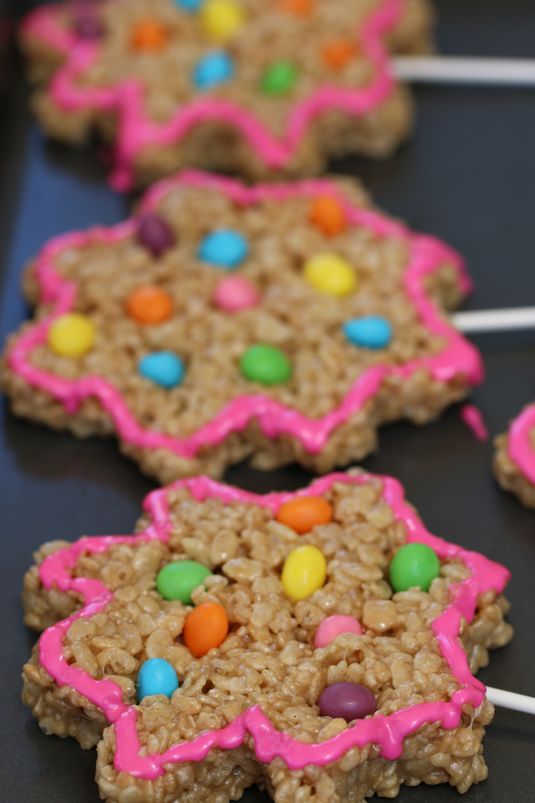

This is an easy and fun treat to make with the kids and grandkids!
You can use any shape silicone mold that you may have, and any color or type of sprinkles that you choose. We use miniature jelly beans and pastel candies for our springtime treats!

INGREDIENTS:
1 cup light corn syrup
1 cup granulated sugar
3/4 cup creamy peanut butter
5 cups Rice Krispie cereal
Spring Sprinkles
Decorator Icing

HOW WE MAKE THESE:
- In heavy pan, pour corn syrup and sugar. Stir over medium-high heat until sugar dissolves and mixture just begins to boil. Remove from heat. Immediately add cup of peanut butter, stirring until blended. Stir in Rice Krispies.
- On a non-stick cookie sheet, place a silicone flower shape or cookie cutter. Fill center of silicone mold with enough krispie mixture to fill; press evenly and firmly into place.
- Invert silicone mold and pop out krispie flower.
- Immediately insert lollipop stick from bottom up until at least the middle of the krispie flower.
- Press spring sprinkles firmly into flower, retaining shape.
- If desired, pipe edging with decorator icing.
- Keep flowers on pan until firm.
- Store in air-tight container with wax paper between flowers, or wrap each individual krispie pop in colorful spring celephane wrap and tie with a ribbon. Keep at room temperature – these will get as hard as a rock if you put them in the refrigerator!

© SnowflakesandCoffeecakes. All images, attachments & content are copyright protected unless otherwise indicated. All rights reserved. Please do not use my images without prior permission. If you want to republish this recipe, please re-write the recipe in your own words, or link back to www.snowflakesandcoffeecakes.com for the recipe.


