Soft & Chewy M&M Cookies
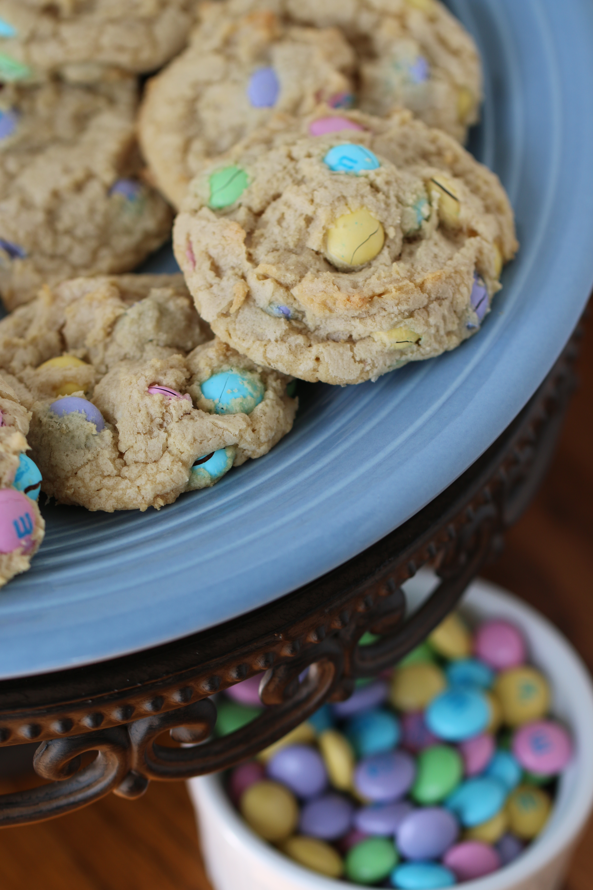

These are such soft and chewy cookies, and the spring colored M&M’s make them extra pretty! These are the best M&M Cookies I've ever had. They're soft, moist, and tender with perfectly chewy edges. The dough is buttery, with hints of vanilla.

INGREDIENTS:

3/4 cup (1 1/2 sticks) unsalted butter, softened
3/4 cup light brown sugar, packed
1/4 cup granulated sugar
1 large egg (room temperature)
2 teaspoons vanilla extract
2 cups all-purpose flour
2 teaspoons cornstarch
1 teaspoon baking soda
pinch salt, optional and to taste
1 1/2 cup milk chocolate M&Ms
SERVINGS: Makes about 22 cookies
HOW I MAKE THESE:
- To the bowl of a stand mixer fitted with the paddle attachment, combine the butter, sugars, egg, vanilla, and beat on medium-high speed until well-creamed, light and fluffy, about 5 minutes (or use a hand mixer and beat for at least 7 minutes).
- Stop, scrape down the sides of the bowl, and add the flour, cornstarch, baking soda, optional salt, and mix until just combined, about 1 minute.
- Add the M&Ms and fold in by hand.
- Using a medium 2-inch cookie scoop, form heaping mounds. Place mounds on a large plate, flatten mounds very slightly with your palm, cover with plastic wrap, and refrigerate for at least 2 hours, or up to 5 days, before baking. Do not bake with warm dough because cookies will spread.
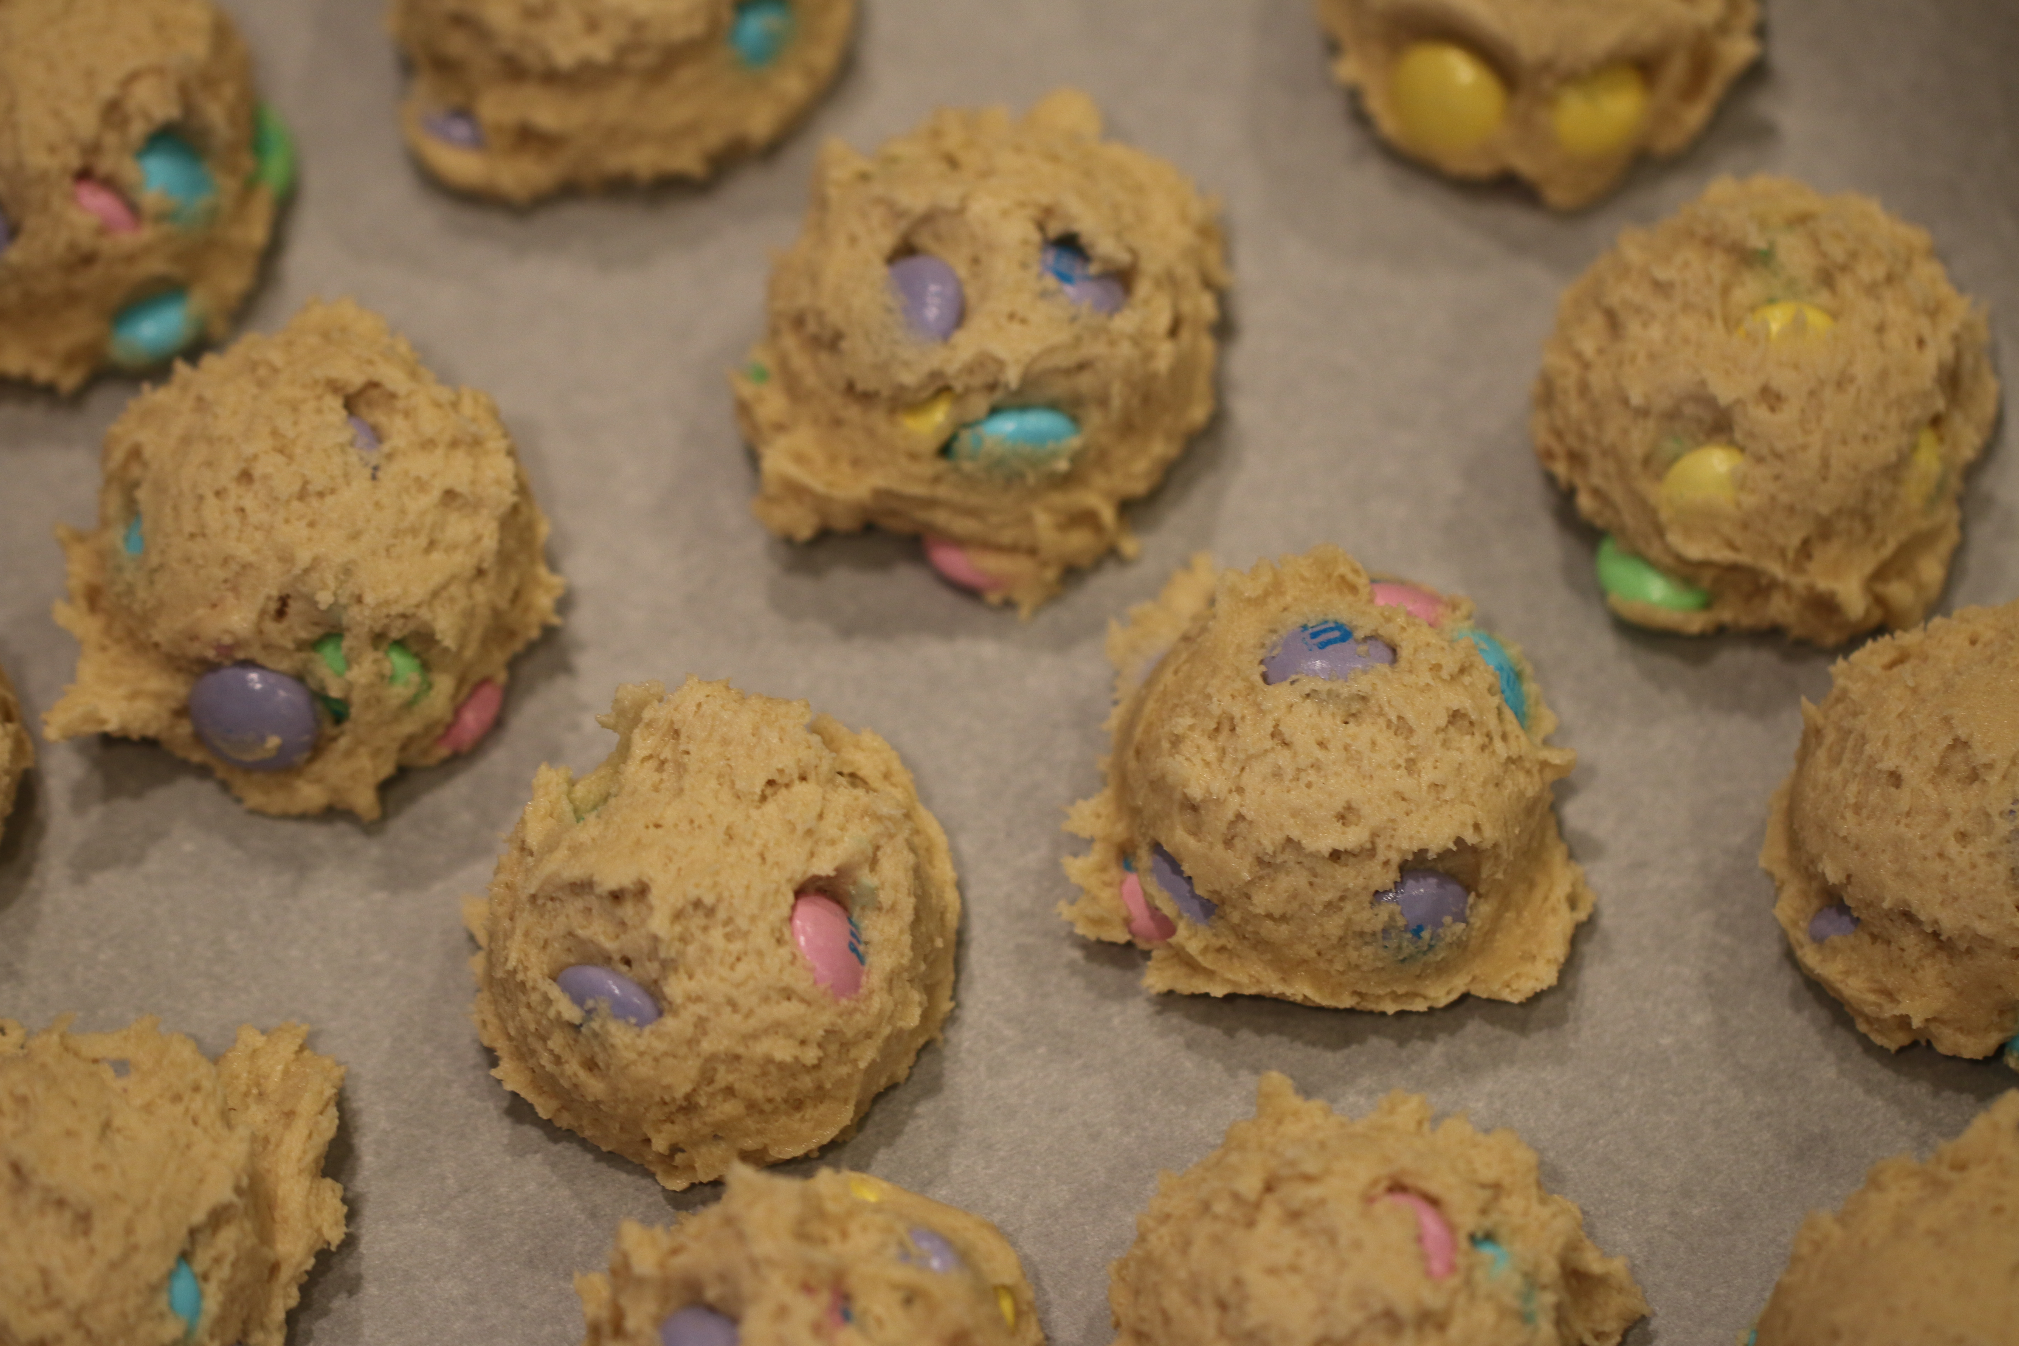
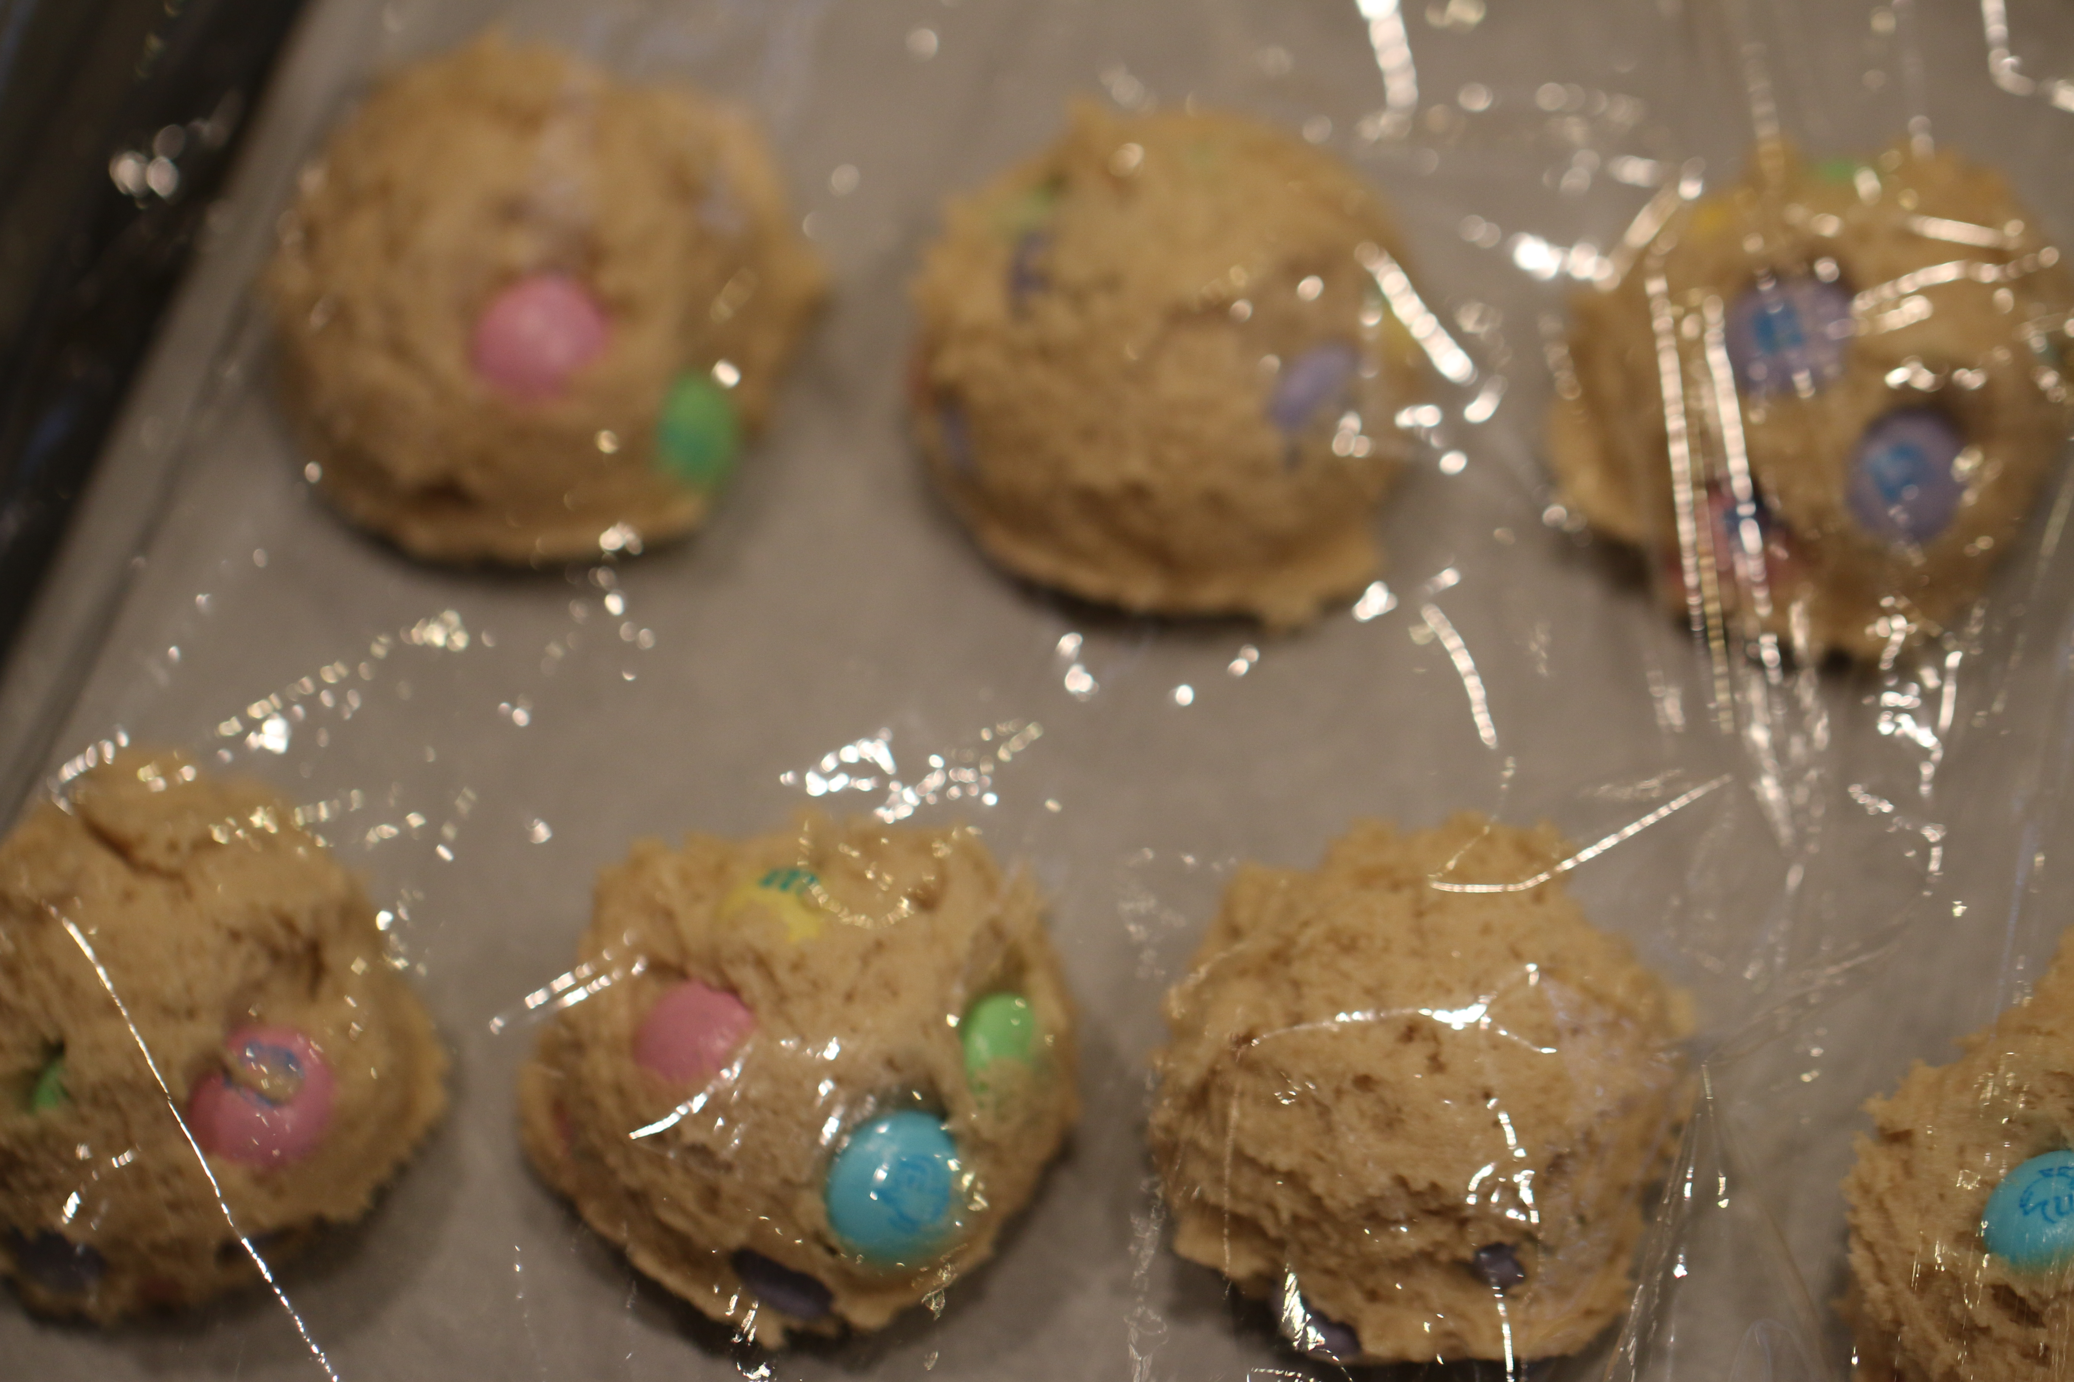
- Preheat oven to 350F, line a baking sheet with a silicone mat or parchment paper/
- Place the cookie balls on the baking sheet, spaced at least 2 inches apart; I bake 8 cookies per sheet. Bake for 8 to 10 minutes, until edges have set and tops are just beginning to set, even if slightly undercooked, pale and glossy in the center. Do not bake longer than ten minutes as cookies will firm up as they cool (The cookies shown in the photos were baked with dough that had been chilled for two days, allowed to come to room temp for 15 minutes, and were baked for 8 1/2 minutes, with trays rotated at the 4-minute mark. They have chewy edges with soft pillowy centers). Allow cookies to cool on the baking sheet for 5 minutes before removing and transferring to a rack to finish cooling.
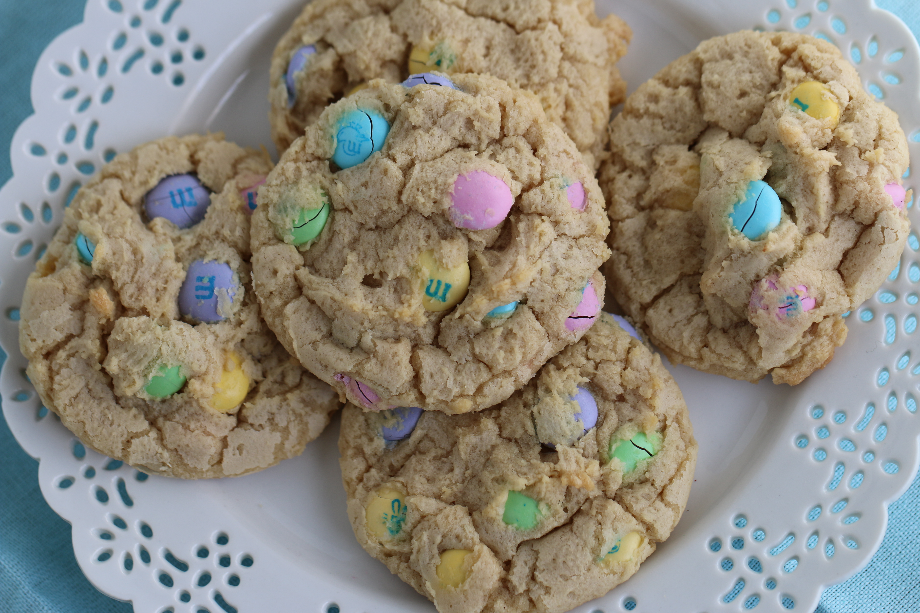
- Store cookies in an airtight container at room temperature for up to 1 week, or in the freezer for up to 3 months. Alternatively, unbaked cookie dough can be stored in an airtight container in the refrigerator for up to 5 days, so consider baking only as many cookies as desired and save the remaining dough to be baked in the future when desired.


