skillet S’More cookie
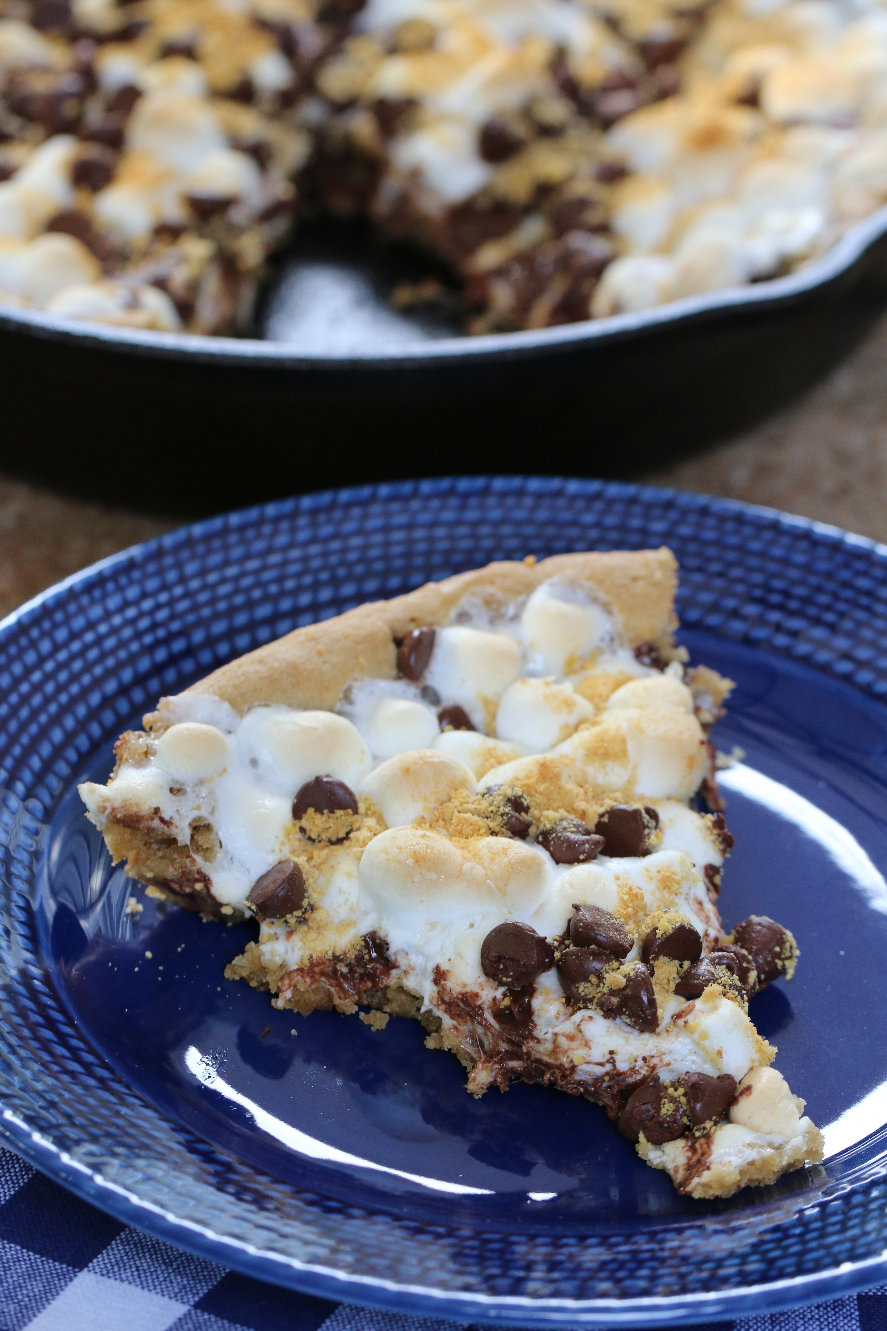

What is a summer camping trip without S’Mores? This delicious twist on a S’More is not only easy to make, but will cause much conversation about which is better – this fabulous treat, or the original? These are delicious, melty, fabulous…and may be your new camping favorite!

INGREDIENTS:
1/2 cup unsalted butter (room temperature)
1/2 cup light brown sugar
1 egg (at room temperature)
1 teaspoon vanilla
1-1/4 cup flour
1/2 teaspoon baking soda
1/2 teaspoon salt
1-1/2 cups mini marshmallows
2/3 cup of chocolate chips
1/3 cup graham cracker crumbs

HOW WE MAKE THESE:
- Preheat the oven to 350 degrees and make sure your 10 to 12-inch skillet is well seasoned; rub the inside with oil so that bottom and sides of skillet are lightly shiny.
- Cream together the butter and sugar until light and fluffy.
- Add egg and vanilla and beat well.
- In a separate bowl, stir together the baking soda, salt and flour with a whisk or spoon.
- Slowly add the flour mixture to the wet mixture and mix just until combined.
- Spread the cookie batter evenly in the skillet (an offset spatula works well).
- Sprinkle ½ cup of chocolate chips evenly on top of batter.
- Sprinkle marshmallows evenly over the top of chocolate chip layer.
- Sprinkle remaining chocolate chips over top of marshmallows.

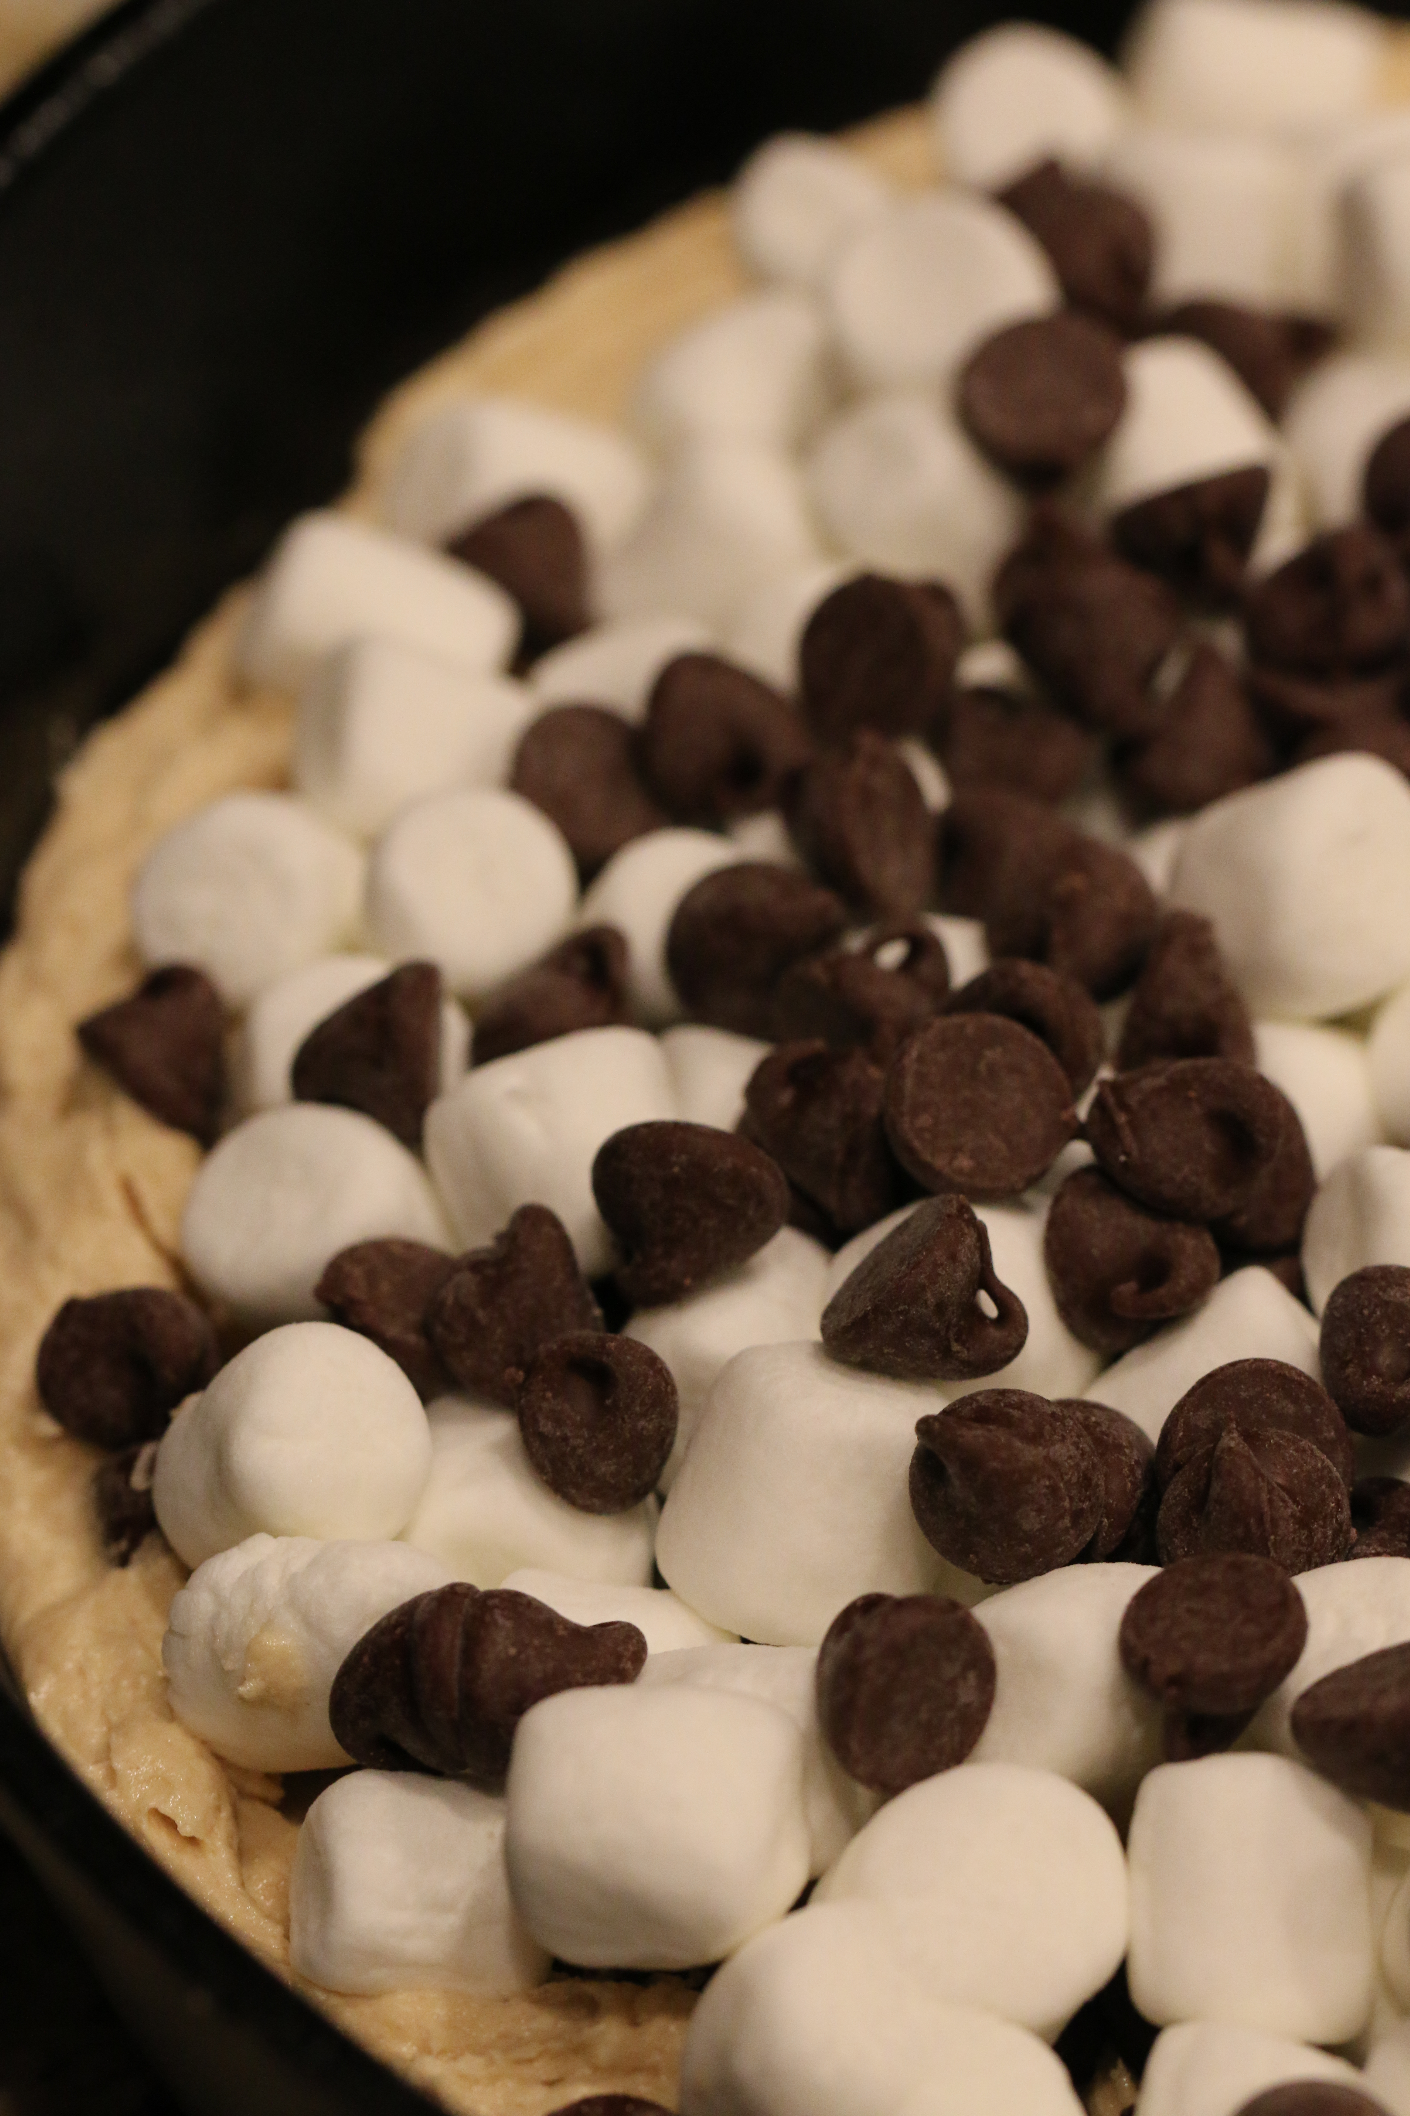
- Sprinkle graham cracker crumbs evenly over the top.

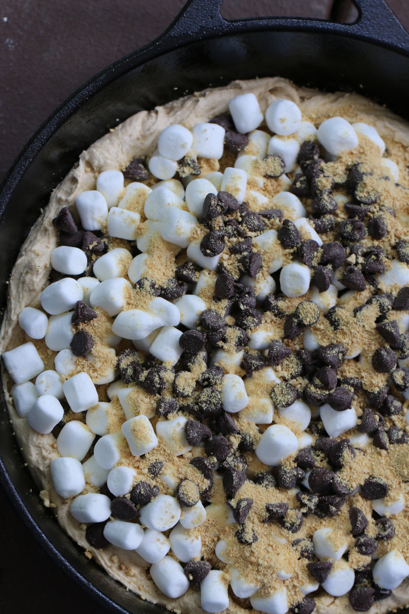
- Bake for 18-20 minutes or until the marshmallows are golden and puffy, and chocolate chips shiny.
- Let the cookie cool completely before cutting and serving.

Servings: One (okay, it really serves 6 easily if you want to share!)

All writing, images, attachments and photography is Copyrighted 2010-2014 by Snowflakes & Coffeecakes Cooking School - www.snowflakesandcoffeecakes.com - unless otherwise indicated. All rights reserved.

