fresh raspberry lemonade
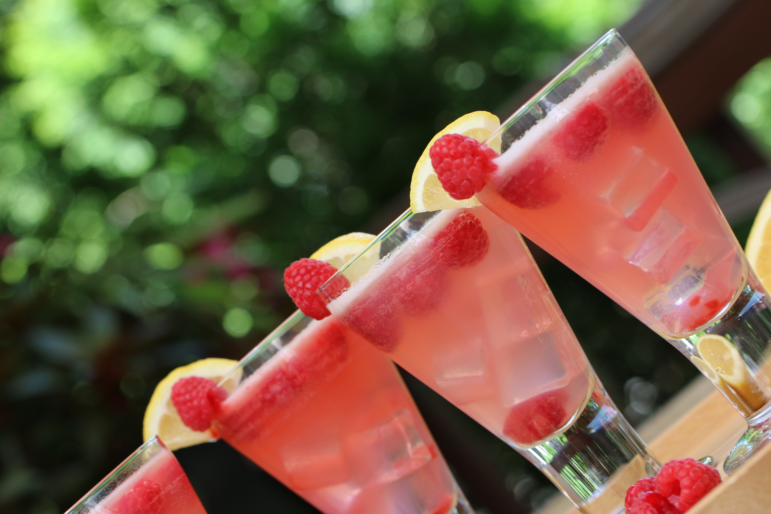

On a hot summer day, nothing screams relaxation more than a tall glass of fresh homemade, icy/slushy lemonade! Doctors Note: Enjoy this with your honey on a shady summer porch swing for additional benefits!

INGREDIENTS:
4 cups Sugar
6 cups Water
24 whole Lemons, Juiced
1 cup fresh or frozen raspberries
8 cups Water (additional)
Lots of Ice!
Lemon Slices (for garnish)
Fresh Raspberries (for garnish)

HOW I MAKE THIS:
Heat 4 cups sugar with 1 cup fresh or frozen raspberries, along with 6 cups of water in a medium saucepan until it’s starting to simmer and the sugar is fully dissolved. You now have a simple syrup. Set this in the fridge to cool. Using a blender (or immersion blender), mix well until combined; strain simple syrup to remove any raspberry seeds.
Juice the lemons and chill if you have the time.
Pour the lemon juice into a large container. Pour in 3/4 of the syrup, then top off the container with ice. Pour in 8 cups of water (give or take), stir it around, then give it a taste. Add more syrup if it needs sweetness, or more water if it needs dilution.
Garnish with fresh raspberries and lemon slices.
Serve immediately!
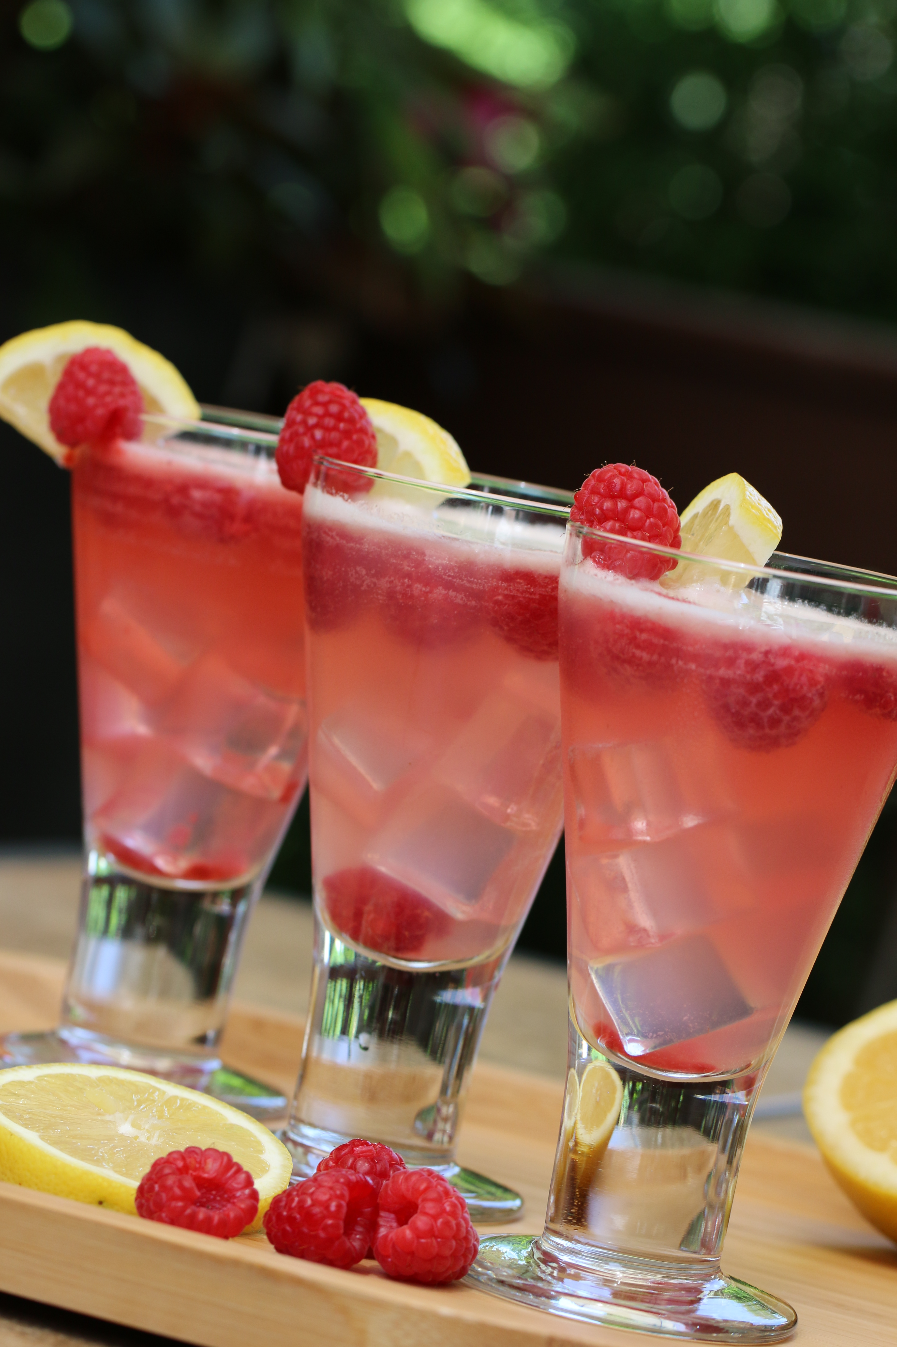
COOKING SCHOOL TIPS:
- Make hard lemonade by adding raspberry vodka or Chambord to the lemonade. (Naughty but nice!)
- If you have the time, you can freeze this lemonade into ice cubes – especially nice for parties or if you don’t like your lemonade getting watered down due to melting ice! For a little extra pizzazz, place a fresh raspberry in each ice cube compartment before freezing.


