FRENCH SILK CHOCOLATE PIE
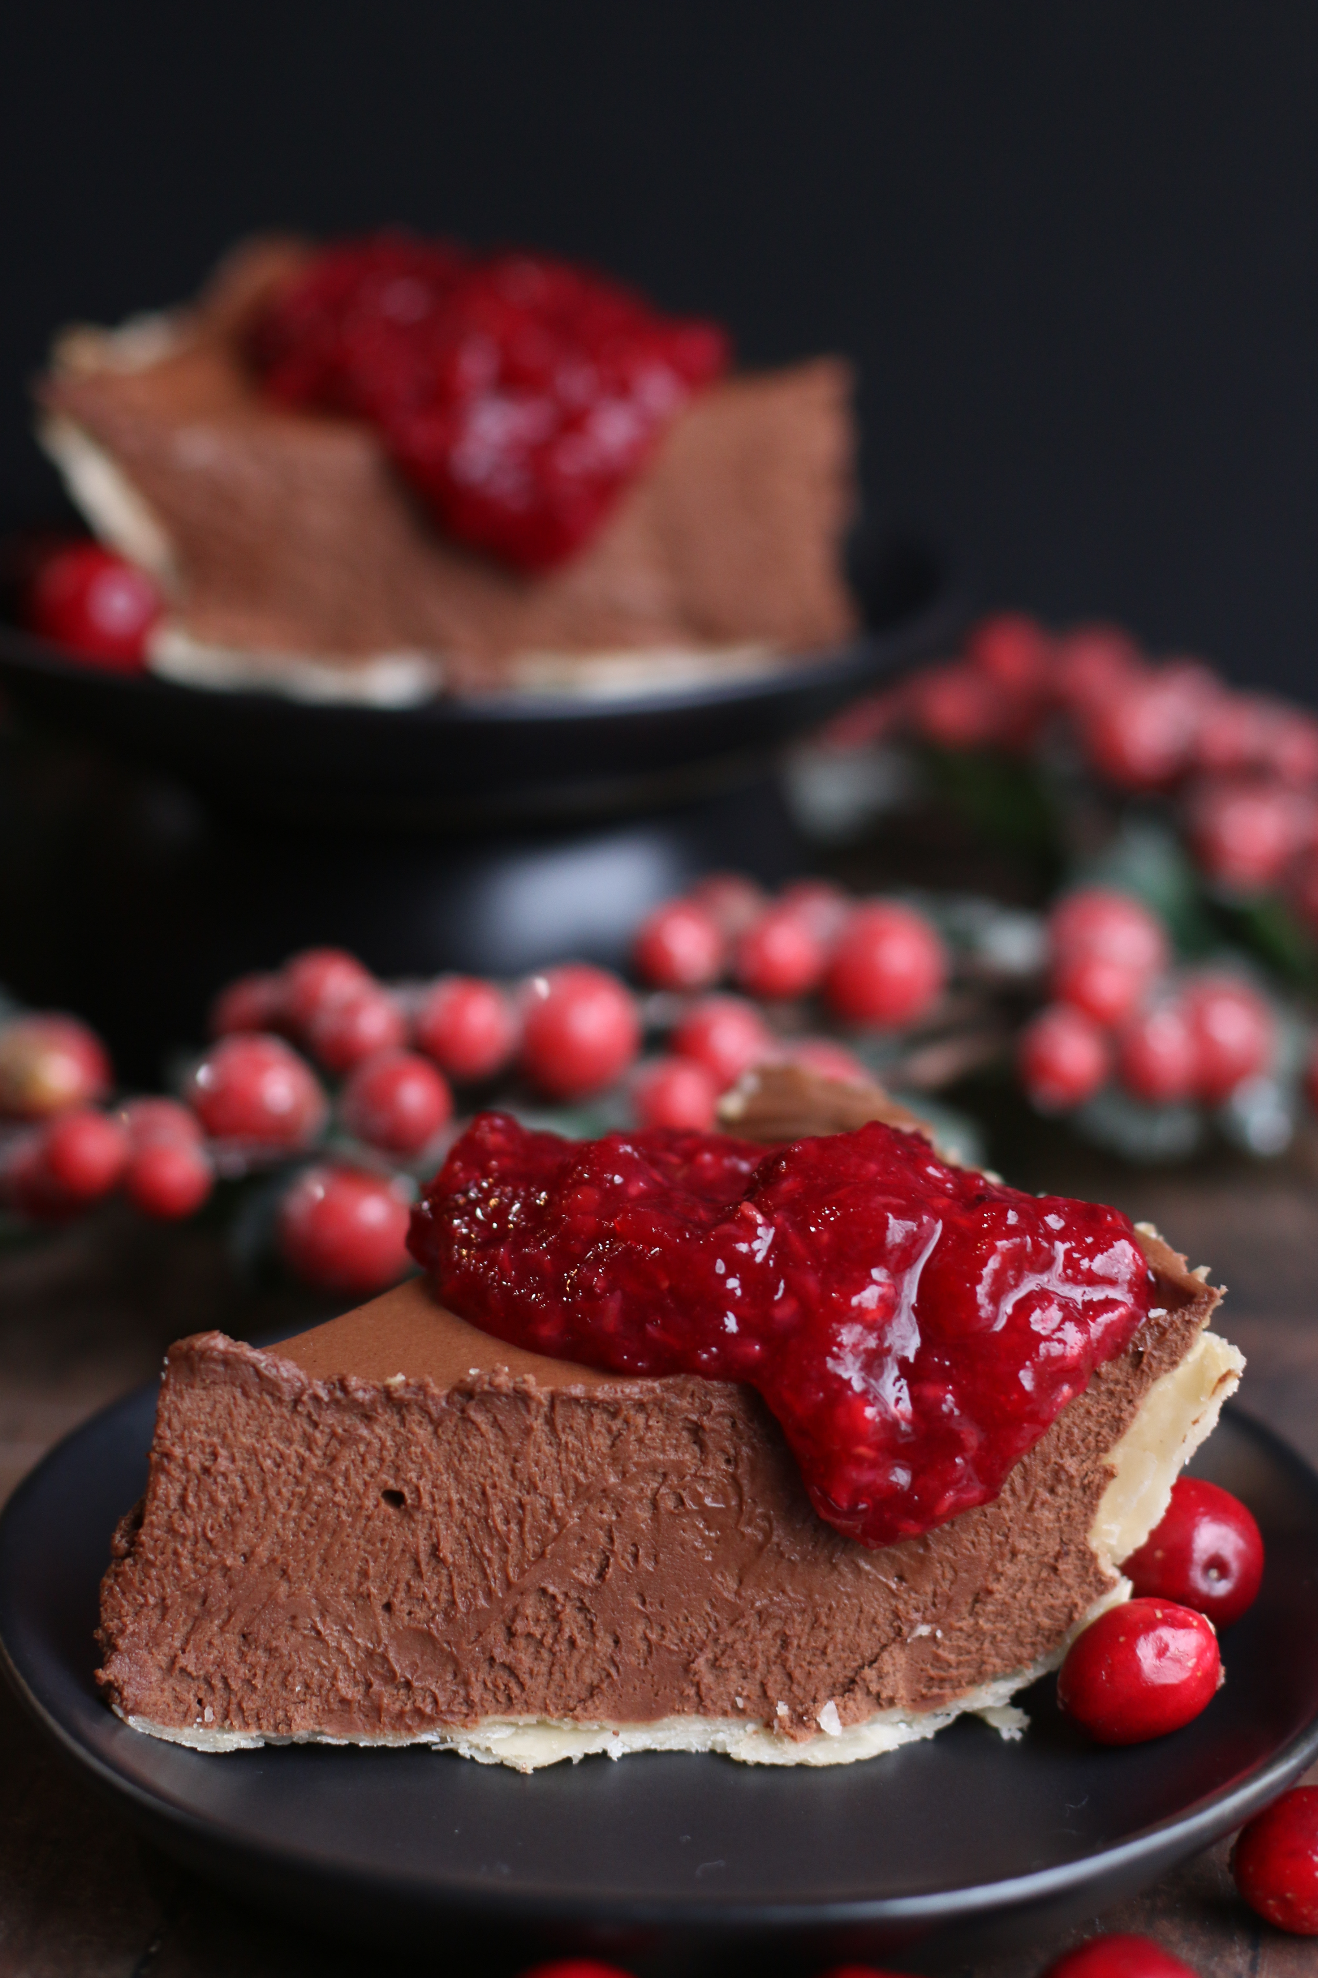

Chocolate and raspberry lovers rejoice! Classic French Silk Pie has been a family favorite for as long as I can remember, but we take it to the next level as Raspberry French Silk Pie! A silky and creamy rich chocolate filling over a layer of raspberry, drizzled with a decadent Raspberry Cranberry Dessert Sauce and dark chocolate curls - all sitting rather elegantly in a flaky & buttery light crust is almost too good to share! This is for my girls – all of you!

INGREDIENTS:
For the Pie Crust:
1¼ cups all-purpose flour
½ teaspoon salt
1 tablespoon granulated sugar
6 tablespoons unsalted butter, chilled, cut into ¼-inch slices
¼ cup solid vegetable shortening, chilled, cut into 2 pieces
2 tablespoons vodka, chilled
2 tablespoons ice water
For the Filling:
1-1/4 cups heavy cream
3 tablespoons unsweetened cocoa powder
2 tablespoons granulated sugar
8 ounces bittersweet Ghirardelli) chocolate, finely chopped
3 large eggs
¾ cup granulated sugar
¼ cup light brown sugar (packed)
¼ tsp salt
2 tablespoons water
1 tablespoon vanilla extract
8 tablespoons unsalted butter (room temperature)
1/3 cup seedless raspberry jam
For the Raspberry Cranberry Topping:
2 cup fresh or frozen cranberries
1 cup fresh raspberries
½ granulated sugar
½ cup cranberry juice

Garnish: (optional)
Fresh Raspberries
Chocolate Curls
HOW I MAKE THIS:
- MAKE PIE CRUST: Process ¾ cups flour, salt, and sugar together in food processor until combined, about 2 one-second pulses. Add butter and shortening and process for 10 seconds (dough will resemble cottage cheese curds with some very small pieces of butter remaining, but there should be no uncoated flour). Scrape down sides and bottom of bowl with a rubber spatula and redistribute dough evenly around processor blade. Add remaining ½ cup flour and pulse until mixture is evenly distributed around bowl and mass of dough has been broken up, 4 to 6 quick pulses. Empty mixture into medium bowl.
- Sprinkle vodka and water over mixture. With rubber spatula, use folding motion to mix, pressing down on dough until dough is slightly tacky and sticks together. Flatten dough into 4-inch disk. Wrap in plastic wrap and refrigerate at least 45 minutes (or up to 2 days).
- Preheat oven to 425 degrees F. On a floured work surface, roll the dough into a 12-inch circle. Transfer the dough to a 9-inch pie plate and gently ease the dough into the pie plate. Leave any dough that overhangs the plate in place, wrap the dough-lined pie plate loosely in plastic wrap and refrigerate until the dough is firm, about 30 minutes.
- Trim the overhang to ½-inch beyond the lip of the pie plate. Tuck the overhang under itself (the folded edge should be flush with the edge of the pie plate). Crimp the dough around the edges. Wrap the dough-lined pie plate loosely in the plastic and refrigerate until the dough is fully chilled and firm, about 15 minutes.
- Line the chilled pie shell with a double layer of aluminum foil, being sure to cover the edges as well, and fill with pie weights. Bake until the pie dough looks dry and is pale in color, about 15 minutes. Remove the foil and the weights and continue to bake until the crust is a deep golden brown, 8 to 12 minutes longer. Transfer the pie plate to a wire rack and let the crust cool completely.
- ADD RASPBERRY LAYER: Spread a thin layer (about ¼ inch) of seedless raspberry jam on the bottom of the cooled pie crust; cover and chill.
- MAKE FRENCH SILK FILLING: Pour the heavy cream into a large mixing bowl and whip on medium-low speed until foamy, about 1 minute. Slowly add in cocoa powder and 2 tablespoons of granulated sugar. Increase the speed to medium-high and continue to whip until stiff peaks form, 2 to 4 minutes. Transfer the whipped cream to a small bowl and refrigerate.
- In a large, heatproof bowl, whisk together the eggs, sugar and water. Beat the mixture on medium speed until pale yellow and thick, about 5 minutes. Set the bowl over a medium saucepan filled ½-inch of barely simmering water over low heat, and warm the mixture, stirring occasionally, until it reaches 160 degrees F on an instant-read thermometer (about 7 minutes).
- Remove the bowl from the heat and add finely chopped dark chocolate piece and vanilla and beat the mixture on medium speed until it is light and fluffy and cooled to room temperature (about 8 minutes).
- Beat in the butter, a few pieces at a time, until well combined. Using a rubber spatula, fold in the whipped cream until no white streaks remain.
- Spoon the chocolate filling into the pie shell on top of the raspberry jam, and gently smooth top. Cover with a tinfoil tent (sealing foil around the edges) and chill at least 3 hours or up to 24 hours.
- PREPARE THE RASPBERRY CRANBERRY TOPPING: Meanwhile, combine the cranberries, raspberries, sugar and cranberry juice in a medium heavy saucepan. Bring to a simmer over medium heat, and continue to simmer for about 15 minutes. As the cranberry sauce cooks, the berries will burst and the sauce will thicken. There’s no need to mash the berries, and the sauce looks prettiest if you stop cooking while there are still some whole cranberries and raspberries. Taste your sauce and add sugar if needed, stirring to dissolve the sugar. Remove from heat, and cool to room temperature. Store in an airtight container and refrigerate until ready to serve.
- Before serving, drizzle Raspberry Cranberry Sauce on top of cut slices of pie and garnish with fresh raspberries, chocolate curls or finely chopped dark chocolate (optional).
- Leftovers should be stored in the refrigerator, covered, for up to 3 days – as if it would ever last that long!
YIELD: 8 Servings
RASPBERRY CRANBERRY SAUCE SECRETS:
- Cranberries. This time of year, you can buy bags of fresh cranberries in the produce section at your grocery store. I always put a couple of extra bags straight into my freezer, where they will keep indefinitely, until I’m ready to use them. For this recipe you can use either fresh or frozen cranberries. Cranberries are extremely tart, and they need sugar to make them palatable. Cranberries are also high in pectin, which is released when they’re cooked, helping to thicken the sauce naturally.
- Cranberry Juice. Your sauce needs some liquid, and I like to use cranberry juice, but you could also just use water. When I make my cranberry orange compote, I use orange juice.
- Raspberries. Since fresh raspberries (as well as frozen) are hard to come by in the fall and winter, if you have a hard time finding ripe fresh raspberries, you can use seedless raspberry jam to add raspberry flavor. I prefer fresh berries, but a girl has to do what a girl has to do!
- Sugar. I’d suggest tasting your raspberry cranberry sauce before adding additional sugar. Of course, if you use a tart, unsweetened cranberry juice, you’ll probably want to add a little extra sugar.
© SnowflakesandCoffeecakes. All images, attachments & content are copyright. All rights reserved. Please do not use my images without prior permission. If you want to republish this recipe, please re-write the recipe in your own words, or link back to www.snowflakesandcoffeecakes.com for the recipe.
Did you make this recipe?
Tag @snowflakesandcoffeecakes on Instagram and hashtag it #snowflakesandcoffeecakes.
Find it online: https://www.snowflakesandcoffeecakes.com/snowflakesandcoffeecakescom/raspberry-french-silk-chocolate-pie

