potato salad

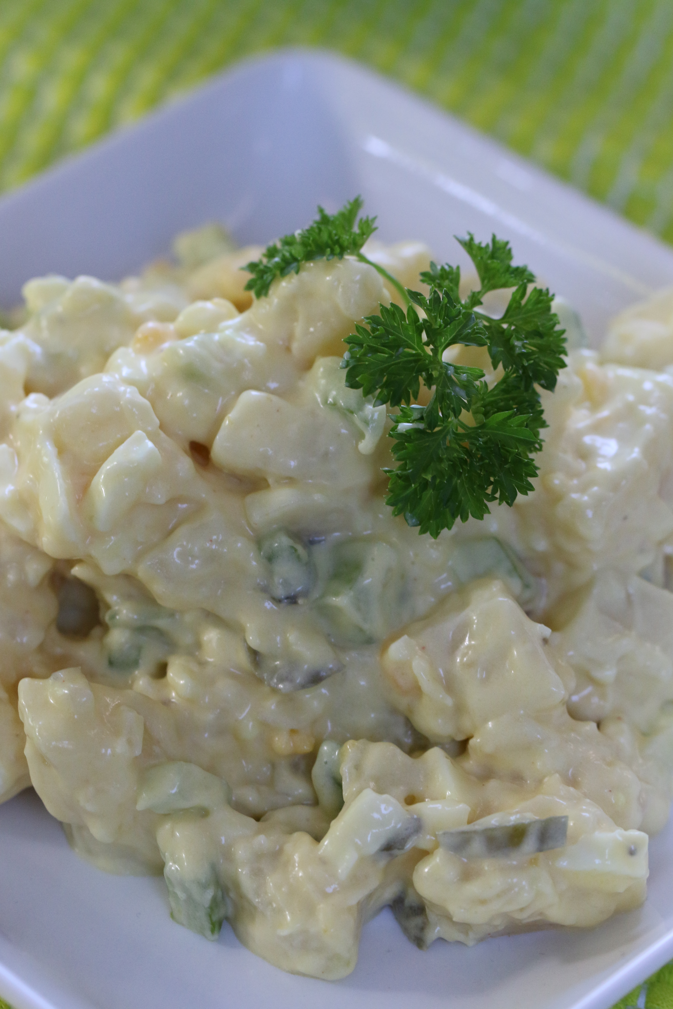

Grama always made the BEST potato salad, but she never used a written recipe – it was always by feel and taste. This family favorite recipe is based on her recollection, which is totally adaptable. If you want more onions, or less eggs, or dill relish instead of sweet relish, make it your own! Want it sweeter? Add some more sugar. Like it with more mustard or some celery seed? Want to garnish with some chopped bacon? Knock yourself out making it your own!

INGREDIENTS:

5 lb red potatoes
6 hard boiled eggs
½ cup finely diced sweet onion
1/3 cup pickle relish (sweet or dill – I use sweet relish)
1 cup finely sliced celery or 1 teaspoon celery seed
2 cups Miracle Whip
3/4 cup whipping cream
2 Tbsp yellow mustard
1/4 cup sugar
1/4 tsp salt
1/8 tsp pepper
1/4 c. vinegar
HOW WE MAKE THIS:
- Place potatoes in large stock pot and cover with water. Bring to rapid boil, turn down to and simmer until potatoes are tender. (I prefer using my large electric steamer to steam the potatoes, but if you don’t have this option, use the stock pot and boil.) Drain potatoes and let cool.
- When cool, peel skins from potatoes and dice; place in large mixing bowl.
- In a medium mixing bowl whisk whipping cream for 1 minute. Stir in Miracle Whip, mustard, sugar, salt, pepper and vinegar. Mix until combined. Stir in pickle relish.
- Pour mixture over cooled potatoes. Peel and dice hard boiled eggs and add to potatoes. Add sliced celery or celery seed. Mix until combined.
- If you’d like, garnish with additional sliced eggs or 4 slices of bacon (cooked and crumbled for garnish)
- Refrigerate until thoroughly cooled.
- Remember to keep this salad chilled or serve immediately – no longer than two hours without refrigeration.


