peanut butter cup cookies
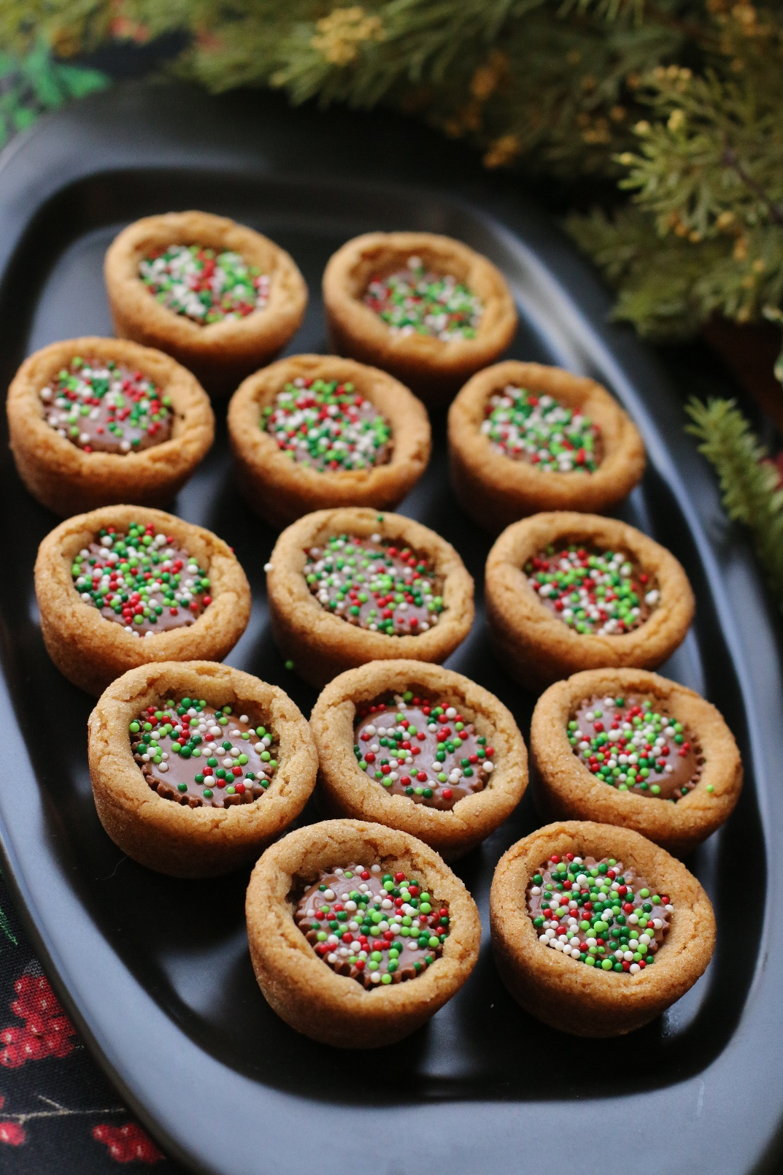

The original perfect butter cup cookie – made famous (almost) by my Great Gram… perfect for a tea party or the holidays!
INGREDIENTS:
1¼ cups all-purpose flour
¾ teaspoon baking soda
½ teaspoon salt
½ cup unsalted butter (room temperature)
½ cup creamy peanut butter
½ cup granulated sugar
½ cup light brown sugar
1 large egg (room temperature)
1 teaspoon vanilla extract
48 miniature Reese’s peanut butter cups, unwrapped
Christmas sprinkles (optional)

HOW I MAKE THESE:
- Preheat oven to 350 degrees. Spray miniature muffin pans with non-stick cooking spray; set aside.
- In a small bowl, whisk together the flour, baking soda and salt; set aside.
- Beat together the butter, peanut butter and both sugars on medium speed until light and fluffy, about 3 minutes, scraping the sides of the bowl as needed. Add the egg and vanilla and mix for another minute or until combined. Reduce the mixer speed to low, add the dry ingredients half at a time, and mix until just combined. Give the dough a final stir with a rubber spatula to ensure all of the flour mixture is incorporated.
- Shape the dough into 1-inch balls (about 2 teaspoons worth of dough) and place in prepared miniature muffin pans (keep the dough in balls – do not press into the pan).
- Bake for 8 to 10 minutes, or until light golden brown and slightly puffy. Remove from the oven and immediately press a miniature peanut butter cup in the middle of each cookie, pressing down so that the top of the peanut butter cup is even with the top of the cookie.
- If desired, sprinkle with Christmas sprinkles while still warm and melty.
- Cool in pans until peanut butter cup firms up again, BEFORE removing from the pans.
- Store in an airtight container at room temperature.
YIELD: Makes 48 cookies.
© SnowflakesandCoffeecakes. All images, attachments & content are copyright protected unless otherwise indicated. All rights reserved. Please do not use my images without prior permission. If you want to republish this recipe, please re-write the recipe in your own words, or link back to www.snowflakesandcoffeecakes.com for the recipe.

