peanut butter cup cheesecake
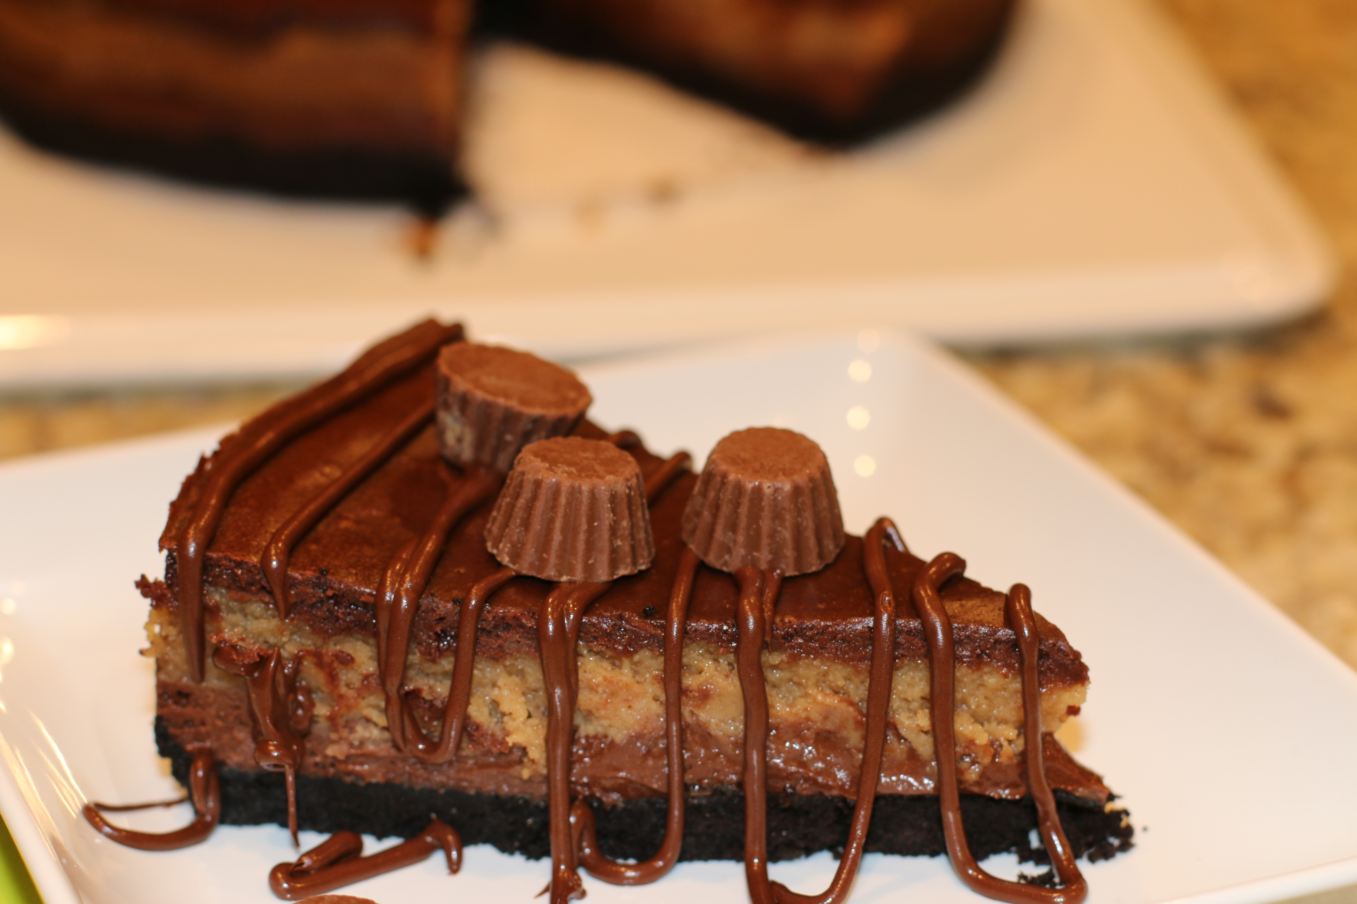

This delectable cheesecake is so easy to make, beautiful to serve, and delicious to eat!

Ingredients
Crust:
2 cups chocolate wafer cookie crumbs,
3 Tablespoons butter, melted

Peanut Butter Layer:
8 ounces cream cheese
1/4 cup sugar
1 cup creamy peanut butter
1 egg
1 teaspoon vanilla

Chocolate Layer:
1 1/2 cups chocolate chips
8 ounces cream cheese
2 eggs
2 Tablespoons heavy cream
1 teaspoon vanilla

Garnish:
1 cup chocolate chips, melted to drizzle over each slice when serving
1 tablespoon vegetable shortening
Reese’s Peanut Butter Cup Mini’s (bite size)

HOW I MAKE THIS:
- Grease and line a 9 inch spring form pan with parchment paper.
- Crush cookie wafers in food processor or blender. Melt butter. Combine cookie crumbs and melted butter.
- Press crust crumbs into the bottom and push with a measuring cup bottom to pack them in. Set aside.
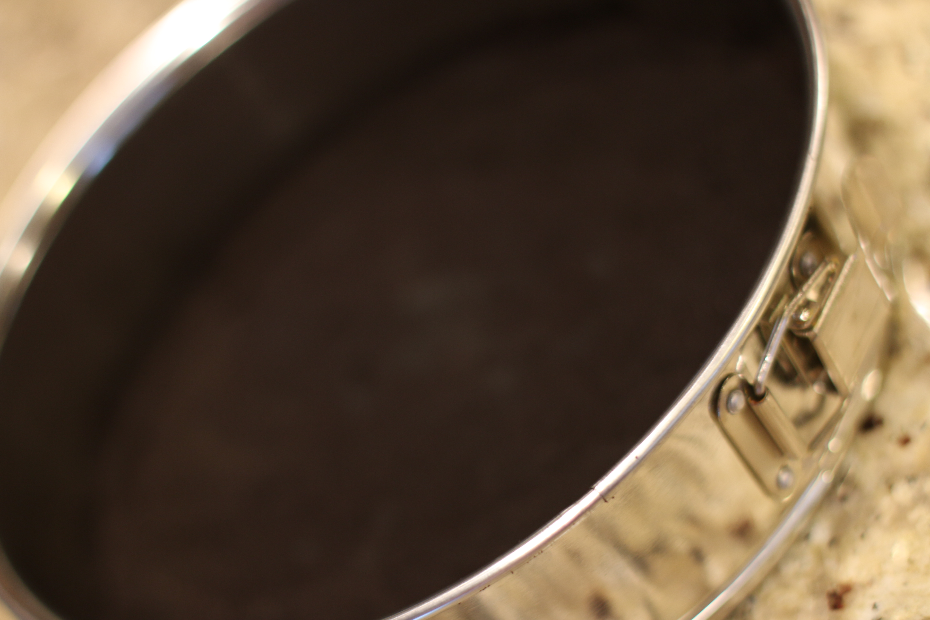
- In a mixer, beat cream cheese and sugar. Add peanut butter, egg, and vanilla. Mix well. Set aside.
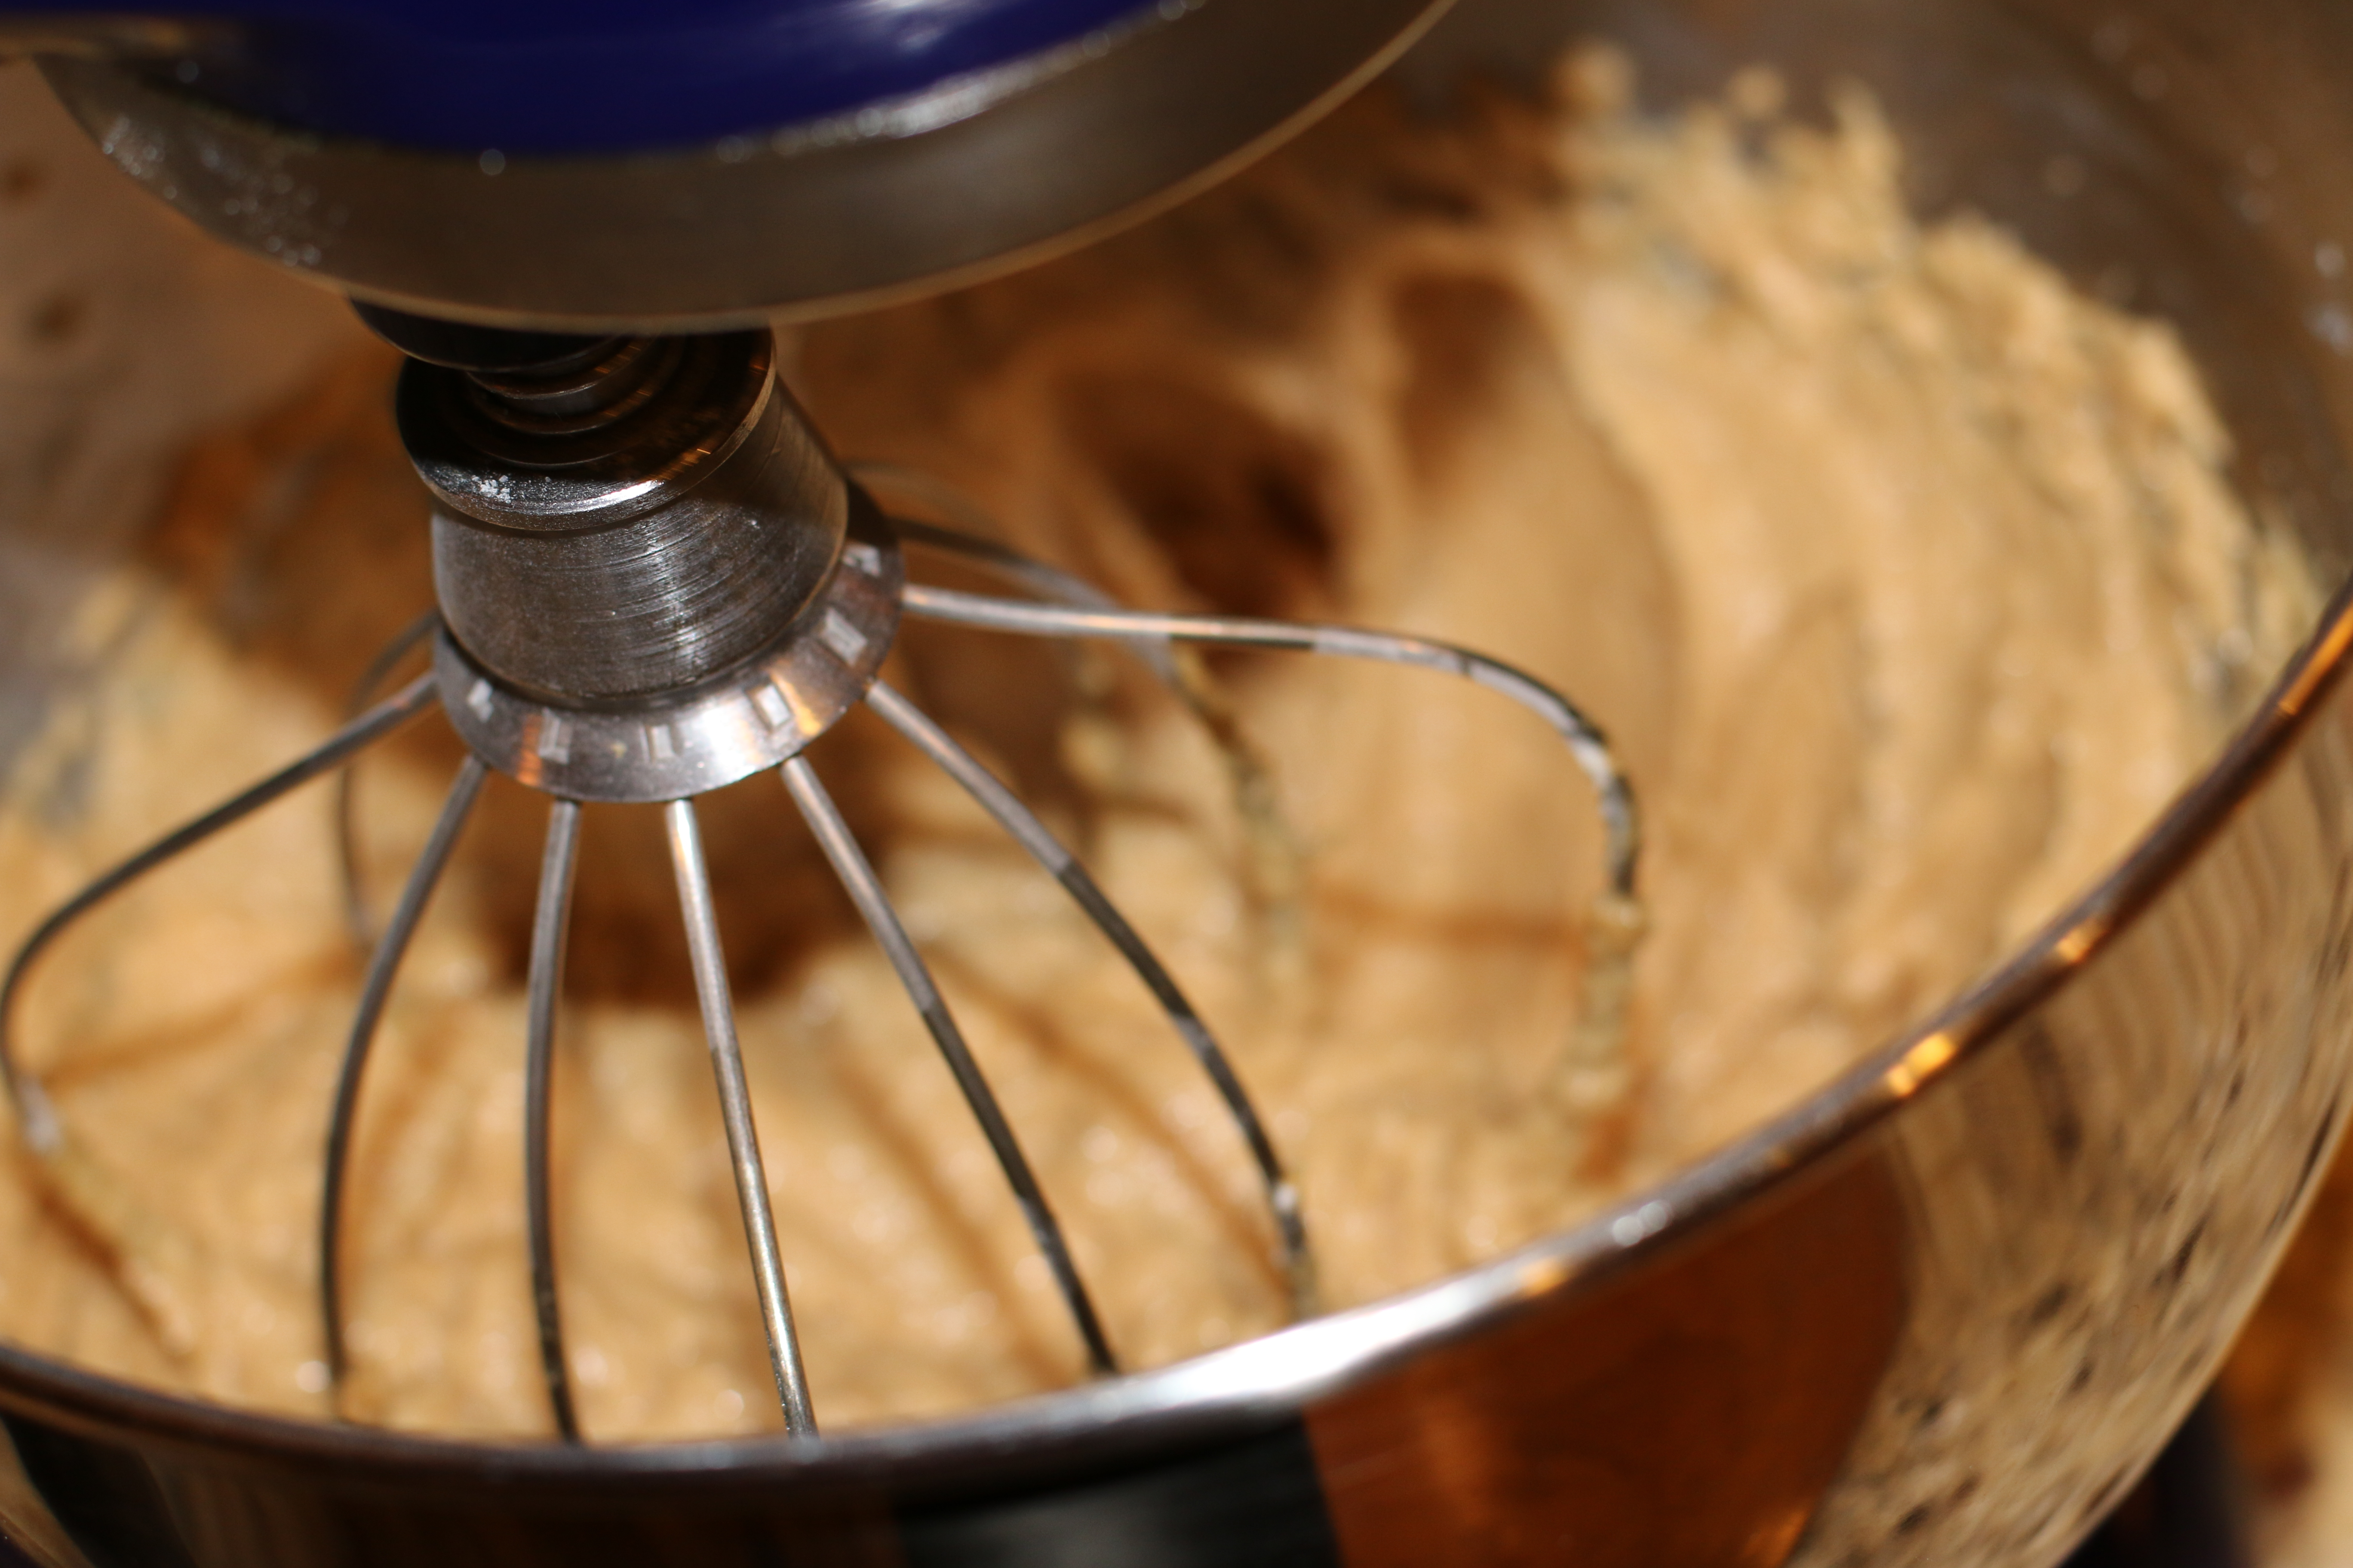
- In a small pot on med-low heat, melt the chocolate chips. Once melted, add the cream cheese and stir until well melted. Whisk in the cream. Add vanilla. Crack the eggs into a small bowl. Pour a little bit of the chocolate mix into the eggs and stir (this will temper the egg mixture). Then add the egg mixture into the pan, whisking constantly so that the egg mixture doesn’t scramble.
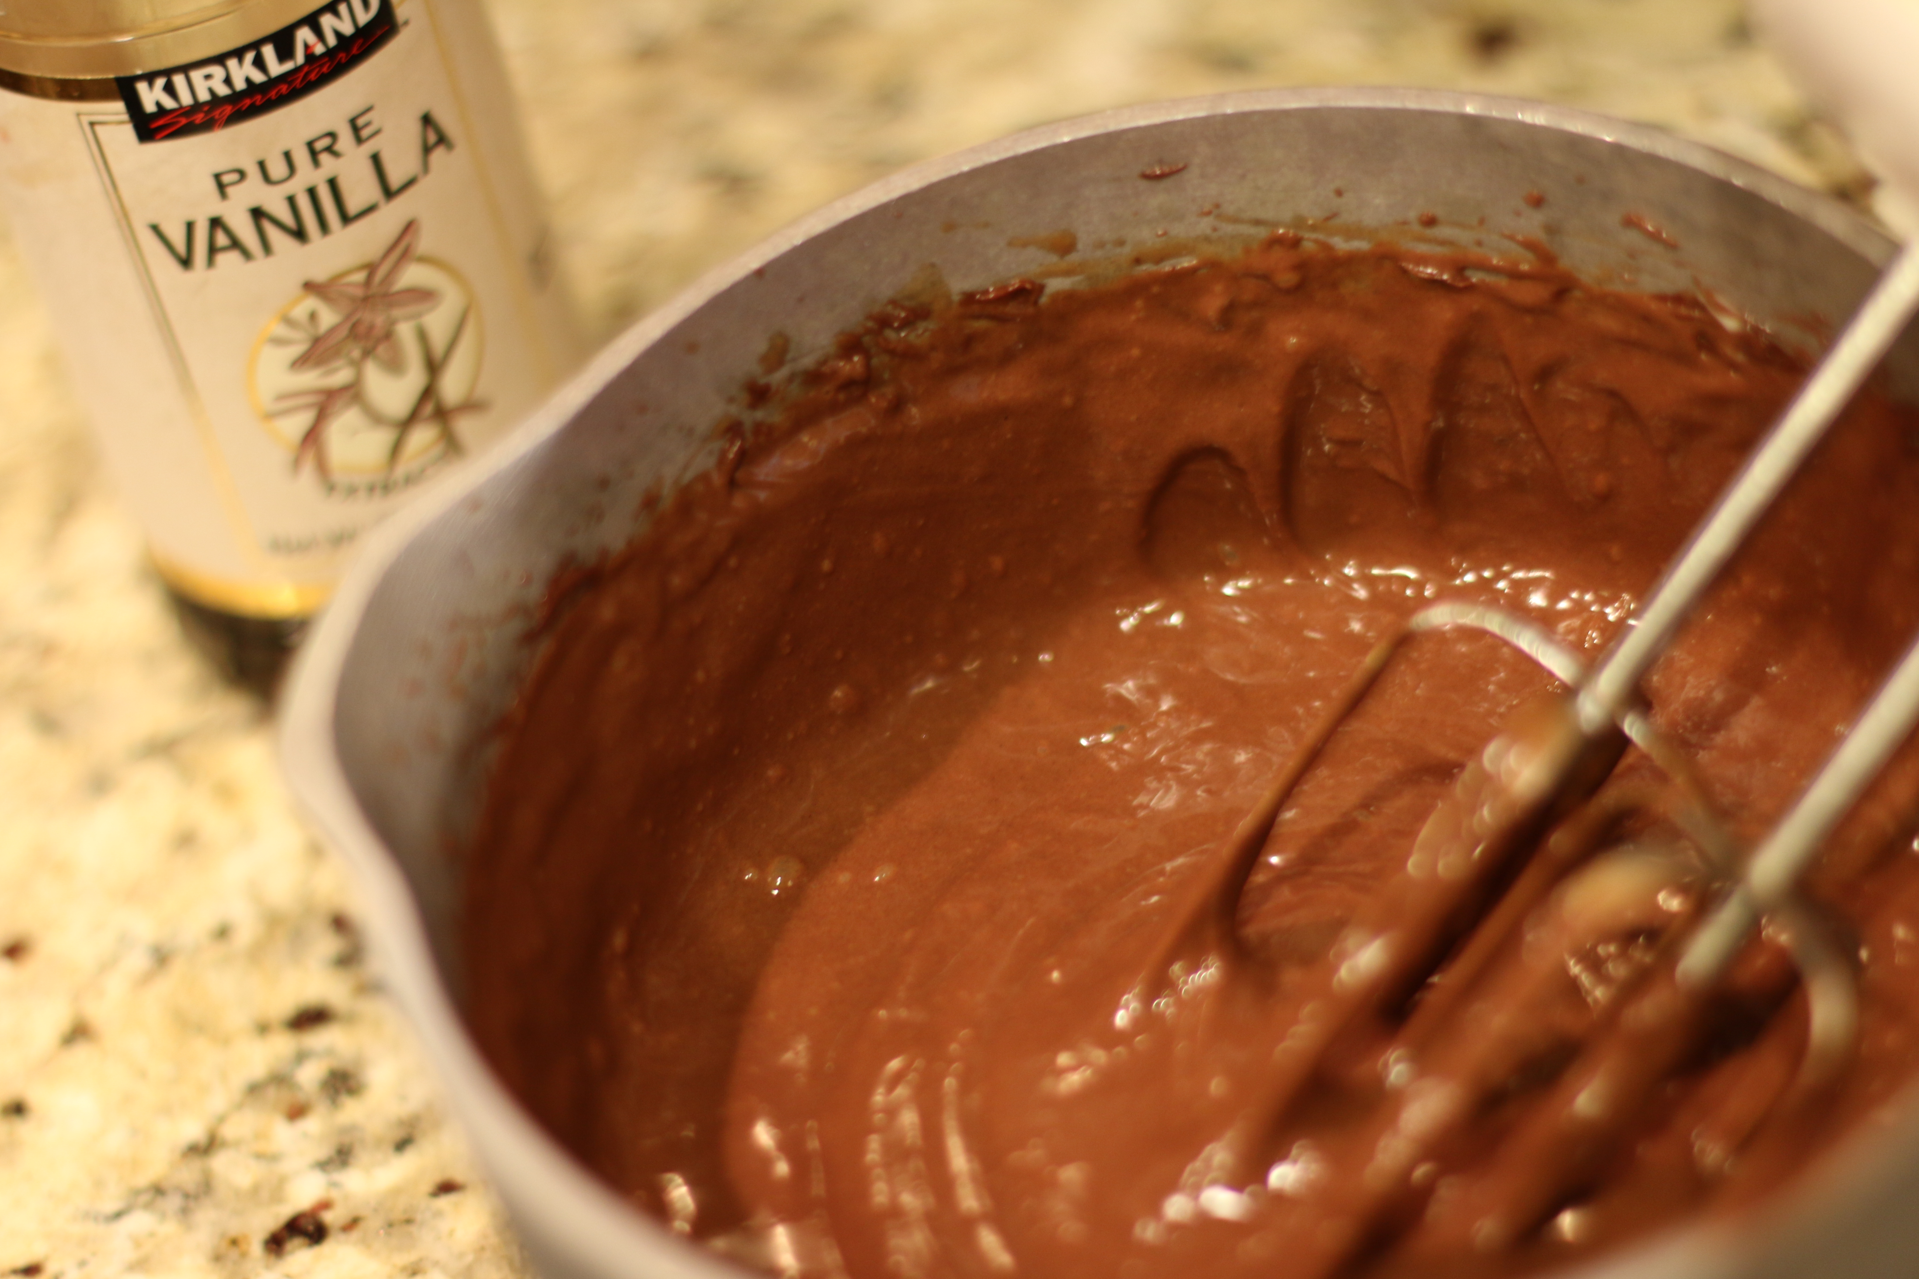
- Scoop 2 cups of the chocolate mix on top of the crust. Chill in freezer 15 minutes to help it set
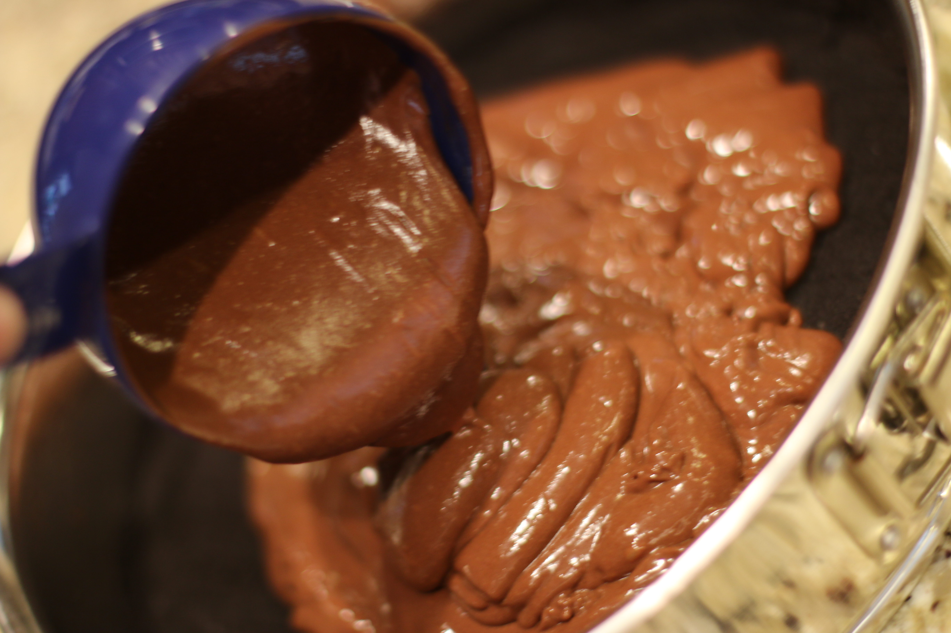
- Carefully spread the peanut butter mixture on top of the chocolate. Spread slowly and carefully. Spread the rest of the chocolate batter on top.
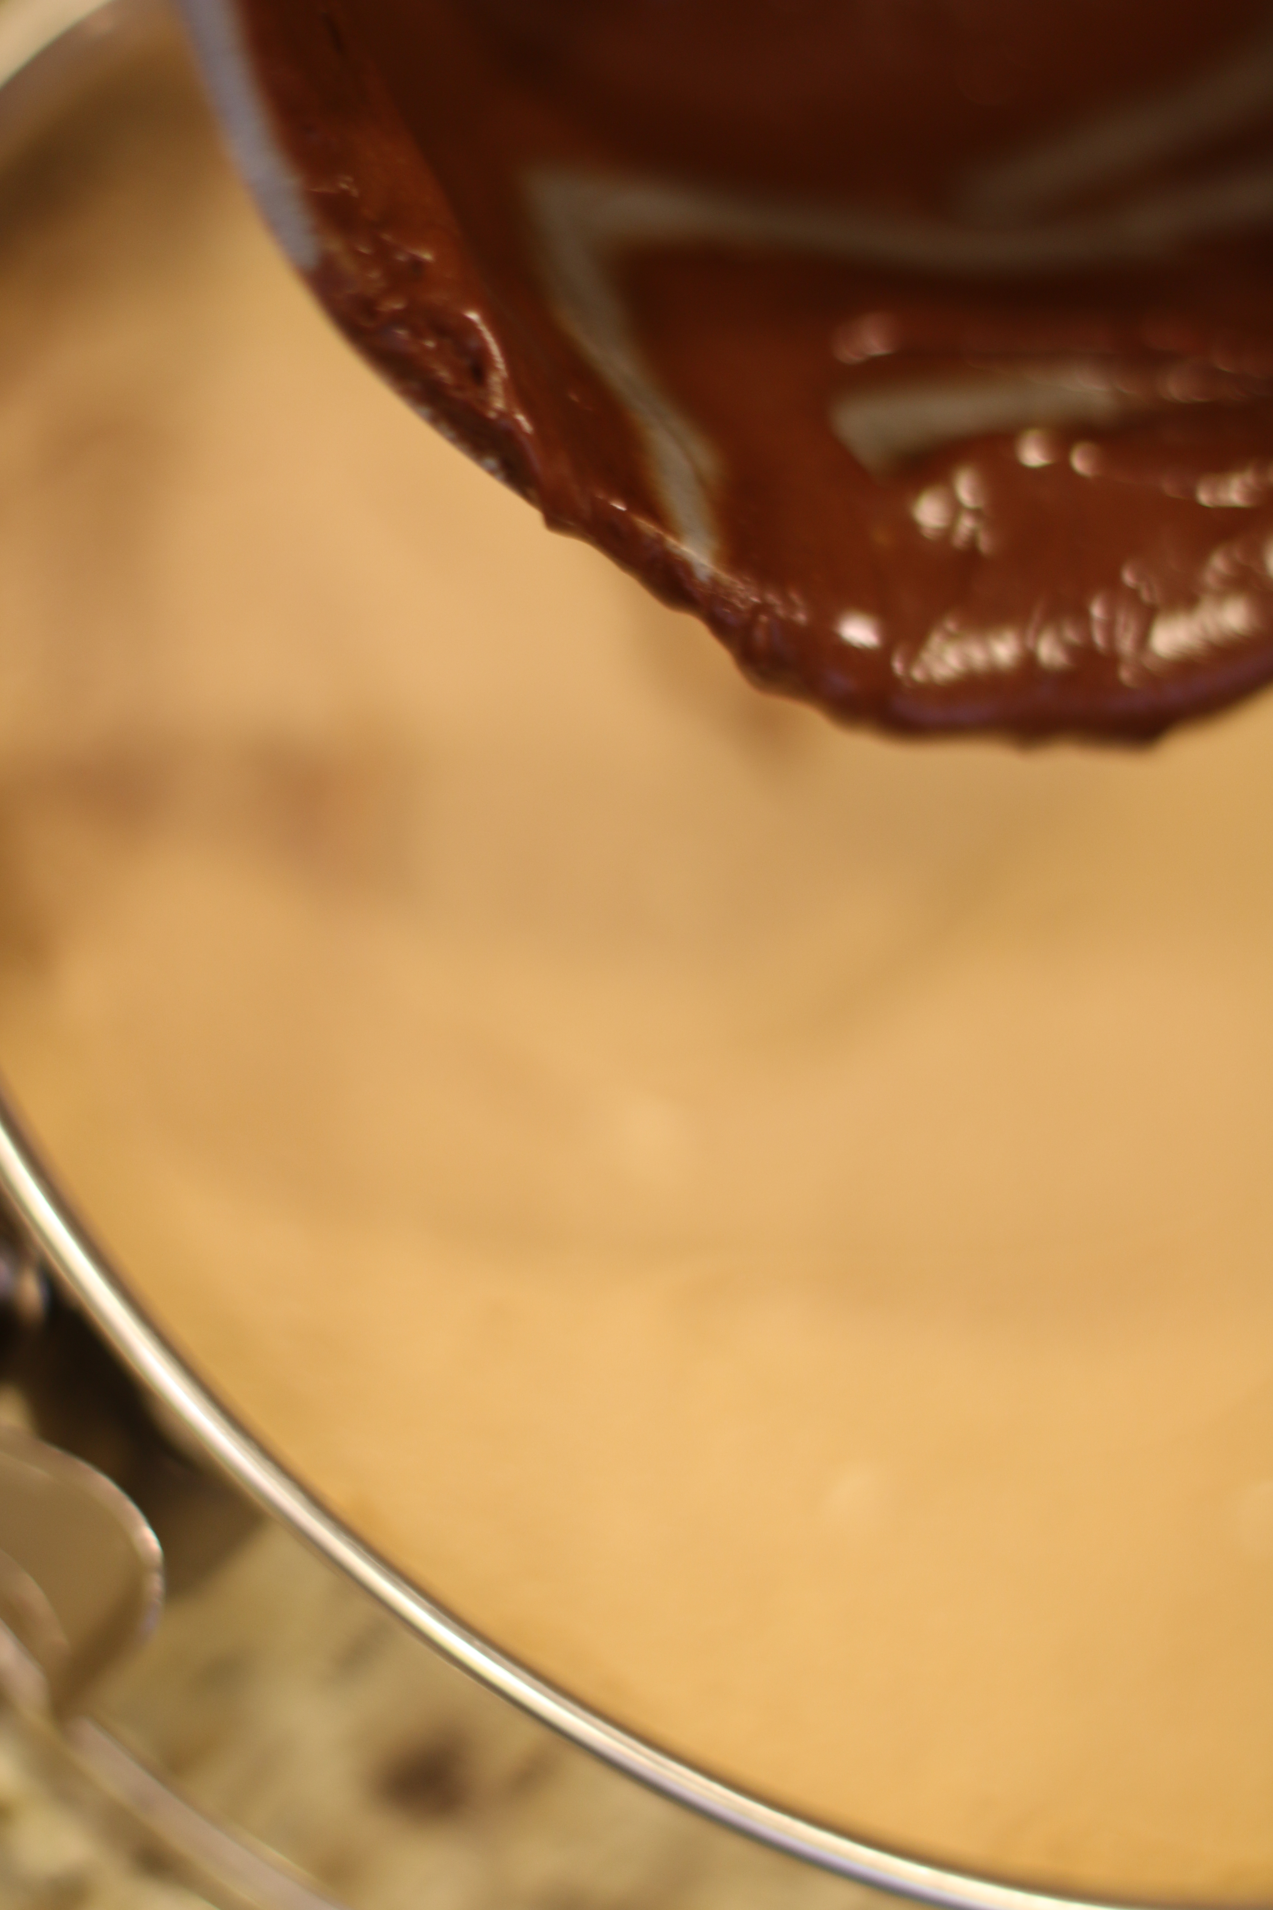
- Preheat oven to 300 degrees. Place a cakepan with 1” of water in a lower rack of the oven (this will keep your cheesecake from cracking).
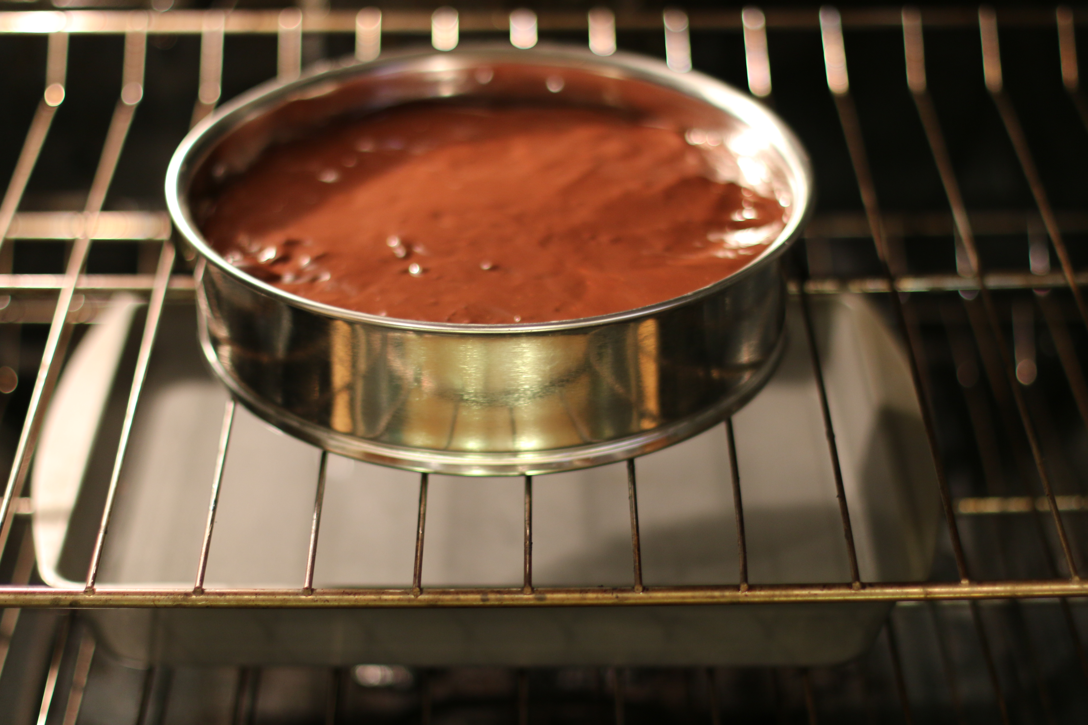
- Bake at 300 degrees for exactly 55 minutes. Remove and cool on rack. Place in fridge until chilled and ready to serve.
- To serve, melt chocolate chips and vegetable shortening. Drizzle over each slice, top with mini-peanut butter cups and serve.

