marshallow lollipops

[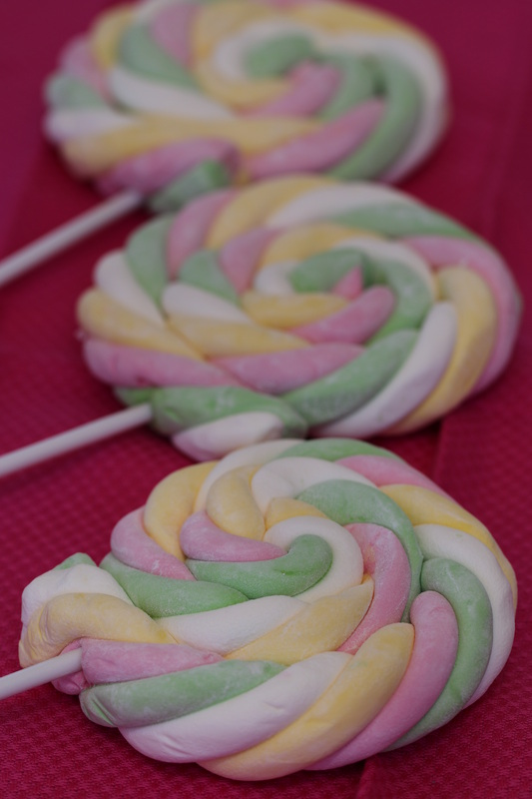](http://weebly-file/4/9/7/7/497710/rep_marshmallow_rope_lollipops.docm)

*Perfect for Easter!*

*To make these soft marshmallow ropes, this recipe will need to be made three separate times using three different colors of food coloring. Gel food coloring is recommended and will not affect the consistency of the marshmallow batter.*

**INGREDIENTS:**

**Marshmallow coating**

3 cups confectioners’ sugar

1/2 cups cornstarch

**Marshmallow**

4 1/2 teaspoons jello powder (pick flavor & color of your choice)

1/2 cup cold water

3/4 cup sugar

1/2 cup light corn syrup, divided

1/4 cup water

Pinch of salt

1/2 tsp. clear vanilla extract

Your choice of gel food coloring

Toothpicks

**HOW I MAKE IT:**

Prepare Marshmallow Coating:

Whisk confectioners’ sugar and cornstarch together in a large bowl. Place several large sheets of parchment paper over a large work surface – you’ll need lots of space. Dust parchment paper generously with the marshmallow coating. Reserve the remaining coating for later use.

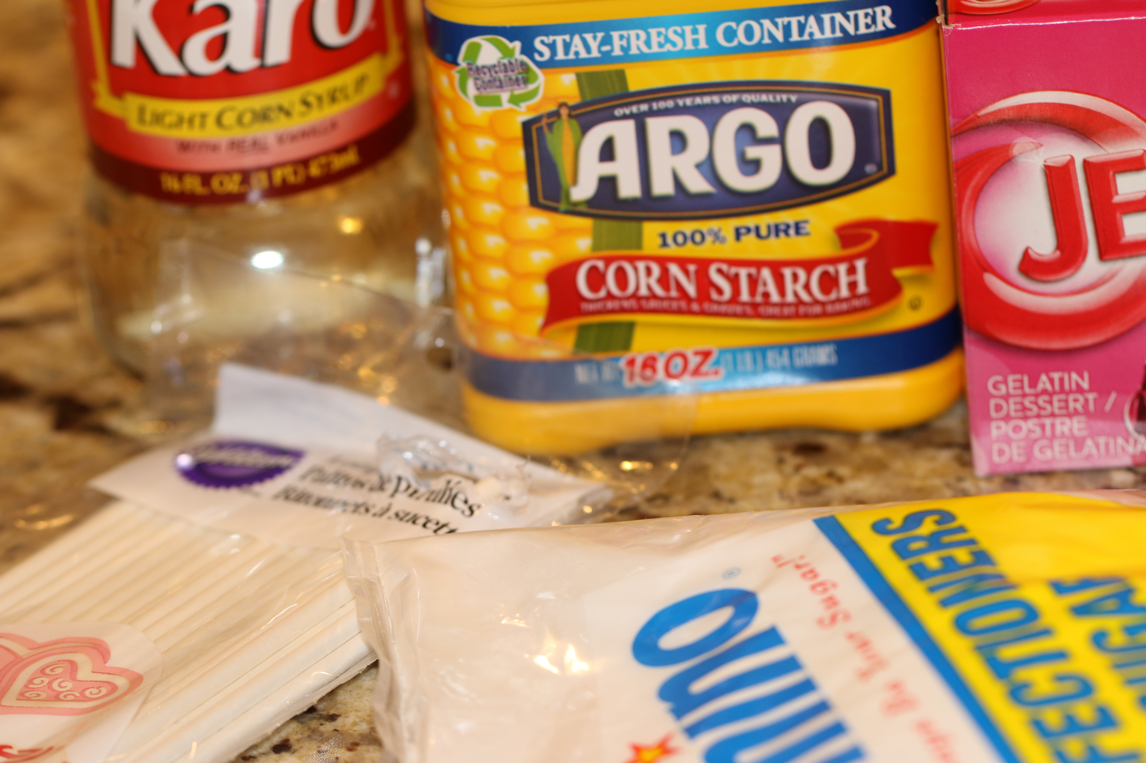

**Prepare Marshmallows:**

1. Whisk together the gelatin and cold water in a small bowl.  Let set for 5 minutes until gelatin absorbs liquid.
2. In a saucepan with a candy thermometer inserted, combine sugar, 1/4 cup corn syrup, 1/4 cup water and salt. Cook over high heat and bring to a boil. Meanwhile, pour the remaining 1/4 cup corn syrup in the bowl of a standing mixer fitted with the whisk attachment. Heat the gelatin in the microwave or on the stove-top until melted completely and pour into the mixing bowl with the corn syrup.  Turn mixer on low and keep it stirring until the sugar syrup is ready.
3. When the syrup reaches 240°F, slowly pour it into the mixer bowl. Increase the speed to medium and beat for 5 minutes, then increase to medium-high and beat 5 more minutes. Finally, increase to highest speed and beat 1-2 more minutes, add vanilla then beat again for 1-2 minutes.  Mixture should be opaque and tripled in volume. Add food coloring and beat until incorporated. Immediately scoop marshmallow into the large piping bag fitted with a plain 1/2-inch tip. You can also use a disposable piping bag with the end snipped to size.
4. Pipe long lengths of marshmallow batter onto the prepared sheets until all the batter is used.  The marshmallow will set quickly, so be sure to pipe as quickly as possible.  Repeat recipe twice more with different colors of gel food coloring.  Dust all of the piped marshmallows with some of the remaining marshmallow coating. Allow to dry about 1 hour or until marshmallow is set.
5. When the marshmallows are set, dust your hands with the remaining marshmallow coating and roll one of each color of rope back and forth in the mixture so they are completely coated.  Lay the three colors of ropes side by side and skewer all three with a toothpick.  Twist the ropes together and skewer the other end with another toothpick.  Repeat process with remaining ropes.  The ropes can be enjoyed immediately, but they will be soft and won’t hold their shape.  Leave ropes uncovered at room temperature for 24 hours to dry.  The next day, remove toothpicks and cut into pieces, tie into ropes or coil them up and skewer them through the center to make a marshmallow lollipop.
6. Keep leftovers in an air-tight container.

Time to Prepare - 4-5 hours plus 24 hours drying time

Yield - makes twenty-five 18-24-inch ropes.

