MARDI GRAS SUGAR COOKIES WITH ROYAL ICING
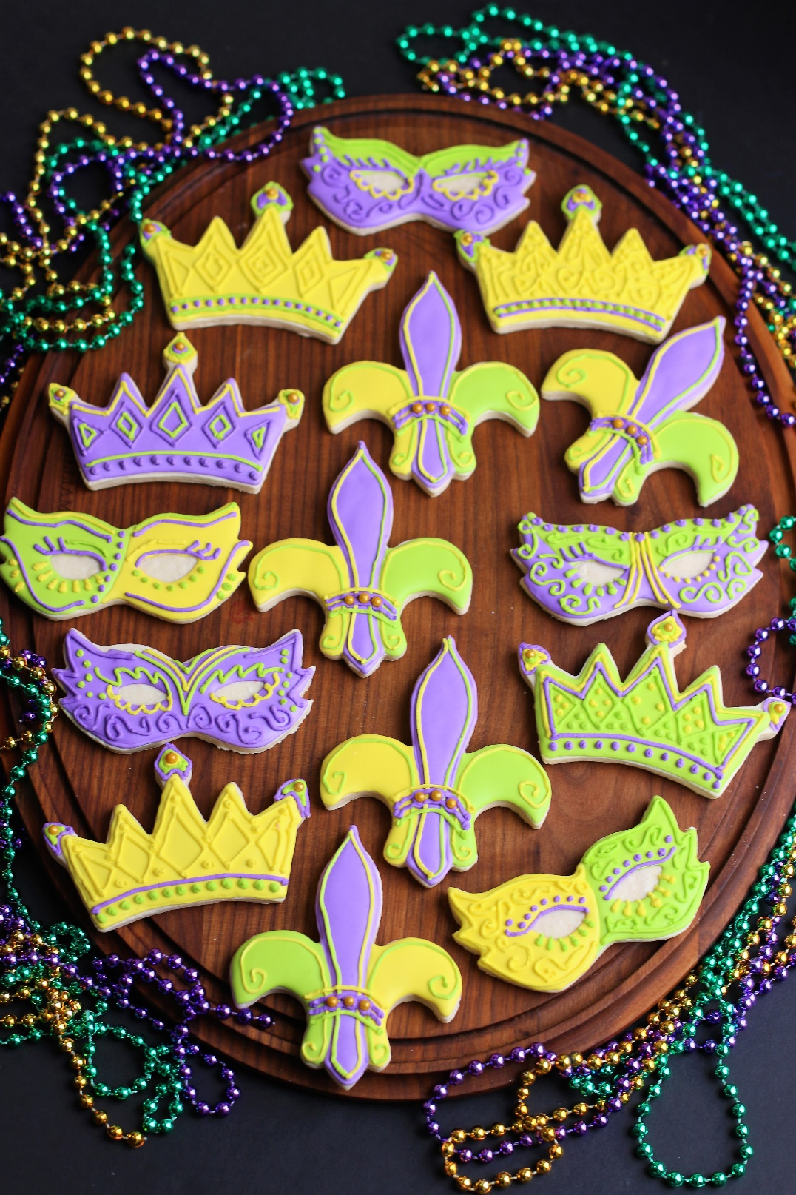

These Mardi Gras Sugar Cookies with Royal Icing are my go-to recipe for the softest, thickest and creamiest sugar cookies and the easiest Royal Icing. The dough is easy to roll out and work with, holds its shape and edges, and has a wonderful surface for fun decorating. Perfectly simple and wonderful!
INGREDIENTS:
CREAM CHEESE SUGAR COOKIES:
3 cups + 2 Tablespoons (390g) all-purpose flour
2 Tablespoons cornstarch
1 and 1/2 teaspoons baking powder
1/2 teaspoon salt
1 cup unsalted butter (softened to room temperature)
4 ounces block cream cheese (softened to room temperature)
1 cup (200g) granulated sugar
1 large egg (room temperature)
1 Tablespoon pure vanilla extract
1 teaspoon pure almond extract

FROSTING: (for Bakery Frosting see SnowflakesandCoffeecakes.com)
EASY ROYAL ICING:
4 cups powdered sugar
3 Tablespoons Wilton Meringue Powder
1 Tablespoon corn syrup (Karo)
2 Tablespoons flavoring (I use clear vanilla)
8-10+ Tablespoons water (room temperature)
AmeriColor Soft Gel Food Coloring (strongly recommended!)

FOR DECORATING: Holiday Sprinkles, Dragees and Sparkling Sugar (optional)

SPECIAL EQUIPMENT:
- Cookie cutter(s)
- Rolling pin (wooden Joseph Joseph Rolling Pin works the BEST for these cookies!)
- Large baking sheets
- Silicone Baking Mats or Parchment Paper
- Piping Bags & Tips

HOW I MAKE THESE:
- Set butter, cream cheese and egg out to warm to room temperature.
- In a medium bowl, whisk together the flour, cornstarch, baking powder and salt; set aside.
- In a large bowl using a hand-held mixer or stand mixer fitted with a paddle attachment, beat the butter and cream cheese on medium speed until completely smooth and creamy (about 3 minutes). Add the sugar and beat on medium high speed until light and fluffy, about 2 minutes. Add in the egg, vanilla and almond extracts and beat on high speed for another minute. Scrape down the sides and bottom of the bowl as needed between additions.
- On low speed, slowly mix half of the flour mixture into the wet ingredients just until combined; add remaining flour mixture and again mix just until combined. This cookie dough will be really soft and creamy!
- Generously flour your work surface and rolling pin. Divide dough into half and place on top of a parchment paper sized for your baking pans. Roll each half to a ¼-inch thickness (you will need to re-flour your rolling pin periodically to keep the dough from sticking). The rolled-out dough can be any shape, as long as it is evenly 1/4-inch thick. We’re rolling the cookie dough out BEFORE chilling it, which isn’t typical for most sugar cookie recipes – but this is a great trick! The dough is so much easier to roll out before it’s chilled.
- Stack the pieces, with parchment paper between the two and a single piece of parchment paper on top, onto a baking sheet and refrigerate for at least 2 hours and up to overnight. Chilling is mandatory for this cookie dough, so that the cookies will keep their shape when baked.
- The next day, preheat oven to 350°. Line 2-3 large baking pans with parchment paper (I prefer parchment paper over silicone baking mats for these cookies).
- Remove one of the chilled cookie dough pieces from the refrigerator. The dough will seem very hard, but it’s softer than it appears! Immediately cut into shapes with cookie cutters that have been dipped in flour. Place each cookie about 2 inches apart on prepared baking sheets. Re-roll dough scraps until all the dough is shaped. Repeat with remaining cookie dough.
- For 3-inch cookies, bake for 11-12 minutes until VERY lightly golden around the edges. Make sure you rotate the baking sheet halfway through bake time. If your cookie cutters are smaller than 3 inches, bake for about 7-10 minutes. If your cookie cutters are larger than 3 inches, bake for about 12-13 minutes. Every oven is a little bit different, so watch your first batch when baking and time accordingly. DO NOT OVERBAKE! The cookies don’t spread much when they’re baking, so they will stay around ¼-inch thick. These are thick sugar cookies! Be sure not to overbake these as they’ll lose their softness.
- Allow cookies to cool on the baking sheet for 5 minutes. Transfer the parchment paper together with the cookies to a cooling rack to cool completely. Once completely cool, decorate with Bakery Frosting or Easy Royal Icing and sprinkles (Bakery Frosting is easier for little ones…)
- TO MAKE EASY ROYAL FROSTING: In the bowl of a stand mixer fitted with a paddle attachment, add the ½ cup room-temperature water and meringue powder and dissolve on low (do not use a whisk attachment) for a minute or two. Once dissolved and slightly frothy, add all the powdered sugar and begin to mix on low. Add the karo syrup as it all starts to come together. Turn your mixer up to medium-high speed and beat for 5 minutes or until stiff peaks form. BE SURE NOT TO OVERMIX! Once still peaks form, it’s enough. If you overmix, the icing can become crumble after it dries on your cookies.
- At this point, you will use the Royal Icing as a base – divide as appropriate and add additional water a little bit at a time so that you have the right consistency for outlining, detail and flooding.
- For flood consistency (usually what you will use the most of) - the icing should drizzle down in a ribbon and smooth out within 10-15 seconds with the frosting in the bowl. If it's too thick, add a little more water (a teaspoon at a time). If it's too thin, add a little more sifted confectioners' sugar (a tablespoon or two at a time).
- When you're not working directly with the Royal Icing (for example, you’ve split the icing into separate bowls and colored with a few drops of food coloring), place a damp paper towel directly on the surface of the Royal Icing. It will start crusting immediately when exposed to air, and by placing the damp towel directly on top it will prevent it from hardening.
- FROST & DECORATE! Pipe or frost completely cooled cookies and sprinkle with optional sprinkles or decorating sugar.
- This Easy Royal Icing usually sets in about 2 hours at room temperature, depending on the temperature and humidity. If you're layering royal icing onto cookies for specific designs and need it to set quickly, place cookies in front of a fan heater (set on low heat), box fan or oscillating fan to help speed it up – you’ll need at least 30-45 minutes between layers. Letting your decorated cookies dry in front of a fan will also increase the “sheen” or “shine” of the frosting, rather than a flat matte finish if dried slower only at room temperature.
- For best results, allow frosting to set and dry OVERNIGHT before storing – keep parchment paper between each layer.
YIELD: Makes about 36 (three-inch) cookies
NOTES: These cookies will stay fresh in an air-tight container at room temperature for up to 3 days or in the refrigerator for up to 1 week.
MAKE AHEAD TIP: Plain baked cookies freeze well up to 1 month. Thaw overnight UNOPENED on your kitchen countertop before decorating.
FOR PARTIES: I package cookies individually in self-sealing clear cellophane cello bags (Pack It Chic are my favorite brand). Make sure cookies are completely dry after decorating before packaging. To make ahead, place individually wrapped and sealed cookies in a larger airtight container and freeze. Thaw on your countertop before serving - do not thaw in refrigerator (you are trying to minimize moisture during defrosting, which can cause your frosting designs to run or bleed).
TO KEEP THESE COOKIES SOFT: These cookies will stay soft and fresh in an air-tight container at room temperature for up to one week.
Originally published February 2021.
© SnowflakesandCoffeecakes. All images, attachments & content are copyright protected. All rights reserved. Please do not use my images without prior permission. If you want to republish this recipe, please re-write the recipe in your own words, or link back to www.snowflakesandcoffeecakes.com for the recipe.

WHAT IS THE SECRET OF PERFECT SUGAR COOKIES?

To ensure the wonderfully soft sugar cookies of your dreams, you want to roll the dough about ¼-inch thick. This may seem too thick when you are rolling and cutting, but it’s absolutely key if you want perfect sugar cookies for munching and decorating!
​
If you’ve found your cut-out sugar cookies lose their shape in the past, it could have been due to a few factors (too much butter in the recipe, dough too warm, dough not rolled thick enough, etc.), but I can tell you that this recipe yields absolutely beautiful edges that do not spread if you take care to roll to the appropriate thickness (if rolled too thin then they can spread) and chill the cut-out dough before baking.​

SUGAR COOKIE TIPS & TRICKS:
- Baking sheets: I use my favorite USA Pan Bakeware half sheet pans, which are aluminized steel, warp resistant and nonstick. I always line with parchment paper, not a silicone baking mat (which I find causes more spread).
- Marble pastry board: This isn’t necessary, but if you have one, it’s great for keeping sugar cookie dough and pie crust cold!
- Rolling pin: A simple wooden one is all you need, but my favorite is my Joseph Joseph Wooden Rolling Pin with adjustable rollers.
- Flavors: I adore the pure vanilla flavor, but some people like a little bit of almond – I would recommend starting with ¼ teaspoon of almond extract in addition to the vanilla. For other fun-flavored sugar cookies, you can also replace the vanilla with your favorite extract or emulsion to the cookie dough if you’d like!
- Cookie cutters: You can use absolutely any, so pick your favorites! I have a mixture of plastic and metal and they all work amazingly well with this recipe. It holds its shape for intricate designs, as well. I always dip mine in flour before cutting for a nice, clean release.
- Scaling: You can double (or more!) this recipe without issue.
- Buttercream frosting: If you want to do a simple frosting (with or without sprinkles!), then I recommend my favorite Vanilla Buttercream Frosting.
- Royal Icing: To do more detailed decorating, I prefer to use Royal Icing.
- Storage: The cookies can be stored in an airtight container at room temperature for up to 5 days.
- Make-Ahead: While I love that you can whip up these cookies immediately, you can mix together the dough, divide in half and form into disks, wrap in plastic wrap, and refrigerate for up to 2 days. You can also freeze the dough (place the wrapped disk in a ziploc freezer bag) for up to 1 month; thaw in the refrigerator overnight, then bring it to almost room temperature, roll out, and proceed with the recipe.
- Freezing: These cookies freeze exceptionally well! You can freeze them plain or decorated; if decorated, let the icing set before freezing. Store in an airtight container or ziplock freezer bag with parchment paper between the layers. The cookies can be frozen for up to 3 months.

