LAVENDER SIMPLE SYRUP
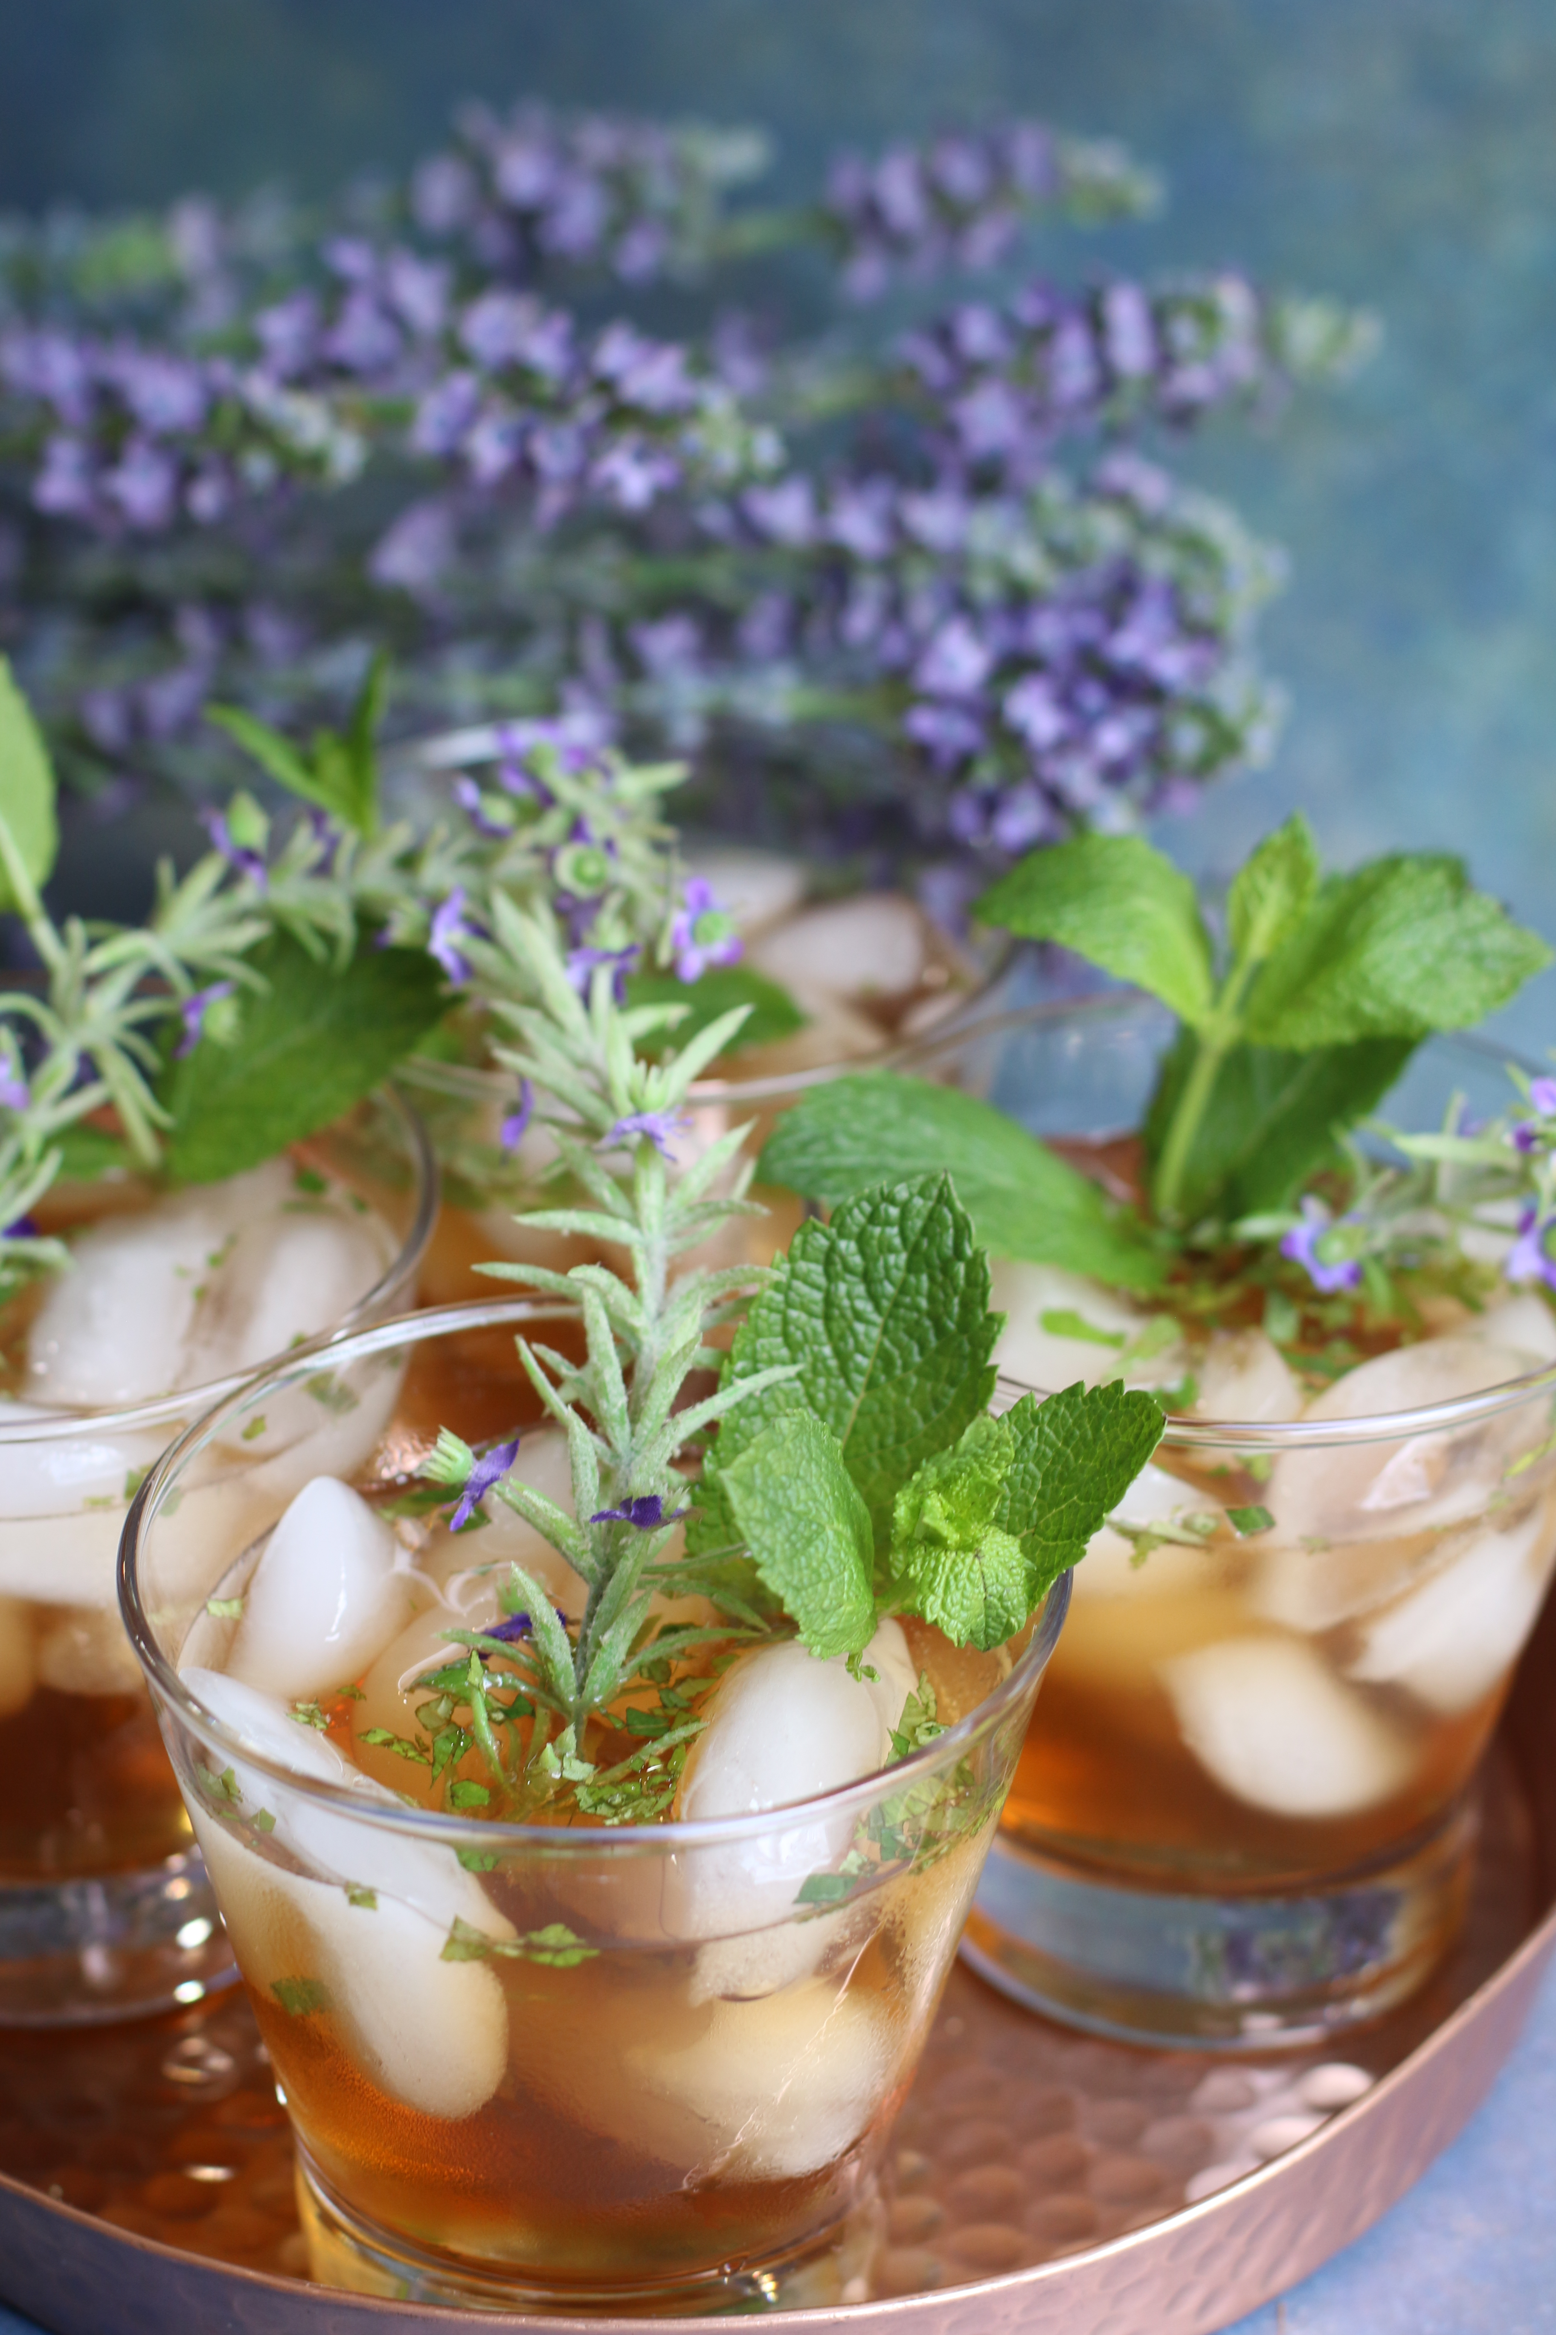

If you love Mint Juleps, you are going to LOVE these! Just a touch of vanilla and hint of Add an enchanting floral fragrance to your juleps with a hint of lavender. fresh lavender syrup make these perfect for Kentucky Derby parties – the perfect springtime drink…

INGREDIENTS:
Lavender Simple Syrup:
- 1 cup water
- 4 tablespoon fresh or dried lavender flowers
- 1 1/3 cup sugar
- 2 tablespoon honey

Instructions
- Bring water and lavender to a boil. Once it starts boiling, stir in the sugar and keep stirring until fully dissolved.
- Reduce the heat to the lowest setting and simmer for about 5 minutes.
- Remove the pot from the heat and allow it to steep for at least an hour.
- Strain out the lavender and pour the mixture into a clean airtight glass container. Store it in the refrigerator. It will be good for at least a week.
Recipe Notes
The recipe makes a very sweet and thick syrup. It will yield just over 1 cup. If you would like to make more, simply double the ingredients. The lavender notes are light, but if you prefer a stronger floral note, you can always add more lavender flowers.

Long considered an aphrodisiac, denoting love and romance, lavender was historically used to spice the food of queens, colonists and conquerors. Lavender was then bought from Europe to the Americas, where it was grown as a herb of hospitality, medicine, perfume and spice. We infuse fresh ‘Provence’ culinary lavender flowers, estate grown for us at Matanzas Creek Winery, as the perfect flavoring for sorbets, shortbreads, champagne cocktails, hot teas or sparkling water.

Long considered an aphrodisiac, denoting love and romance, lavender was historically used to spice the food of queens, colonists and conquerors. Lavender was then bought from Europe to the Americas, where it was grown as a herb of hospitality, medicine, perfume and spice. We infuse fresh ‘Provence’ culinary lavender flowers, estate grown for us at Matanzas Creek Winery, as the perfect flavoring for sorbets, shortbreads, champagne cocktails, hot teas or sparkling water.

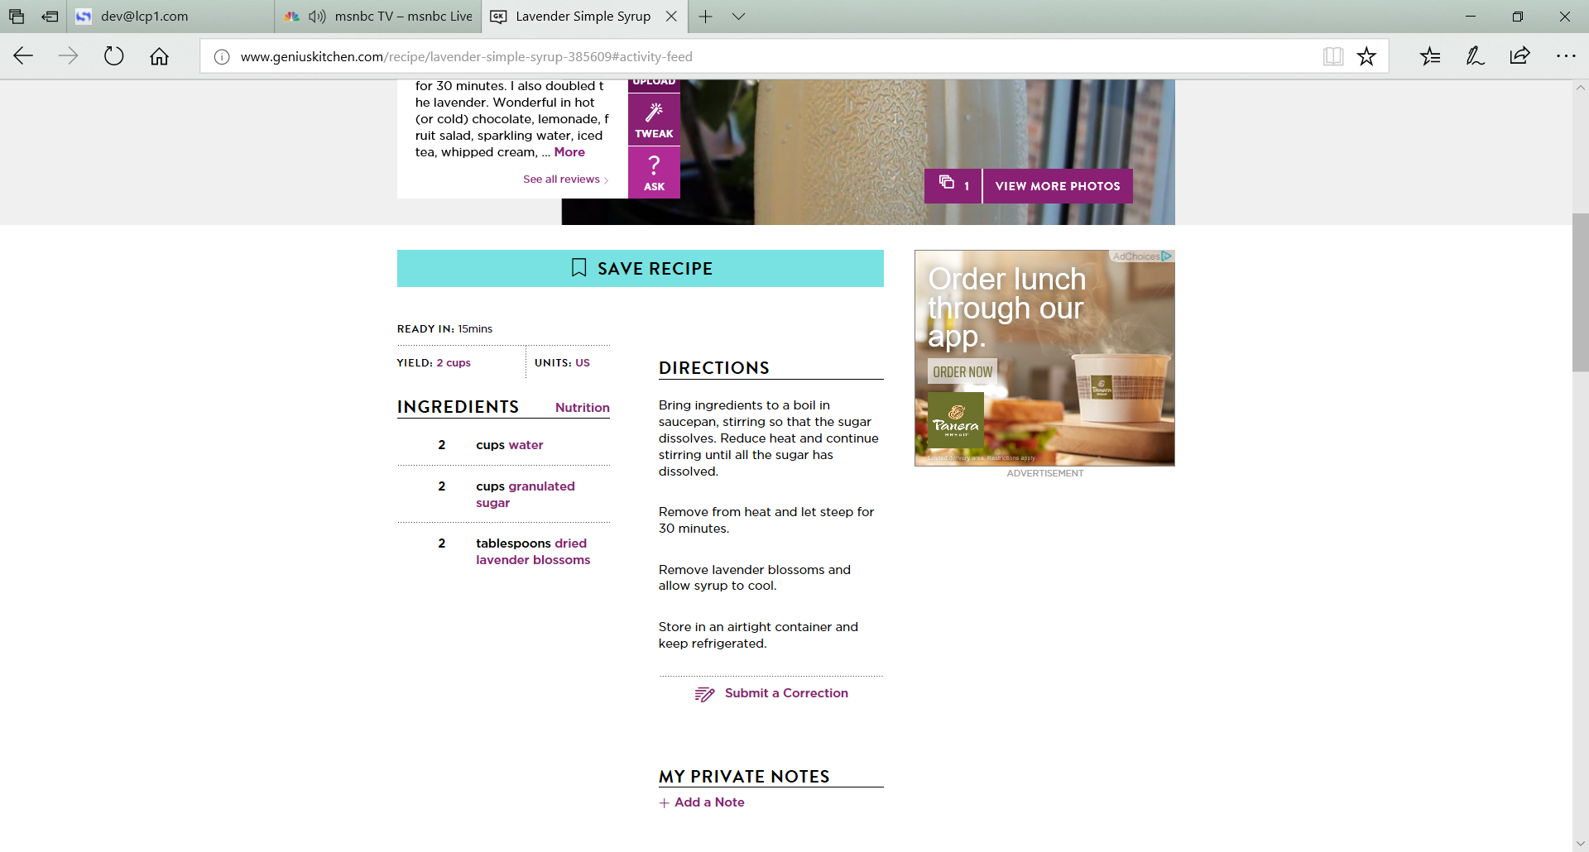
½ teaspoon Rodelle Pure Vanilla Extract

HOW I MAKE THESE:
- Roast Pecans: Preheat oven to 250 degrees and place rack in center of oven. Spread pecan halves on a large baking sheet that has been lined with nonstick foil; roast them for 15 minutes, turning over with a spatula carefully at 7 minutes.
- Make Browned Butter: In a medium saucepan over medium heat, melt butter. It will start to foam up the tiniest bit, and then subside. Keep stirring and watch carefully. After 3-4 minutes, the butter will turn from light brown and turn a darker brown – the butter will start to smell “nutty” at this point. Once you reach this point, remove from heat immediately so that it doesn’t burn.
- Caramelize Pecans: Add pecans to browned butter, add brown sugar, vanilla and finely chopped rosemary, stirring gently until the pecans are evenly coated.
- Pour pecans into a single layer on the baking sheet and continue baking for 15 minutes. Remove from oven and immediately sprinkle with sea salt.
- Garnish with sprig of lavender and mint.

YIELD: about 2 cups
Originally posted May 2013, Revised and Reposted May 2018.
© SnowflakesandCofeecakes. All images, attachments & content are copyright protected. All rights reserved. Please do not use my images without prior permission. If you want to republish this recipe, please re-write the recipe in your own words, or link back to www.snowflakesandcoffeecakes.com for the recipe.

