halloween
severed finger cookies
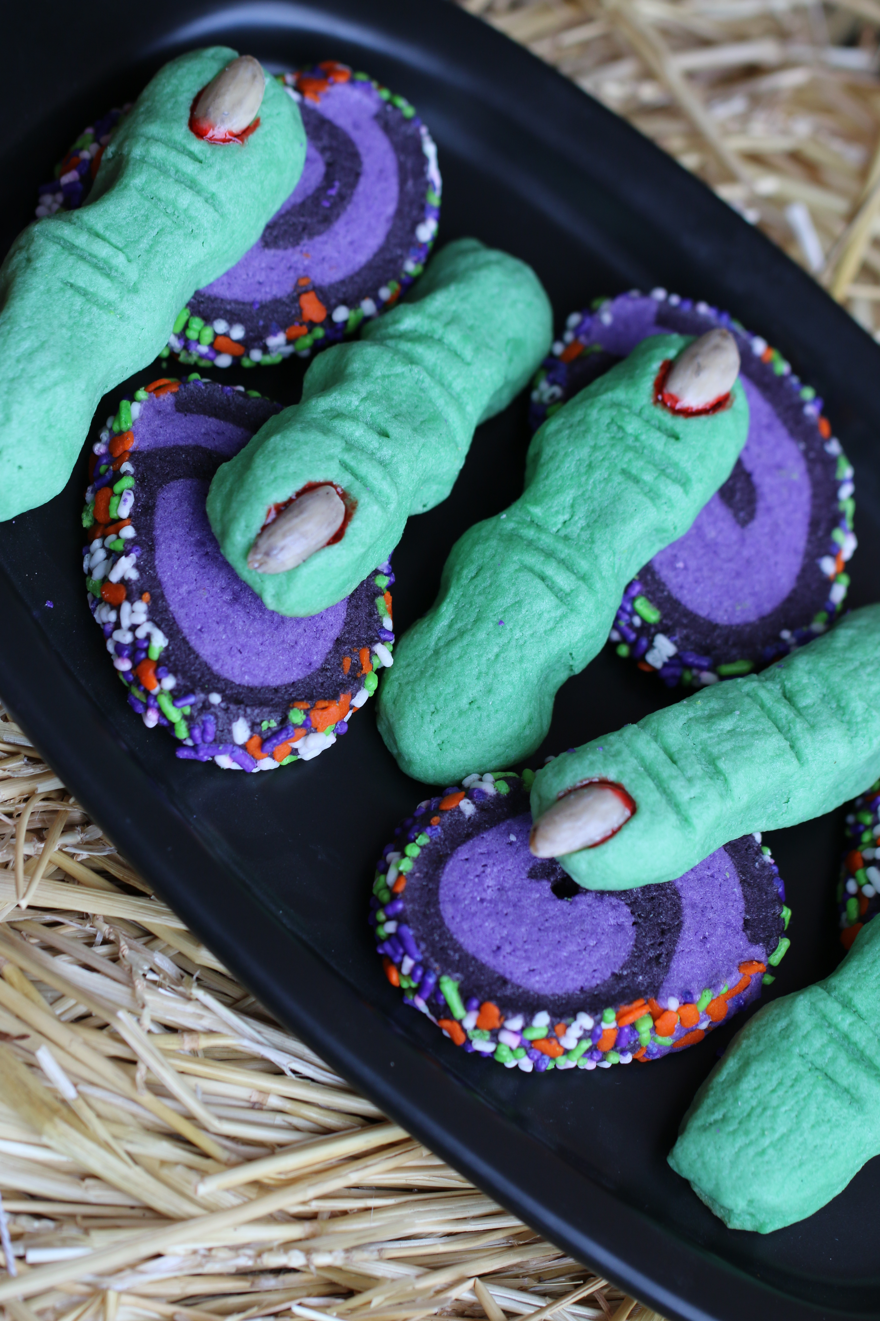

Creepy fun and so delicious!!

INGREDIENTS:
2 tablespoons red food coloring
30 blanched almonds
2 large eggs
¼ tsp. vanilla extract
¼ tsp almond extract
Green food coloring
½ cup butter (room temperature)
½ cup confectioners’ sugar
5 tablespoons granulated sugar
1 pinch salt
1-2/3 cups all-purpose flour
Raspberry Jam (seedless)

HOW I MAKE THIS:
- Place red food coloring in shallow bowl. Carefully crack each whole almond into halves, and gently place them in the bowl with the food coloring; stir gently until color is evenly distributed.
- Separate one egg. Set aside the egg white.
- In a small bowl, whisk together yolk, remaining egg, and vanilla.
- In bowl of electric mixer fitted with the paddle attachment, combine butter, confectioners’ sugar, granulated sugar. Green food coloring and salt. Beat on medium speed until well combined. Add egg mixture, and beat until smooth, about 2 minutes. Slowly add the flour and mix on low speed just until mixed in. Wrap the dough in plastic, and chill until firm, about 30 minutes.
- Heat oven to 350 degrees. Line two baking sheets with parchment paper or silpat baking sheets.
- Divide the dough in half. Work with one piece at a time, keeping remaining dough covered with plastic wrap and chilled. Divide the first half into fifteen pieces.
- On a lightly floured surface, roll each piece back and forth with palms into finger shapes, 3 to 4 inches long. (NOTE: cookies will expand 1-1/2 to 2 times the unbaked size, so make them smaller than you think you should and they will look more realistic.)
- Pinch dough in two places to form knuckles. Shape knuckles big and uneven. To keep the fingers from puffing out too much when the bake, roll the finger portion extra skinny and flatten a bit (skinnier than you want them to look – they will puff out slightly when they bake.) Score each knuckle lightly with the back of a teaspoon. Transfer fingers to prepared baking sheets. Repeat with remaining dough.
- When all fingers are formed, brush lightly with egg white. Place a small amount of raspberry jam at nail bed, then position almond nails, push into dough to attach.
- Bake until just starting to turn golden brown at edges, about 12 minutes. Cool completely.
- To serve, drizzle a small amount of warm seedless raspberry jam onto your serving platter and place cookies so that it looks like “blood” is running from cut end of finger.
YIELD: Makes 30 cookies.
VARIATION: To make pinwheel cookies, separate dough into 1/3 and 2/3 portions. Add purple food coloring to larger portion, and black food coloring to smaller portion. Roll out purple cookie dough ½ inch thick rectangle; set aside. Roll out black cookie dough ¼ to 1/3 inch thick rectangle, lay on top of purple cookie dough. Starting at long end, roll cookie dough up into log shape. Roll cookie log in Halloween sprinkles. Wrap in plastic wrap and chill for one hour. When ready to bake, preheat oven, slice cookies and place on parchment paper. Bake for 10-12 minutes or until just starting to turn golden at edges. Remove from oven and allow to cool on pan.
© SnowflakesandCoffeecakes. All images, attachments & content are copyright protected unless otherwise indicated. All rights reserved. Please do not use my images without prior permission. If you want to republish this recipe, please re-write the recipe in your own words or link back to www.snowflakesandcoffeecakes.com for the recipe.


