granola with
dark chocolate & cashews
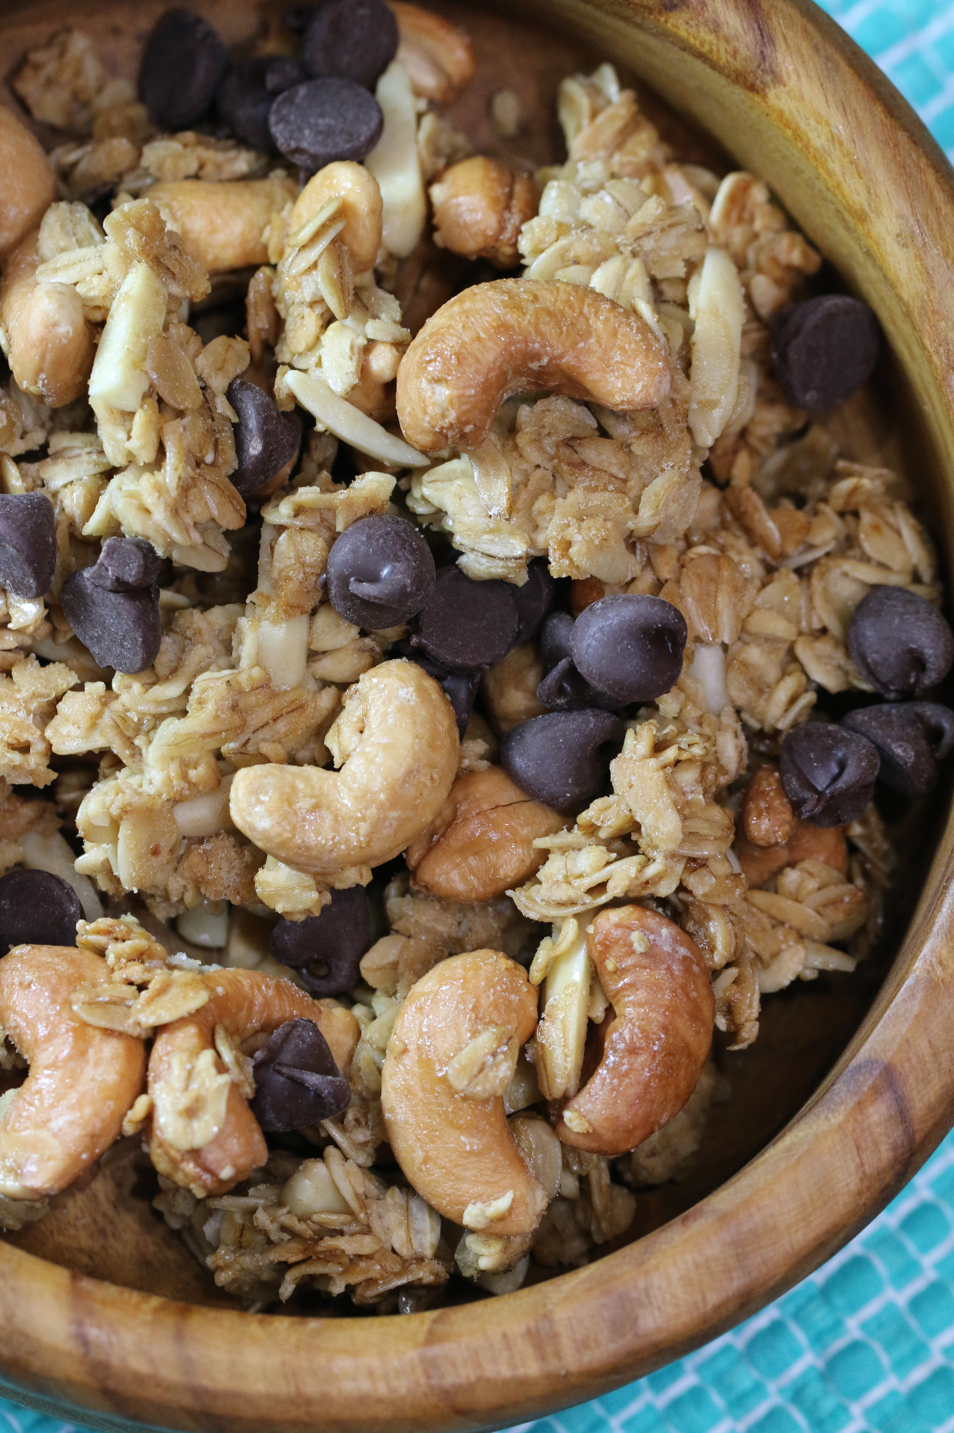

What a wonderful way to start the day – at home or on the trail!

INGREDIENTS:
⅓ cup pure maple syrup (not pancake syrup)
⅓ cup light brown sugar
4 teaspoons vanilla extract
1 egg white
½ teaspoon salt
½ cup coconut or vegetable oil
5 cups old-fashioned rolled oats
2 cups dark chocolate chips
1 cup cashews (optional)

HOW WE MAKE THIS:
- Preheat oven to 325 degrees. Line a rimmed baking sheet with parchment paper.
- In a large bowl, whisk together the maple syrup, brown sugar, egg white, vanilla extract and salt. Whisk in the coconut oil to combine. Add the oats and chocolate chips and fold the mixture together with a rubber spatula until all of the oats and almonds are thoroughly coated.
- Pour the oat mixture onto the prepared baking sheet and spread into an even layer. Using a stiff metal spatula, press the oat mixture down until compact.
- Bake until the top is lightly browned, 40 to 45 minutes, rotating the sheet halfway through baking. Remove the granola from the oven and let cool on a wire rack to room temperature.
- Break the cooled granola into pieces as small or large as you like.
- This granola can be stored in an airtight container at room temperature for up to 2 weeks.
Yield: 7-8 cups

© SnowflakesandCoffeecakes. All images, attachments & content are copyright protected unless otherwise indicated. All rights reserved. Please do not use my images without prior permission. If you want to republish this recipe, please re-write the recipe in your own words, or link back to www.snowflakesandcoffeecakes.com for the recipe.

