GOURMET LEMON BROWNIES
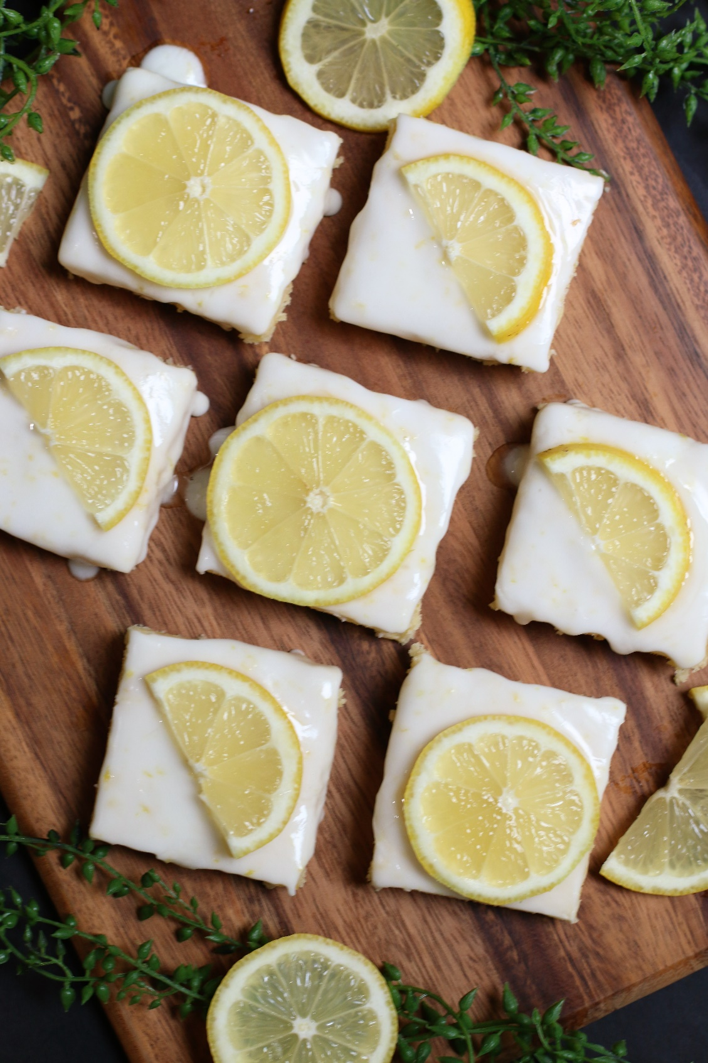

Move over chocolate - Gourmet Lemon Brownies may just be your new favorite brownie! Tart and tangy, and with a perfectly fudgy texture of a brownie, these are always one of the first treats to disappear when I serve them. If you love Lemon Bars or Lemon Sugar Cookies, these are even better – and super simple to whip up! These Lemon Brownies are perfect for picnics, barbecues, birthday parties and always brighten up a dessert table – everyone ADORES them!

INGREDIENTS:
1 cup unsalted butter (room temperature)
4 large eggs (room temperature)
2 cups (250g) all-purpose flour
1 teaspoon baking powder
½ teaspoon salt
1 cup (400g) granulated sugar
¼ cup freshly squeezed lemon juice
(you’ll need 4-5 fresh lemons for this recipe)
2 Tablespoons fresh lemon zest

LEMON GLAZE:
1-1/2 cup (180g) powdered sugar
2-4 Tablespoons fresh lemon juice
1 Tablespoon fresh lemon zest

HOW I MAKE THESE:

- Remove butter and eggs from refrigerator to allow butter to soften and eggs to come to room temperature.
- Zest and juice fresh lemons; set aside.
- Preheat oven to 350 degrees. Line 9x13-inch baking pan with parchment paper and grease or spray with non-stick baking spray; set aside. PRO TIP: I like to line my brownie pans with parchment paper so that I can easily remove the brownies for glazing and slicing.
- In a small bowl, whisk together the flour, baking powder and salt.
- In the bowl of a stand mixer fitted with a blade, beat the butter until creamy, about 2 minutes. Add granulated sugar and continue beating until light and well combined.
- In a small bowl, beat eggs until yolks are broken and mixture is well mixed.
- Add eggs to mixer bowl and beat on medium speed just until well combined.
- Add fresh squeezed lemon juice and lemon zest. Note: Your batter may look curdled at this point, but that’s normal and will come back together.
- Add in the flour mixture and blend just until mixed – DO NOT OVERMIX!
- Spread batter in prepared pan, using an offset spatula to even the surface.
- Bake for 30-35 minutes, or just until the edges start to turn gold and set in center. DO NOT OVERBAKE – this is critical to have a fudgy texture.
- Remove from oven and cool on a baking rack until room temperature.
- PREPARE LEMON GLAZE: In a small bowl, whisk together the powdered sugar and fresh lemon juice until smooth and well combined. Pour glaze evenly over the top of the cooled brownies. Sprinkle with fresh lemon zest.
- Let the glaze harden before slicing brownies. You can place the glazed brownies in the fridge to speed up this process.
- Refrigerated brownies are the easiest to cut and slice. Simply lift parchment paper “sling”, remove the brownies from the pan, and use a sharp knife to cut cleanly and easily.
- Store in a covered container at room temperature for up to 3 days, or in the refrigerator for up to 5 days. These Lemon Brownies also freeze like a dream for up to 2 months.
YIELD: 12-18 servings
RECIPE NOTES:
- MAKE AHEAD INSTRUCTIONS: I suggest baking the lemon brownies, cooling them completely, then wrapping in plastic wrap and refrigerating for up to 2 days. Glaze and sprinkle with fresh lemon zest the day you plan to serve.
- FREEZING INSTRUCTIONS: To freeze these, wrap the entire Lemon Brownie slab in plastic wrap, wrap in foil and then place it in an airtight plastic container and freeze for up to 2 months. Thaw overnight in the fridge or on the countertop for a few hours, and then glaze and sprinkle with fresh lemon zest the day you plan to serve – this will preserve the texture and shine of the glaze!
- GLUTEN FREE OPTION: It’s easy to make these Lemon Brownies gluten free – simply substitute a great gluten-free flour substitute from King Arthur Flour or Bob’s Red Mill.
- LIKE YOUR BROWNIES WITH A “CAKEY” TEXTURE? Brownies typically don’t include rising agents so that they stay dense and moist. Add an additional teaspoon of baking powder if you prefer your brownies taller and cakey. You can also substitute cake flour for all-purpose flour for a more delicate cake-like texture.
- KEY LIME BROWNIES OR ORANGE BROWNIES? Absolutely! If fresh lime or orange flavor are your jam, replace the lemon juice and zest with key lime juice & zest, or fresh squeezed orange juice and zest. So summery!

Original recipe created by Snowflakes & Coffeecakes; published September 2022.

© SnowflakesandCoffeecakes. All images, attachments & content are copyright protected. All rights reserved. Please do not use my images without prior permission. If you want to republish this recipe, please re-write the recipe in your own words, or link back to www.snowflakesandcoffeecakes.com for the recipe.

Tried it and loved it? Snap a picture and share it with me on Instagram @SnowflakesandCoffeecakes and by using the hashtag #SnowflakesandCoffeecakes.

