funfetti cupcakes

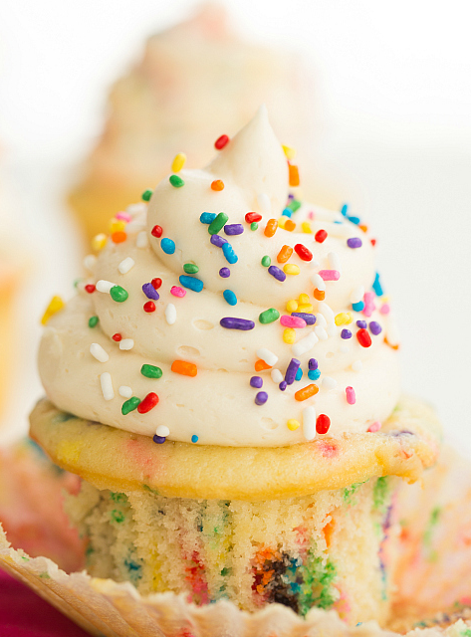

*These birthday party favorites are even more wonderful homemade, where you can pick the exact colors you want to burst thru your cupcake creations!*

**INGREDIENTS:**

***Cupcakes***:  
1¾ cups cake flour  
1¼ cups all-purpose flour  
1¾ cups granulated sugar  
2½ teaspoons baking powder  
1 teaspoon salt  
1 cup unsalted butter, at room temperature  
4 eggs  
1 cup whole milk  
2 teaspoons vanilla extract  
½ cup rainbow sprinkles

***Vanilla Buttercream Frosting:***  
2 cups unsalted butter, at room temperature  
5 cups powdered sugar  
2 tablespoons vanilla extract  
Rainbow sprinkles, for decorating

SERVINGS: Makes 24 cupcakes

**HOW I MADE IT**:

1. Make the Cupcakes: Preheat oven to 350 degrees. Line a cupcake pan with 24 paper liners.
2. In the bowl of a stand mixer, add the flours, sugar, baking powder and salt, and mix together on low speed for 1 minute. With the mixer on low, add the butter, a small amount at a time, continuing until all the butter has been added and the mixture resembles coarse sand.
3. Keeping the mixer on low speed, add the eggs one at a time, scraping down the sides of the bowl between additions. Slowly pour in the milk and vanilla and mix until combined. Increase the mixer speed to medium and beat for 2 minutes, until batter is smooth, scraping the sides of bowl as needed. Using a rubber spatula, very gently stir in the sprinkles.
4. Fill the liners two-thirds full (about ¼ cup of batter) and bake for 15-18 minutes, until the centers are set and a toothpick inserted into the center comes out clean. Cool in pan for 10 minutes, then remove to a wire rack to cool completely before frosting.
5. Make the Frosting: Using the wire whisk attachment of your stand mixer, whip the butter on medium-high speed for 5 minutes, scrapping the bowl periodically. Reduce the speed to low and slowly add the powdered sugar. Once all of the powdered sugar has been added, increase the speed to medium-high and add the vanilla, mixing until well blended. Whip at medium-high speed until light and fluffy, about 2 minutes, scraping the bowl as needed.
6. Frost the cupcakes and garnish with sprinkles.

