frozen berry yogurt parfait FIRECRACKERS

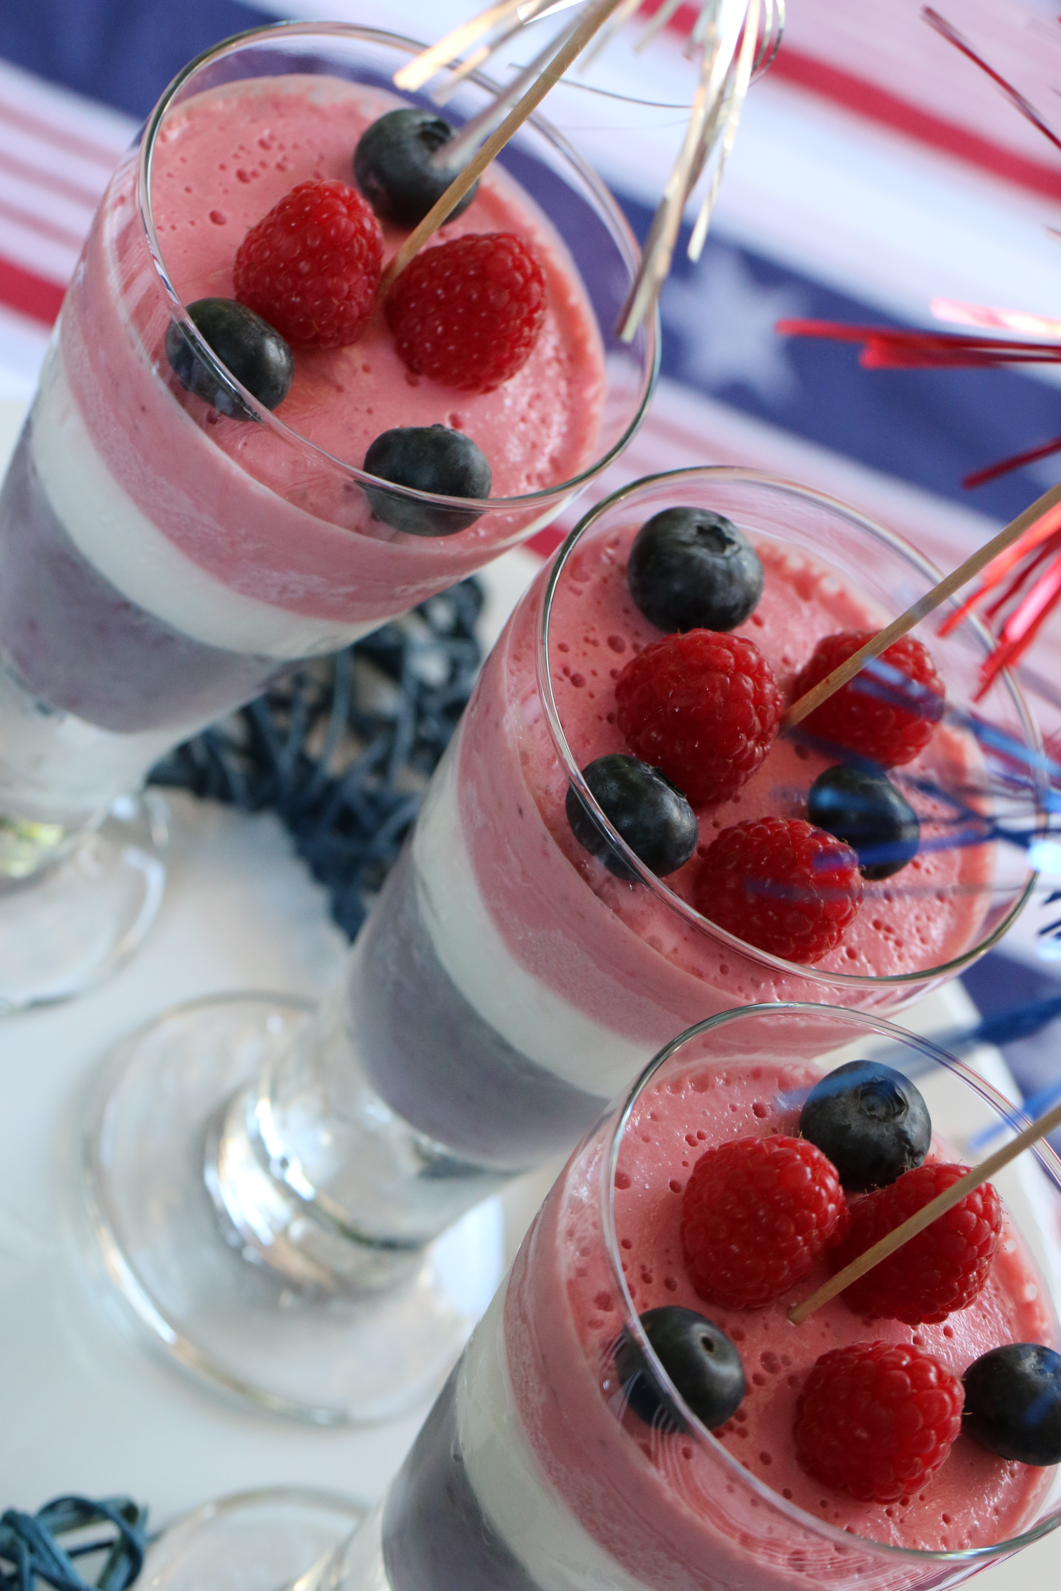

These are so easy to make – and so delicious and healthy! These layered treats are not just for the Fourth of July – you’ll learn the tricks to making layered smoothies so that you can mix up your favorite flavors and color combinations any time.

INGREDIENTS:

For the Blue Layer:
- 1/2 cup cranberry juice
- 2 cups blueberries, fresh or frozen
- 6 oz Greek yogurt (I used Lemon Noosa or Chobani)
- 5-8 ice cubes
For the White Layer:
- 1/2 Cup milk
- 6 oz Greek yogurt (I used Lemon Noosa or Chobani)
- 1 cup Cool Whip
- 6-8 ice cubes
For the Red Layer:
- 1/2 Cup cranberry juice
- 2 cups strawberries or pitted cherries, fresh or frozen
- 6 oz Greek yogurt (I used Lemon Noosa or Chobani)
- 5-8 ice cubes

HOW I MAKE THESE:
- Blend together the ingredients for the blue layer and divide into 3 (or more) glasses or 12 shooter glasses. Place in the freezer for 10 minutes.
- Repeat for each layer, freezing for at least 10 minutes in between each color.
- Let thaw for 10 minutes before serving.

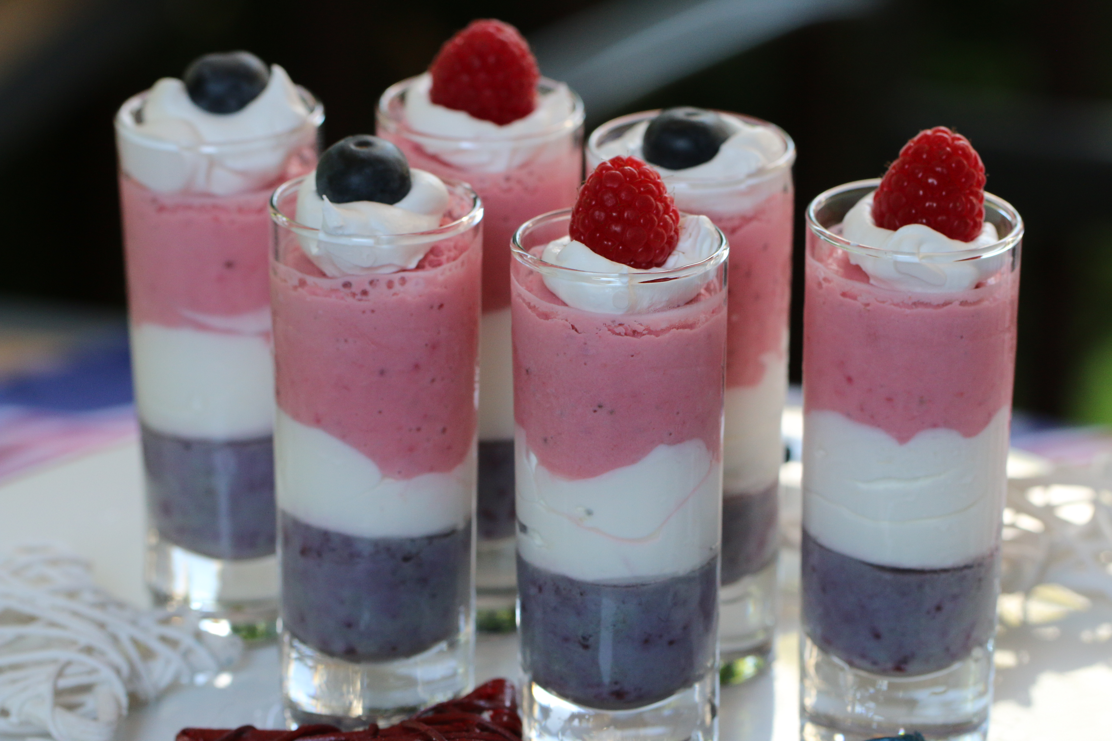

COOKING SCHOOL NOTES:
- Use juice instead of milk for the red and blue layer for a deeper color. Use milk for a lighter color and a bump in protein.
- As with any smoothie recipe you can flavor to your liking – experiment with peaches, raspberries, key lime – whatever flavor and color combination that you like!
- If you have any leftover smoothie, these make wonderful homemade frozen pops for the little ones!


