Fiesta Ranch dip

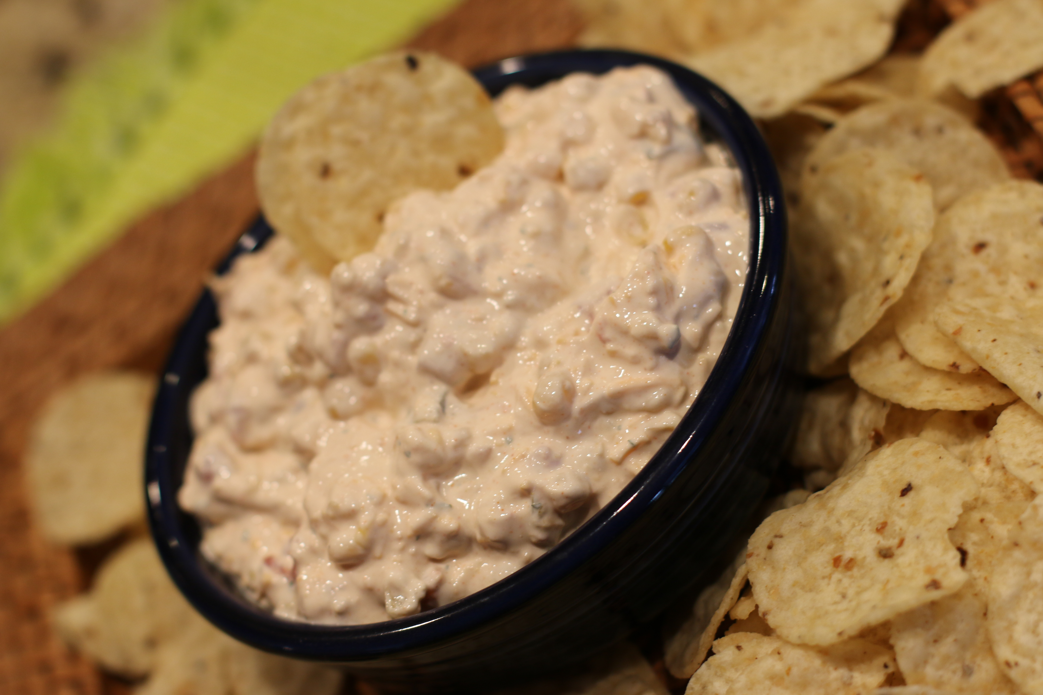

*This spicy and delicious dip is great with your favorite tortilla chip or fresh veggies!*

**INGREDIENTS:**

1 packet Hidden Valley Fiesta Ranch Dip

10 ounce can Rotel Original (drained)

16 oz sour cream

1 cup finely shredded cheddar cheese

1 can niblets sweet corn (drained)

Shredded cheddar cheese, shredded lettuce and diced tomatoes (for garnish)

**HOW I MADE IT:**  
Mix all ingredients in a medium size bowl.  Chill in fridge for 1 hour.