grandma’s easy potato salad
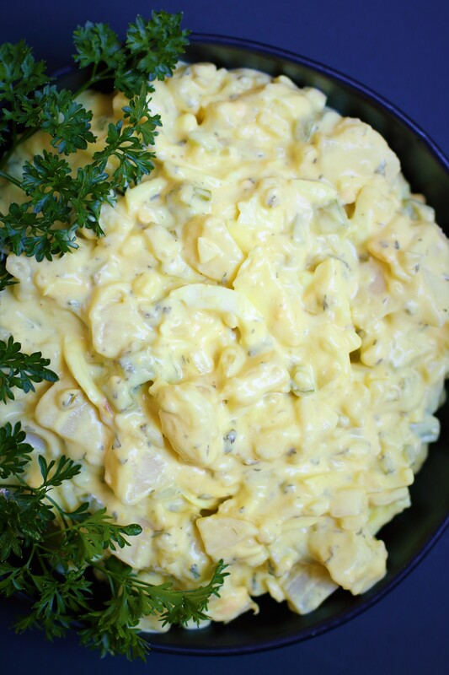

Today we're taking a delightful journey back to the past to rediscover the vintage charm of old-fashioned Potato Salad. Our family recipe is filled with nostalgic flavors that transport us back to a time when life was slower and Potato Salad with the star of the picnic. It may be retro, but sometimes the old-fashioned way is the tastiest way! Grandma always made the BEST potato salad, but she never used a written recipe – it was always by feel and taste. This family favorite recipe is based on her recollection, which is totally adaptable. Everyone raves about this Potato Salad – it’s rich and creamy, perfectly flavorful, hearty and has all the best textures – but feel free to customize and make it your own! If you want more onions, or less eggs, or dill relish instead of sweet relish, make it your own! Want it sweeter? Add some more sugar. Like it with more mustard or some celery seed? Want to garnish with some chopped bacon? Knock yourself out making it your own!
INGREDIENTS:
POTATO SALAD
3 pounds white or Yukon gold potatoes (about 6 medium potatoes)
1-1/2 tablespoons salt
6 hard boiled eggs (peeled and diced)
1 cup celery (chopped)
¾ cup red, sweet or vidalia onion (finely chopped)
1/3 cup sweet pickle relish
6 green onions, diced
OPTIONAL: 6 thick-cut bacon strips (cooked and crumbled)

CREAMY DRESSING
1-cup Miracle Whip
½ cup sour cream
2 Tablespoons yellow mustard or Dijon mustard
1 ½ Tablespoons cider vinegar
1 Tablespoon sugar
1 teaspoon salt
½ teaspoon pepper
½ teaspoon garlic powder

GARNISH:
Fresh green onions, chives or parsley
HOW I MAKE THIS:
- PREPARE POTATOES: Place 2 inches of water in large stock pot and bring to a rapid boil, then add potatoes and salt. Reduce heat to medium, cover, and continue to cook for about 20-30 minutes or until potatoes are easily pierced with a fork but DO NOT OVERCOOK. After the 20-minute mark, prick the potatoes gently with a fork every minute or so to be sure you’re not over cooking them. (I prefer using my large electric steamer to steam the potatoes, but if you don’t have this option, use the stock pot and boil.) Drain potatoes and let cool to room temperature (or place in refrigerator to cool quicker).
- When cool, peel skins from potatoes and dice; place in large mixing bowl.
- PREPARE CREAMY DRESSING: In a small bowl, whisk together the Miracle Whip, sour cream, mustard, sugar, salt, pepper and vinegar. Mix until combined. Stir in pickle relish.
- Pour mixture over cooled potatoes.
- Stir in onions, celery, pickle relish and eggs. Stir gently until well blended and evenly coated.
- Refrigerate at least 1 hour before serving; best if chilled overnight.
- When ready to serve, stir in optional bacon and garnish with fresh green onions, chives or parsley.
- Remember to keep this salad chilled – no longer than two hours without refrigeration!
- Potato Salad should be stored in an airtight container in the refrigerator. When properly stored, it should easily last 3-4 days in the fridge if properly stored. Potato Salad does not freeze well.
YIELD: 8 servings
RECIPE NOTES:
- USE THE RIGHT POTATOES: Yukon gold potatoes are best. They boast a delicious buttery flavor, are a little sweet, hold their shape after cooking while still imparting a creaminess, all without getting mushy. They also absorb the dressing better than waxy potatoes resulting in tastier potatoes. You can use russet potatoes, but be careful that they aren’t overcooked and mushy. Russet potatoes also tend to absorb more dressing as they chill, so you may need to make and add extra creamy dressing.
- UNIFORM POTATOES: Select potatoes that are uniform in size so they cook evenly.
- COOK POTATOES JUST UNTIL TENDER: You need perfectly cooked potatoes for best results! It’s important that they aren’t undercooked or overcooked – no one likes crunchy or mushy potato salad. Potatoes are done as soon as they are tender enough to be pierced through with a fork. The best thing you can do is test your potatoes often.
- ADD SALT WHEN COOKING YOUR POTATOES: By adding salt, you will infuse the potatoes with flavor.
- COOL POTATOES BEFORE ADDING DRESSING: Let your potatoes cool completely before adding dressing.
- MAKE AHEAD DIRECTIONS: Preparing and chilling Potato Salad ahead of time will make it more flavorful! You can make the Potato Salad a day or two in advance, and store in an airtight container in the refrigerator. If adding bacon, store the bacon separately or cook it up right before you serve to keep it crispy.
- This creamy Potato Salad is easy to double/triple for a large crowd, can be made in advance for stress free sharing, and best of all, everyone loves this recipe!
- FOOD SAFETY: The USDA recommends that “if potato salad is held in excess of 41°F for over two hours, then discard.” To keep potato salad cold while serving for an extended period of time, you can fill a large bowl with ice then place the Potato Salad bowl in the ice.

RECIPE VARIATIONS:
Every homemade potato salad recipe claims to be the “best” potato salad – so it really comes down to personal preference. Using the basic ingredients and technique in this recipe, you can have fun experimenting with all sorts of add-ins. If you want more onions, or less eggs, or dill relish instead of sweet relish, make it your own! Want it sweeter? Add some more sugar. Like it with more mustard or some celery seed? Want to garnish with some chopped bacon? Knock yourself out making it your own!
- Prefer mayonnaise rather than Miracle Whip? If you prefer, go for it! Personally, the sweetness in Miracle Whip is the secret to this fabulous potato salad!
- Substitute Greek yogurt for sour cream
- Add thick-sliced hickory bacon (cooked until crisp and crumbled) for a hearty flavor
- Try adding fresh chopped pickles in place of the pickle relish. For more zing, add diced sweet pickles, dill pickles or banana peppers for another layer of flavor
- Chopped radishes or chili powder will add a bit more heat
- Baked Potato Salad: Replace the Miracle Whip with sour cream (or equal amounts of sour cream and tater topping), and add chopped bacon (crisp and crumbled) and fresh shredded cheddar cheese
- Barbecue Potato Salad: Add ½ tablespoon smoked paprika and ¼ cup barbecue sauce
- Buttermilk Ranch Potato Salad: Add 1 tablespoon of Hidden Valley salad dressing mix or ¼ cup Hidden Valley Buttermilk Dressing

Original recipe by Snowflakes & Coffeecakes June 2010; revised and reposted June 2023.
© SnowflakesandCoffeecakes. All images, attachments & content are copyright protected. All rights reserved. Please do not use my images without prior permission. If you want to republish this recipe, please re-write the recipe in your own words, or link back to www.snowflakesandcoffeecakes.com for the recipe.

Tried it and loved it? Snap a picture and share it with me on Instagram @SnowflakesandCoffeecakes and by using the hashtag #SnowflakesandCoffeecakes.

