dark chocolate cadbury creme egg cupcakes
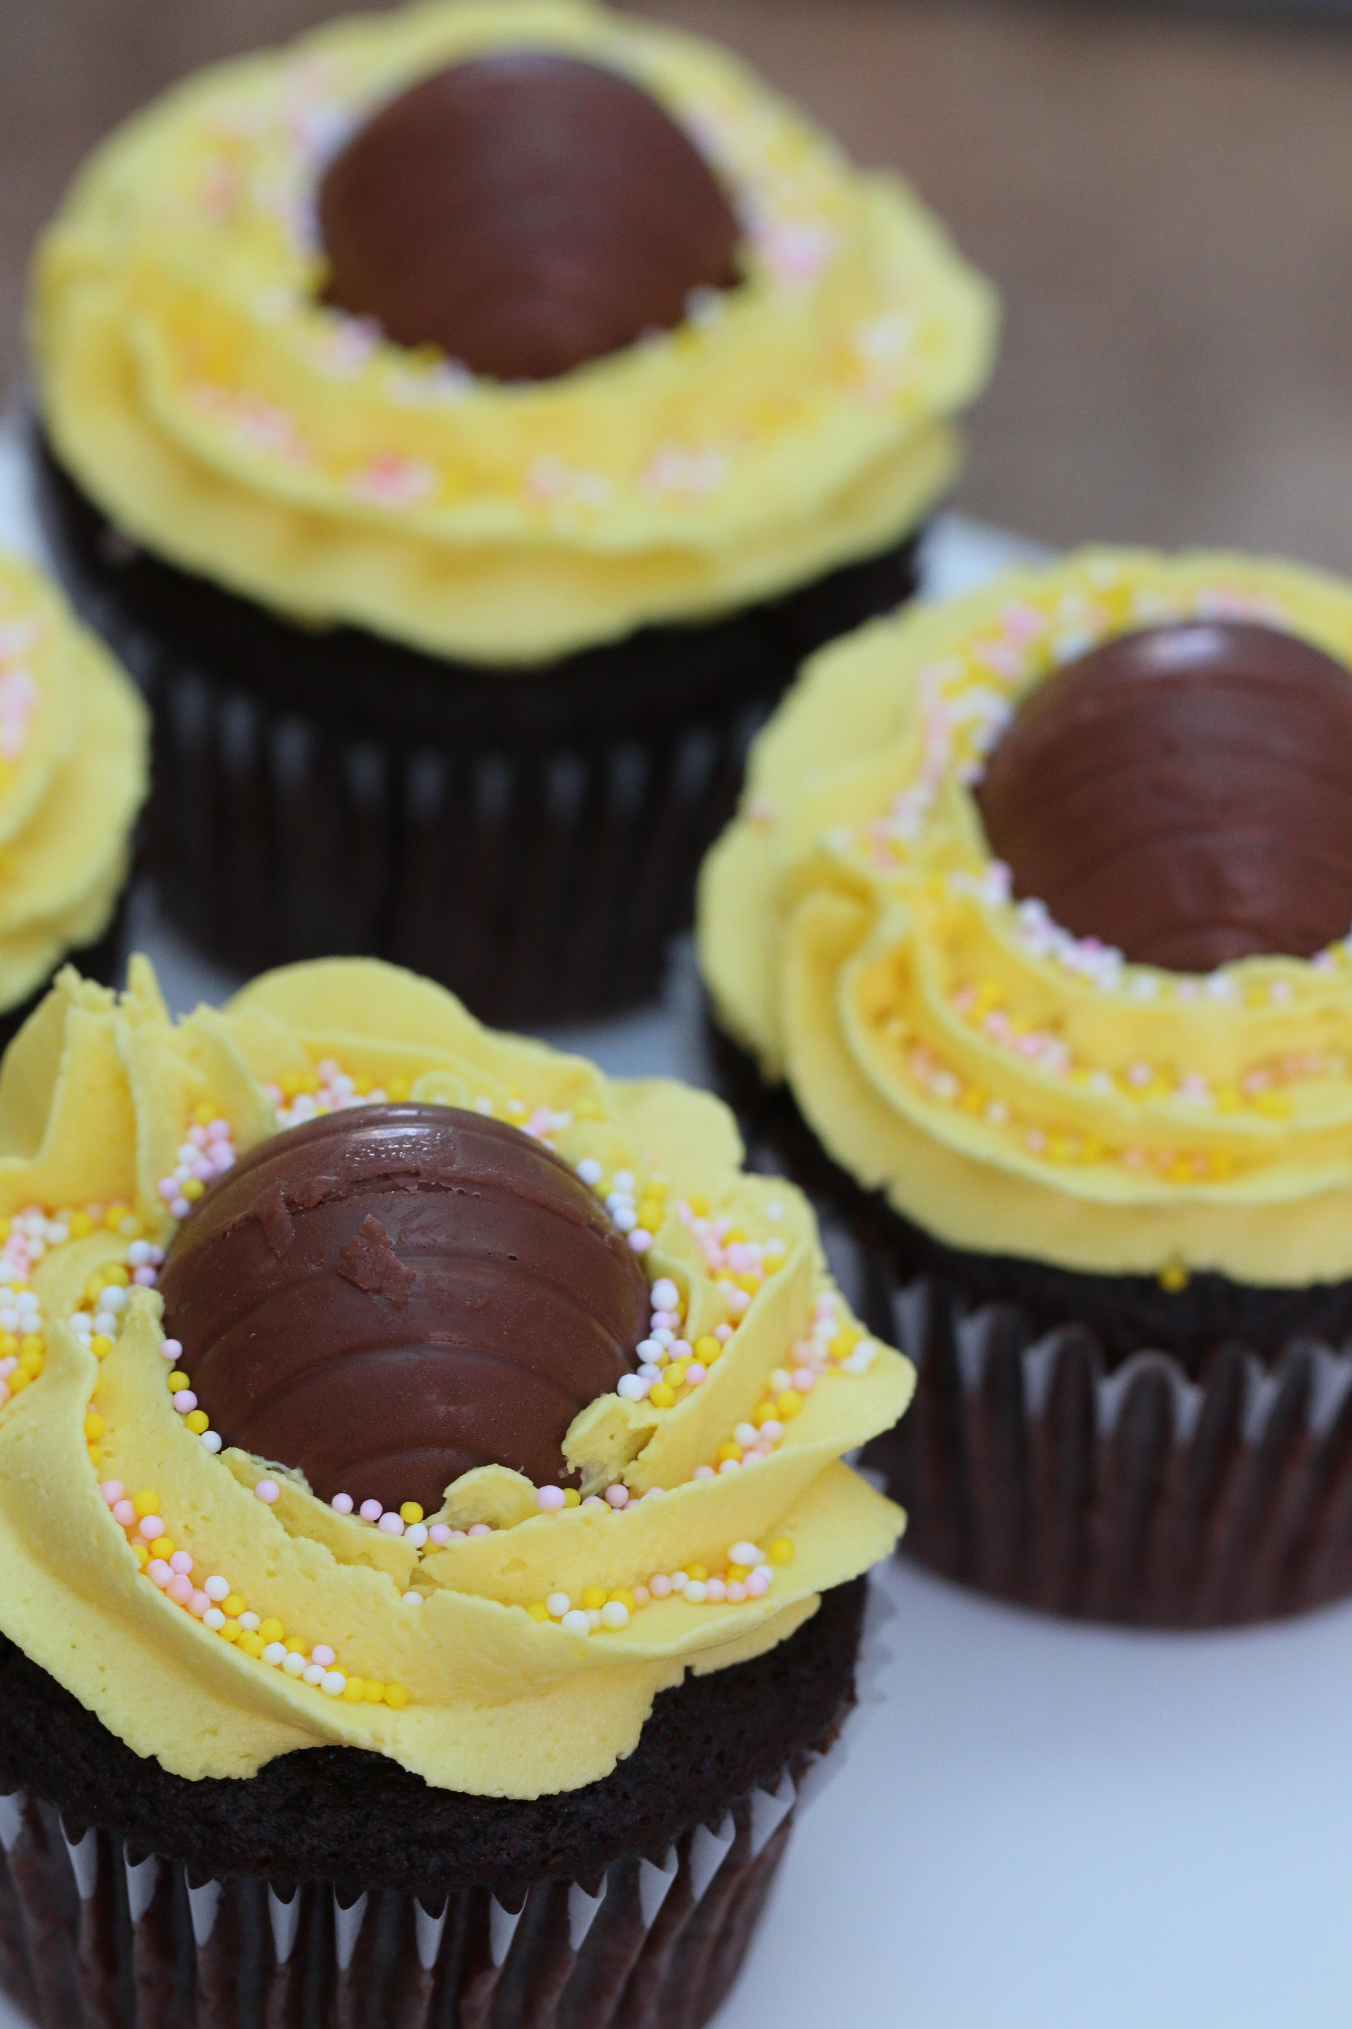

Another family favorite that we hope you will love as much as we do!

INGREDIENTS:
2 oz. unsweetened dark chocolate, chopped (I use Ghiradelli)
3/4 cup + 2 Tablespoon all-purpose flour
1/4 cup + 2 Tablespoon unsweetened cocoa powder
3/4 teaspoon baking soda
1/4 teaspoon salt
1 cup granulated sugar
1/4 cup unsalted butter (room temperature)
1 large egg (room temperature)
1 large egg yolk (room temperature)
1-1/2 teaspoon vanilla extract
1/2 cup sour cream
1/2 cup boiling water
Buttercream Frosting
12 Cadbury Creme Eggs (regular size)

HOW WE MAKE THESE:
- Preheat oven to 350 degrees. Line a 12-cup muffin tin with cupcake liners.
- Chop chocolate and melt chocolate in a small microwave-safe bowl on 50% power in 20 second intervals, stirring between intervals until melted and smooth, set aside to cool slightly.
- In a mixing bowl whisk together flour, cocoa powder, baking soda and salt until well combined, set aside. (I always sift my flour and cocoa powder when making this recipe – sift prior to measuring for best results.)
- In a large mixing bowl using an electric hand mixer mix together sugar and butter until combined (it won't come together entirely but mix until lumps of butter are creamed), add in egg, egg yolk and vanilla extract and mix well. Add in melted chocolate, then mix in sour cream. Add half of the flour mixture at a time and mix on low speed until. Add about 1/4 of the boiling water at a time, mixing until combined after each addition. Once water has all been mixed in, mix batter on medium-low speed for 1 minute.
- Divide batter among prepared muffin cups, filling each about 2/3 full (it's a little more than 1/3 cup of batter per cupcake).
- Bake in preheated oven until set and toothpick inserted into center comes out clean, about 17 - 20 minutes. Remove from oven, transfer to a wire rack and cool 10 minutes, then transfer to an airtight container (one that doesn't touch tops. I like to do this to seal in moisture) and allow to cool completely before frosting.
- One cupcakes are completely cooled, core the center of the cupcake, using either a cupcake-corer or a sharp knife – save the cupcake cores for snacking on!
- Unwrap Cadbury Creme Eggs and place one into the opening on each cupcake (insert the smaller side of the egg down).
- Frost with Buttercream Frosting around the edges of the Cadbury Creme Egg, sprinkle with spring-colored sprinkles if desired.
- Store in an airtight container.

YIELD: 12 Cupcakes

© SnowflakesandCoffeecakes. All images, attachments & content are copyright protected unless otherwise indicated. All rights reserved. Please do not use my images without prior permission. If you want to republish this recipe, please re-write the recipe in your own words, or link back to www.snowflakesandcoffeecakes.com for the recipe.



