FRENCH SILK PIE COOKIES
(BEST CRUMBL COPYCAT)
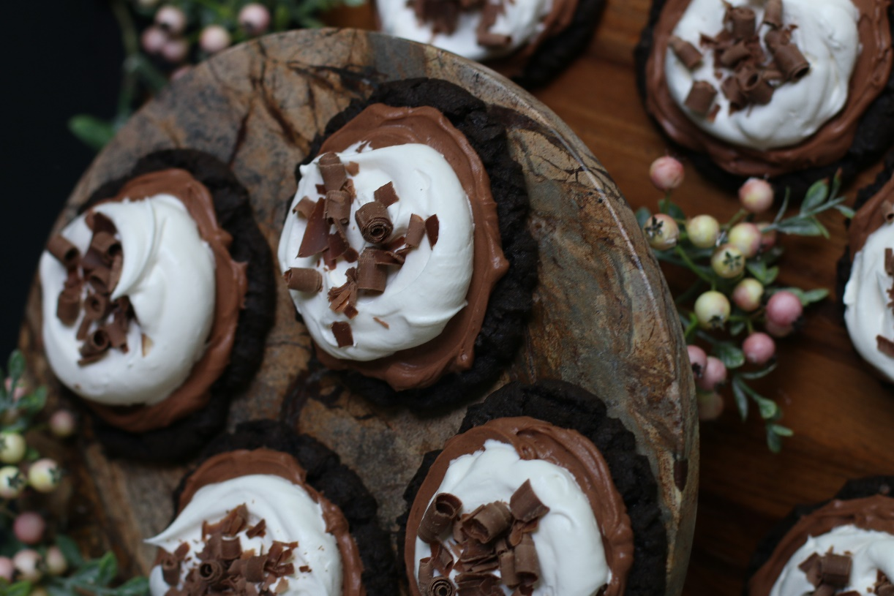

Step aside, Crumbl! There's a new cookie sensation in town that will have your taste buds dancing with delight! Say bonjour to my irresistible French Silk Pie Cookies - a heavenly fusion of French silk pie and classic cookies that will leave you craving more. When it comes to desserts that take your breath away, these French Silk Pie Cookies reign supreme. Combining the rich, velvety smoothness of French silk pie with the convenience of cookies, this recipe is a game-changer in the world of sweet treats. Whether you're a seasoned baker or a novice in the kitchen, this indulgent delight is guaranteed to impress everyone!
With a buttery, chocolatey crust that crumbles delicately in your mouth and a luscious, silky chocolate filling that melts on your tongue, each bite of these decadent and luxurious cookies is a symphony of flavors and textures. The best part? They are surprisingly easy to make and a luxurious treat that is perfect for special occasions or whenever you want to indulge in something truly decadent. My taste-testers agree these are BETTER than Crumbl, with no waiting in line! Get ready to experience a taste of pure bliss with every bite of the best French Silk Pie Cookies. Bon appétit!
INGREDIENTS:
CHOCOLATE OREO COOKIE BASE:
1-1/2 cups (3 sticks) unsalted butter (softened)
2 large eggs (room temperature)
3 cups (3750g) all-purpose flour
1 cup (109g) black cocoa powder (sifted)
2 tablespoons (15g) cornstarch
1 tablespoon (5g) milk powder
1-1/2 teaspoons baking soda
1 teaspoon baking powder
1 teaspoon salt
2-1/2 cups (215g) Oreo crumbs (regular Oreos crushed with filling & cookies)
1-1/2 cups (319g) brown sugar (light or dark)
1 cup (200g) granulated sugar
1 Tablespoon corn syrup
1 tablespoon pure vanilla extract

FRENCH SILK FILLING:
8 oz. dark chocolate (Ghirardelli or other high quality chocolate bar)
1 can (14 oz.) Eagle Brand Chocolate Sweetened Condensed Milk
16 oz. Cool Whip (thawed)

GARNISH:
Sweetened whipped cream
Chocolate shavings

HOW I MAKE THESE:
- Set eggs and butter out to come to room temperature (this helps them incorporate into the cookie dough better).
- PREPARE CHOCOLATE OREO COOKIE BASE: In a medium bowl, whisk together the flour, cocoa powder, cornstarch, milk powder, baking powder, salt and Oreo cookie crumbs until well combined; set aside.
- In a large bowl using a hand-held mixer or stand mixer fitted with a paddle attachment, beat the butter, granulated sugar and brown sugar on medium speed until completely creamy and fluffy (about 3-4 minutes).
- Scrape down the sides and add in the eggs one at a time, beating well between until each is fully mixed in.
- Add corn syrup and vanilla extract; continue beating until well blended.
- Scrape down the sides and add in the flour mixture, ½ at a time, mixing just until blended; add remaining flour mixture and again mix just until blended. This cookie dough will be really soft and creamy!
- Cover cookie dough and chill overnight.
- THE NEXT DAY: Remove cookie dough from refrigerator and allow to sit at room temperature for 1 hour.
- Preheat oven to 350 degrees. Line baking sheets with parchment paper; set aside.
- Portion dough into ¼ cup sized balls and roll into balls with your hands. Place six cookie dough balls on each baking sheet, leaving room between each cookie as the cookies will spread when they bake.
- Flatten the cookie dough balls by pressing gently with your hand to about ¾-inch thickness.
- Bake for exactly 12 minutes. Every oven is a little bit different, so watch your first batch when baking and time accordingly. DO NOT OVERBAKE, as these will lose their softness.
- Remove from oven and immediately press the bottom of a measuring cup into the center of each cookie, creating an indentation in the middle of the cookie and creating a small crust or edge. (Use a measuring cup that is slightly smaller than the cookie that has been sprayed with nonstick cooking spray to prevent it from sticking to the baked cookies.)
- Bake for an additional 1-2 minutes (if needed) until center of cookies are no longer glossy. Remove from oven and let cool on pan for 10 minutes before transferring to a wire rack to cool completely.
- PREPARE FRENCH SILK FILLING: Break or chop dark chocolate bars into pieces and melt according to package directions (double boiler or microwave). Stir until melted and smooth.
- In the bowl of a stand mixer fitted with a paddle attachment, pour Sweetened Condensed Milk. Add melted dark chocolate and blend until well combined. Add half of Cool Whip, blending on slow speed just until well blended; adding remaining half and continue mixing until just blended. (NOTE: French Silk Filling can be made ahead of time and stored in an airtight container in the fridge for several days.)
- ASSEMBLE COOKIES: Spoon about ½ cup of the French Silk Filling into the well of each cookie, giving the top a gentle swirl with the back of your spoon for a nice, smooth finished look.
- Immediately top each cookie with a dollop of whipped cream and sprinkle with chocolate shavings.
- Once the cookies have been frosted and decorated, chill in the fridge until ready to serve. These cookies are best served chilled, and best served the same day that they are filled.
- Keep cookies in an airtight container and refrigerate until ready to serve.
YIELD: Makes 30 (four-inch) cookies
RECIPE VARIATIONS:
- RASPBERRY FRENCH SILK PIE COOKIES: Add a burst of fruity raspberry flavor by substituting Ghirardelli Dark Chocolate Raspberry Squares in place of the Ghirardelli chocolate bars in the French Silk Pie Filling. Top with a miniature Ghirardelli Dark Chocolate Raspberry Square for a special treat. The sweet and tangy combination is sure to be a crowd-pleaser!
- CHOCOLATE-COVERED STRAWBERRY FRENCH PIE COOKIES: For a special Valentine treat, top each French Silk Pie Cookie with a chocolate-covered strawberry. So simple, and so elegant!
- MINT CHOCOLATE FRENCH SILK PIE COOKIES: Add a refreshing twist to your cookies by substituting Mint Oreo Cookies for regular Oreo cookies in the cookie dough; substitute good quality mint chocolate bars for the chocolate bars in the filling. Top with a sprinkle of crushed peppermint candies for a festive touch.
- SALTED CARAMEL FRENCH SILK PIE COOKIES: Elevate your cookies with a drizzle of homemade salted caramel sauce on top of the French Silk Pie Filling and sweetened whipped cream. The sweet and salty contrast is out of this world!
- PEANUT BUTTER CUP FRENCH SILK PIE COOKIES: For all the peanut butter lovers out there, swirl ¼ cup warm creamy peanut butter into the French Silk Pie filling. Top with chopped peanut butter cups for an extra indulgent treat.
- S’MORES FRENCH SILK PIE COOKIES: Take a classic campfire treat to the next level by adding a layer of marshmallow fluff on top of the chocolate filling. Toast the marshmallow with a kitchen torch for that authentic s'mores flavor.
- GLUTEN-FREE FRENCH SILK PIE COOKIES: You can easily make this recipe gluten-free by substituting your favorite 1:1 gluten free flour for the all-purpose flour - I use and recommend King Arthur, Measure for Measure Flour and Bob's Red Mill Gluten Free 1-to-1 Baking Flour. You will also need to replace the Oreo cookies with Gluten-Free Oreo Cookies.
RECIPE NOTES:
WEIGH INGREDIENTS CAREFULLY FOR BEST RESULTS: If I can only share one baking secret with you, always use a DIGITAL KITCHEN SCALE. You can use measuring cups and spoons for most recipes, but using a digital scale makes for the more consistent and efficient baking. Take this from someone that bakes A LOT!
HOW TO MEASURE OREO COOKIES: There are 11 regular Oreo cookies per cup (136g per cup of Oreo cookie crumbs).
MAKE AHEAD TIP: You can bake the cookies and freeze UNTOPPED in an airtight container for up to 2 months – simply defrost and then fill and decorate before you plan on serving. To keep your cookies from getting soggy, remove from the freezer and place the unopened container in the refrigerator overnight to thaw.
FOR PARTIES: Because of the chilled French Silk Pie filling and whipped cream topping, this is one of the few cookies that I recommend NOT be bagged individually for parties. If you need to package separately, I recommend using 4”-inch clear cookie boxes.
Original recipe created by Snowflakes & Coffeecakes June 2022; revised & reposted February 2024.
© SnowflakesandCoffeecakes. All images, attachments & content are copyright protected. All rights reserved. Please do not use my images without prior permission. If you want to republish this recipe, please re-write the recipe in your own words, or link back to www.snowflakesandcoffeecakes.com for the recipe.

Tried it and loved it? Snap a picture and share it with me on Instagram @SnowflakesandCoffeecakes and by using the hashtag #SnowflakesandCoffeecakes.

