CRUMBL BROWNIE BATTER COOKIES
(COPYCAT RECIPE)
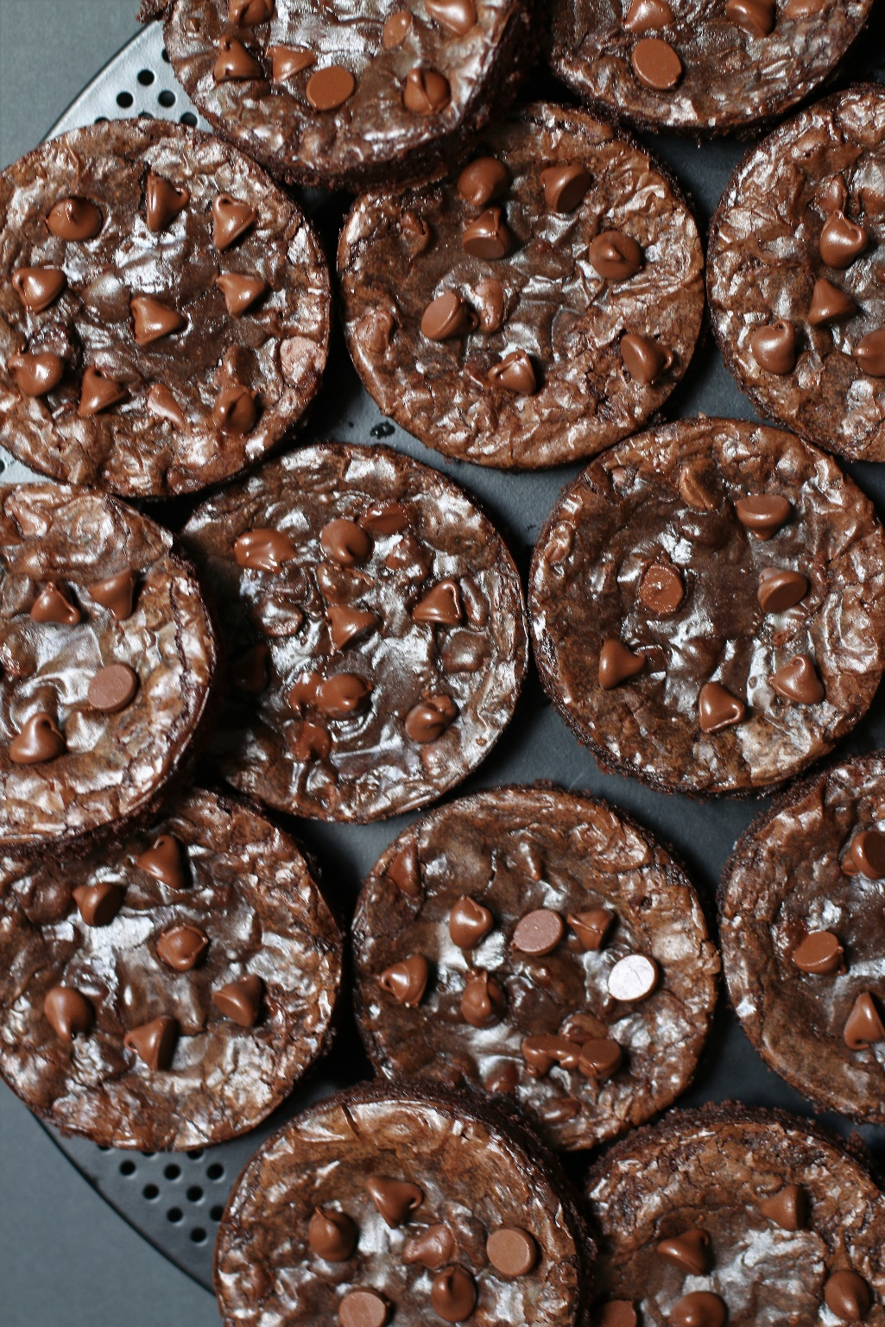

If you love brownies, you are going to love this copycat recipe for Crumbl Brownie Batter Cookies! So fast and easy to make, with a no-chill dough, it’s easy to see why these are always a favorite at our house! Super soft and chewy, with perfect crackly tops, fudgy centers, and loaded with melted chocolate chips, sometimes you just need a warm Brownie Batter cookie fresh from the oven! For those times that you have to make cookies FAST, or are having a “need-to-have-chocolate-now” emergency, you can be enjoying these warm from the oven in less than 30 minutes!
INGREDIENTS:
BROWNIE BATTER COOKIES:
18.3 oz brownie mix (I recommend Ghirardelli)
1/3 cup unsalted butter, melted
1 teaspoon espresso powder
1 teaspoon pure vanilla extract
1 Tablespoon light corn syrup
3 tablespoons all purpose flour
2 Tablespoons cornstarch
2 Tablespoons Dutch process cocoa
2 large eggs (room temperature)
1/4 teaspoon baking powder
1 cup chocolate chips (dark, semi-sweet chocolate or milk chocolate, or combo)

HOW I MAKE THESE:
- Set eggs out to come to room temperature (this helps them incorporate into the cookie dough better) or place them in a bowl of hot water for 10 minutes.
- Preheat oven to 350 degrees. Line two baking sheets with parchment paper; set aside.
- OPTIONAL: I like to use 3-1/2 inch English Muffin Rings for this recipe, for tall cookies that are all perfectly shaped. If using these, spray the insides of the rings with non-stick baking spray and place them on top of the prepared baking sheets. You don’t have to use rings, but your cookies will be larger and not as thick.
- PREPARE BROWNIE BATTER COOKIES: In a small bowl, melt the butter and add the cocoa powder and espresso powder. Stir gently until the cocoa powder and espresso powder is melted and blended in. (PRO TIP: Whisking cocoa powder and espresso powder into the melted butter until smooth allows the chocolate flavor to bloom - don't skip this step!)
- Add vanilla and light corn syrup and stir until blended.
- In a medium bowl, whisk together the brownie mix, flour, cornstarch, cocoa and baking powder until well combined.
- Beat eggs in a small bowl with a fork until frothy.
- Add the butter mixture to the middle of the flour mixture. Pour in the beaten eggs.
- Stir just until combined (you can use a hand mixer if you need to, as this is a thick batter), but again, mix just until combined. DO NOT OVERMIX! If you do, you’ll lose that beautiful crackly and glossy top on the cookies!
- Stir in chocolate chips.
- Using a large cookie scoop (3 Tablespoon size), scoop out cookie dough and drop into the center of each cookie form (or place six cookie dough balls on each baking sheet, leaving room between each cookie as the cookies will spread when they bake).
- Bake for 11-12 minutes or until the edges are set and the centers of the cookies have puffed up and do not look wet. Every oven is a little bit different, so watch your first batch when baking and time accordingly. DO NOT OVERBAKE, as these will lose their softness.
- Remove from oven and allow cookies to cool on the baking sheets for 10 minutes.
- These Brownie Batter Cookies are best served warm!
YIELD: Makes 12 (3-1/2 inch) cookies
NOTES: These cookies will stay fresh in an air-tight container at room temperature for 4-5 days, or in the refrigerator for up to 1 week.
MAKE AHEAD TIP: Baked Brownie Batter Cookies freeze well for up to 2 months. Thaw overnight UNOPENED on your kitchen countertop. You can also warm these up in the microwave (30 seconds at 50% power) for a warm brownie treat or emergency!
FOR PARTIES: I package Brownie Batter Cookies individually in self-sealing clear cellophane cello bags (Pack It Chic are my favorite brand). Make sure cookies are completely cooled down to room temperature before packaging. To make ahead, place individually wrapped and sealed cookies in a larger airtight container and refrigerate or freeze. Thaw frozen cookies in the refrigerator or on your countertop before serving - you are trying to minimize moisture during defrosting.
TO KEEP THESE COOKIES SOFT: Brownie Batter Cookies will stay soft and fresh in an air-tight container for 4-5 days, or in the refrigerator for up to one week.
NUTRITION INFORMATION FOR BROWNIE BATTER COOKIES:
calories: 366kcal (18%) carbohydrates: 49g (16%) protein: 5g (10%) fat: 17g (26%)
saturated fat: 8g (40%) polyunsaturated fat: 1g monounsaturated fat: 6g trans fat: 1g cholesterol: 54mg (18%) sodium: 196mg (8%) potassium: 84mg (2%) fiber: 1g (4%)
sugar: 31g (34%) vitamin a: 248IU (5%) calcium: 15mg (2%) iron: 2mg (11%)

Original recipe created by Snowflakes & Coffeecakes; published April 2022.
© SnowflakesandCoffeecakes. All images, attachments & content are copyright protected. All rights reserved. Please do not use my images without prior permission. If you want to republish this recipe, please re-write the recipe in your own words, or link back to www.snowflakesandcoffeecakes.com for the recipe.

Tried it and loved it? Snap a picture and share it with me on Instagram @SnowflakesandCoffeecakes and by using the hashtag #SnowflakesandCoffeecakes.

WHAT ARE YOUR FAVORITE CRUMBL COPYCAT FLAVORS?
- Crumbl Sugar Cookies with Sweet Almond Frosting
- Crumbl Chocolate Chip Cookies
- Crumbl Confetti Cake Cookies with Confetti Cake Cream Cheese Frosting
- Crumbl Brownie Batter Cookies

