creamy spaghetti lasagna
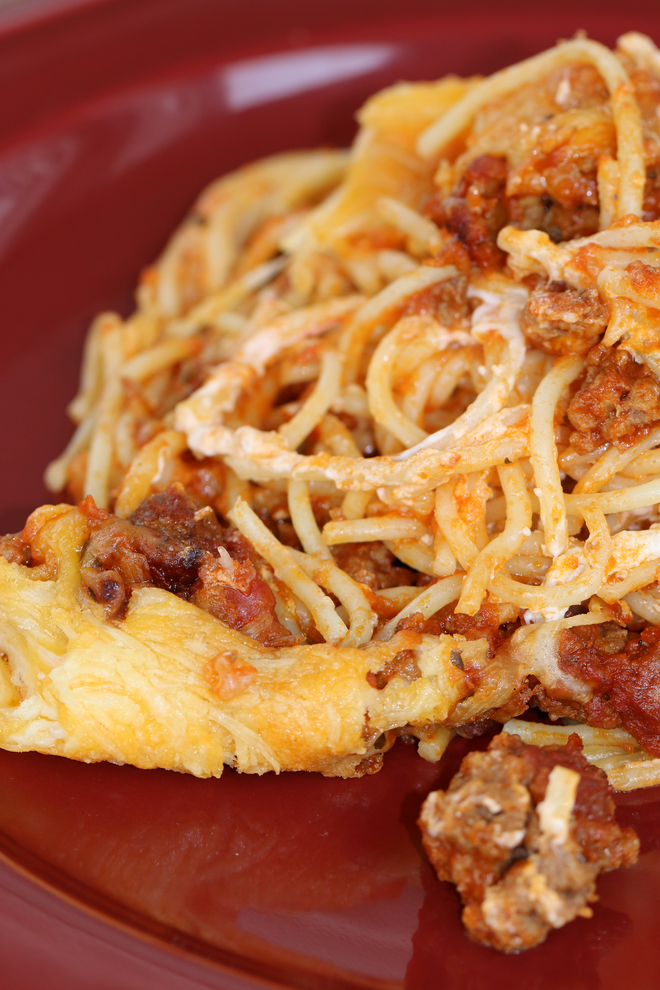
This is a family favorite. I usually make a double batch of my homemade spaghetti sauce and split it into batches to free and use for various recipes– you could also use your favorite jar of spaghetti sauce if you are in a hurry. Every single time I make it, someone asked why I don’t make it more often! And they will fight over the leftovers – if there are any! The white sauce is very smooth, creamy and delicious. I’ve seen this called Million Dollar Spaghetti all over the internet, but that typically includes cottage cheese. Whatever you want to call this dish, it’s a family favorite!

INGREDIENTS:
1 pound spaghetti noodles, cooked al dente and drained
1 pound ground beef or turkey, browned and drained
1 large Vidalia onion, chopped
4 cups of your favorite spaghetti sauce
6 ounces whipped regular cream cheese
3 ounces whipped chive cream cheese
1 cup sour cream
1-1/2 cups Kraft Italian Five-Cheese Blend shredded cheese
3 cups Kraft Three-Cheese Cheddar Cheese shredded cheese
grated parmesan cheese (for topping)
HOW I MAKE THIS:
- If your spaghetti sauce already contains meat of your choice, skip to step 3. Brown the meat until pink, add chopped onion and sauté until tender; drain and set aside.
- Add spaghetti sauce to meat mixture and simmer for 30 minutes.
- Preheat the oven to 350 degrees.
- Butter the bottom and sides of a 9x13 casserole dish.
- In a medium bowl, beat together the cream cheese, sour cream, and Italian cheese blend shredded cheese until smooth, creamy, and well combined. Salt and pepper to taste.
- Place 1/3 of the meat sauce mixture on the bottom of the casserole dish.
Layer half of the cooked spaghetti on top of the meat sauce.
- Dollop half of the white cheese mixture over the spaghetti as evenly as possible.
- Spread with another 1/3 of the meat mixture. Repeat the layers once and top with shredded cheddar cheese blend and parmesan cheese.
- Cover with foil and bake for 20-30 minutes or until hot and bubbly. Remove foil and continue baking until cheese is melted and golden. Remove from oven and cut into squares or scoop with large serving spoon.
- Bang the dinner bell – and take cover!

SERVINGS: Makes 10 servings.



