CORNbread WAFFLES WITH
MAPLE bacon & FRESH BLUEBERRIES
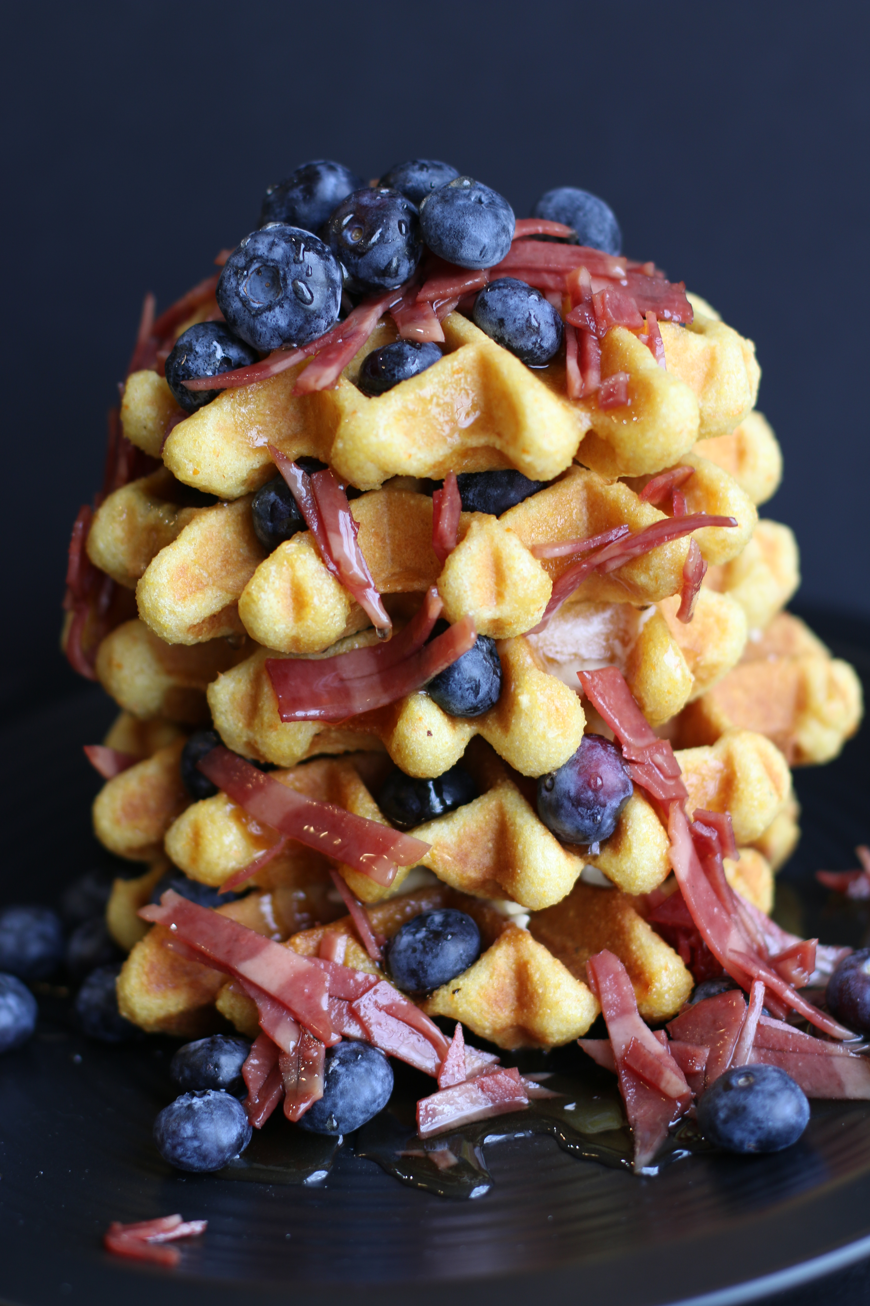

These traditional cornbread waffles are lightly sweetened with real maple syrup, studded with bacon bits and fresh blueberries, and drizzled with maple syrup glazed bacon and a boatload of even more fresh blueberries. SO GOOD!

INGREDIENTS:
1 cup yellow stone ground cornmeal
1 cup all-purpose flour
2 teaspoons baking powder
½ teaspoon baking soda
¼ teaspoon salt
2 cups buttermilk
2 large eggs (room temperature & slightly beaten)
¼ cup real maple syrup (for waffles)
1 teaspoon vanilla extract
2 tablespoons butter (melted & cooled slightly)
12 oz. bacon (ham or turkey), cooked and crumbled
1 pint fresh blueberries
1 cup maple pancake syrup

HOW WE MAKE THESE:
- In a large bowl, whisk together the cornmeal, flour, baking powder, baking soda and salt.
- In a smaller bowl, combine the buttermilk, eggs, honey and vanilla extract. Pour the liquid ingredients into the dry mix and stir just until the ingredients are combined. Stir in the melted butter. Gently stir in 1/3 cup crumbled bacon bits and 1 cup fresh blueberries.
- Allow waffle batter to rest while you are preheating your waffle iron.
- Grease hot waffle iron with nonstick cooking spray. Pour about ½ cup batter (or amount recommended by your waffle iron instructions) onto the hot iron. Close the lid and bake until golden brown and crisp. (We usually set these at a slightly lower cooking time than traditional buttermilk waffles.) The blueberries will burst with flavor while cooking!
- Warm maple pancake syrup and stir remaining bacon bits into it; set aside.
- Spoon warm maple bacon syrup on top of each warm waffle and sprinkle with more fresh blueberries; serve immediately!
YIELD: 4 to 6 large waffles
© SnowflakesandCoffeecakes. All images, attachments & content are copyright protected unless otherwise indicated. All rights reserved. Please do not use my images without prior permission. If you want to republish this recipe, please re-write the recipe in your own words, or link back to www.snowflakesandcoffeecakes.com for the recipe.

