CHOCOLATE COVERED RASPBERRIES
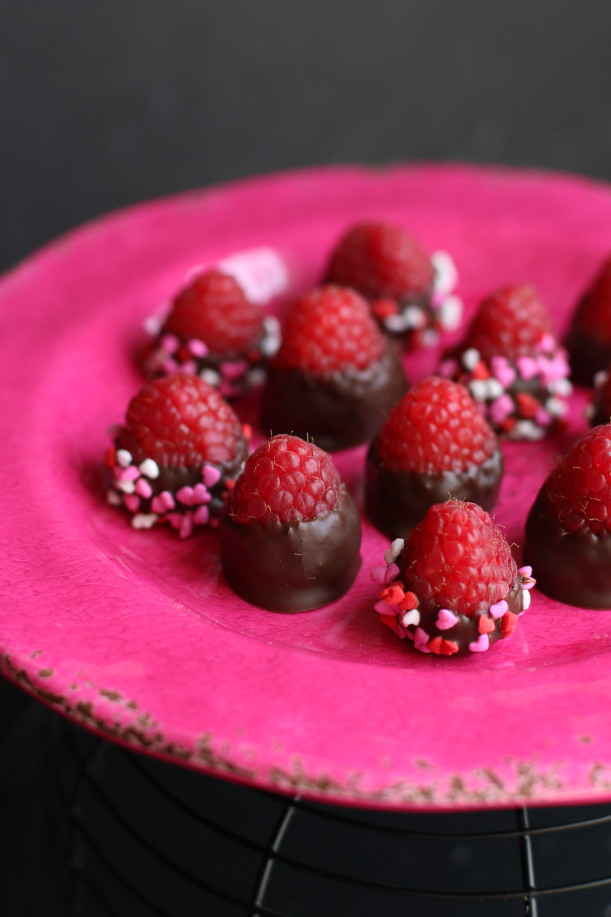

These decadent fresh raspberries, dipped in rich dark chocolate, taste even more wonderful than they look! So simple to make, my family loves these even more than Chocolate Covered Strawberries!

INGREDIENTS:
Fresh Raspberries (as large, red and perfectly ripe as you can find!)
Good quality Chocolate (dark, milk, semi-sweet or white)
1-2 teaspoons coconut oil or vegetable shortening (not vegetable oil)
Optional: Sprinkles or Toppings

HOW WE MAKE THESE:
- PICK THE RIGHT RASPBERRIES. Raspberries can be tricky depending on the time of the season. The tastiest and sweetest raspberries are usually the smaller ones – and the most flavorful ones have a deep royal red hue. We love homegrown berries, but they are so seasonal that at other times of the year I’ll pick up fresh berries from the market – Costco tends to have the best berries available year-round. I try to find berries that are fresh, dark red, plump and large enough to “dip” in chocolate. There’s no sense trying to dip a bad berry!
- USE THE RIGHT CHOCOLATE! I try to use the best quality chocolate that I can for dipping – whether it’s dark chocolate, milk chocolate, or white chocolate. Ghirardelli are always a favorite, but you can use a high quality chocolate bar or Wilton Chocolate Melts.
- PREPARING YOUR BERRIES. One of the main reasons that chocolate falls off fresh berries is that people wash them right before dipping. Washing isn’t the problem – but any moisture that remains on any type of fruit before you dip it in chocolate will prevent the chocolate from sticking to the surface of the berry. Rinse your berries in cool water, then drain well. And then place each raspberry stem-side down on paper towels and allow them to dry completely before you even start melting your chocolate. Room temperature berries also hold the melted chocolate better than refrigerated ones.
- MELT THE CHOCOLATE. There are different ways to melt the chocolate – choose the one that works best for you. Whether you melt it in a glass measuring cup in the microwave (30 seconds at a time on 50% power), in a double boiler on the stove (over just simmering and not boiling hot water), or in a Wilton Chocolate & Candy Melting Pot (my favorite way to melt chocolate!), just remember that you don’t want any moisture or high heat involved. Any moisture will cause your chocolate to seize up, high heat will cause chocolate to burn or seize up – and in either case you’ll need to start all over with new chocolate – and that would make you cry! COOKING SCHOOL SECRET: Add a teaspoon of coconut oil or vegetable shortening to the chocolate when you are melting it, and it will help keep it smooth, shiny, and the perfect light consistency for dipping.
- PREPARE YOUR PANS. Line baking sheets with parchment paper and have them ready. Also, make sure that you have space in your refrigerator or another cool location so that the chocolate will set-up once you’ve dipped your berries.
- DIP YOUR BERRIES. Some cooks use forks or toothpicks to pick up the berries and dip in the melted chocolate. I prefer just picking the berries up, one at a time, and dipping them into the melted chocolate stem-side down – I feel like I have more control, but feel free to use two forks or toothpicks if you prefer. Once you’ve dipped and swirled the berry in the melted chocolate, lift it out of the chocolate and allow any excess to drip off. Then place the dipped berries on the parchment paper.
- TOP WITH SPRINKLES OR EXTRAS AS YOU GO. If you want to add sprinkles, now is the time to sprinkle those on top or dip the berries into shallow bowls of your favorite toppings – berry by berry, as you go. The chocolate will start to harden within a minute of dipping, so you don’t have time to go back and do this later on. Sprinkles are always beautiful, but you can also dip into coconut, toffee pieces, cookie crumbles, nuts, mini M&M’s…whatever you fancy!
- DOUBLE DIPPING, DRIZZLING, SWIRLING or SPRINKLES. After the chocolate has set up and hardened, you can double dip, drizzle or swirl with additional melted chocolate. Be as creative as you like! Drizzle with more chocolate or colorful white chocolate – have fun!
- Store the chocolate dipped berries on the parchment paper in a single layer in an airtight container in the refrigerator. Remove from the refrigerator and the berries will peel off beautifully from the parchment paper and have smooth bottoms. I like to serve chocolate dipped berries at room temperature when possible – the fruit is more flavorful and the chocolate less “hard and crunchy” – but depending on the weather, you may not have that option. They are best served within a day or two of preparing – if they last that long!
YIELD: Varies
Originally posted February 2011; photographed & reposted February 2018
© SnowflakesandCoffeecakes. All images, attachments & content are copyright protected unless otherwise indicated. All rights reserved. Please do not use my images without prior permission. If you want to republish this recipe, please re-write the recipe in your own words, or link back to www.snowflakesandcoffeecakes.com for the recipe.

