chicken pecan gorgonzola salad with sweet balsamic dressing

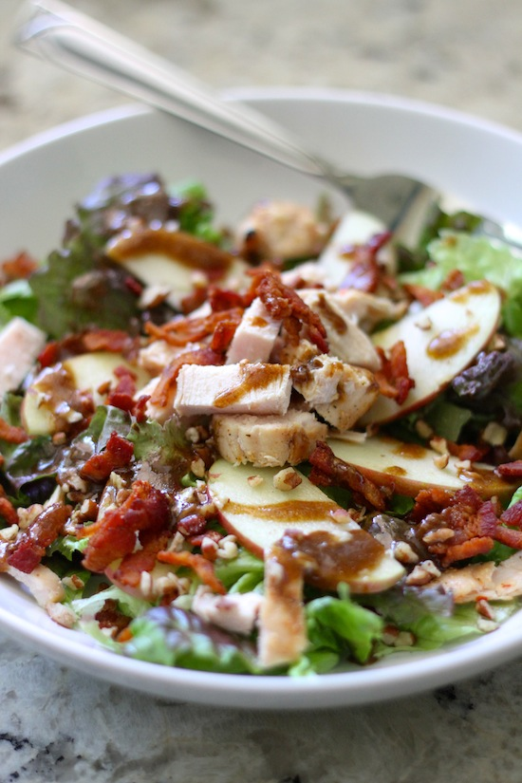

*This is my absolute favorite salad in the world – so many layers of flavors!*

***SALAD*:**

1 bag spring salad mix

1 bag romaine

 4 slices hickory smoked bacon (cooked and crumbled)

1/2 cup dried cranberries or cherries

1 large granny smith apple (chopped or sliced)

1/2 cup glazed pecans

5 oz  Gorgonzola or blue cheese (crumbled)

2 chicken breasts (grilled and chopped)

***SWEET BALSAMIC DRESSING***:

1/2 cup vegetable oil or canola

1/3 cup sugar

3 tablespoons good balsamic vinegar

1/8 teaspoon dry mustard or one teaspoon Dijon mustard

Fresh cracked pepper

**HOW I MAKE IT**:

1. Mix salad ingredients together in large bowl.
2. Whisk all the dressing ingredients together, until sugar and oil are blended. Keep whisking – it takes a few minutes for the oil and sugar to blend.
3. Slowly pour desired amount of dressing over salad and serve.

Servings: 4

© **SnowflakesandCoffeecakes**. All images, attachments & content are copyright protected unless otherwise indicated. All rights reserved. Please do not use my images without prior permission. If you want to republish this recipe, please re-write the recipe in your own words, or link back to [www.snowflakesandcoffeecakes.com](http://www.snowflakesandcoffeecakes.com) for the recipe.

