chicken pecan & apple salad with sweet balsamic dressing

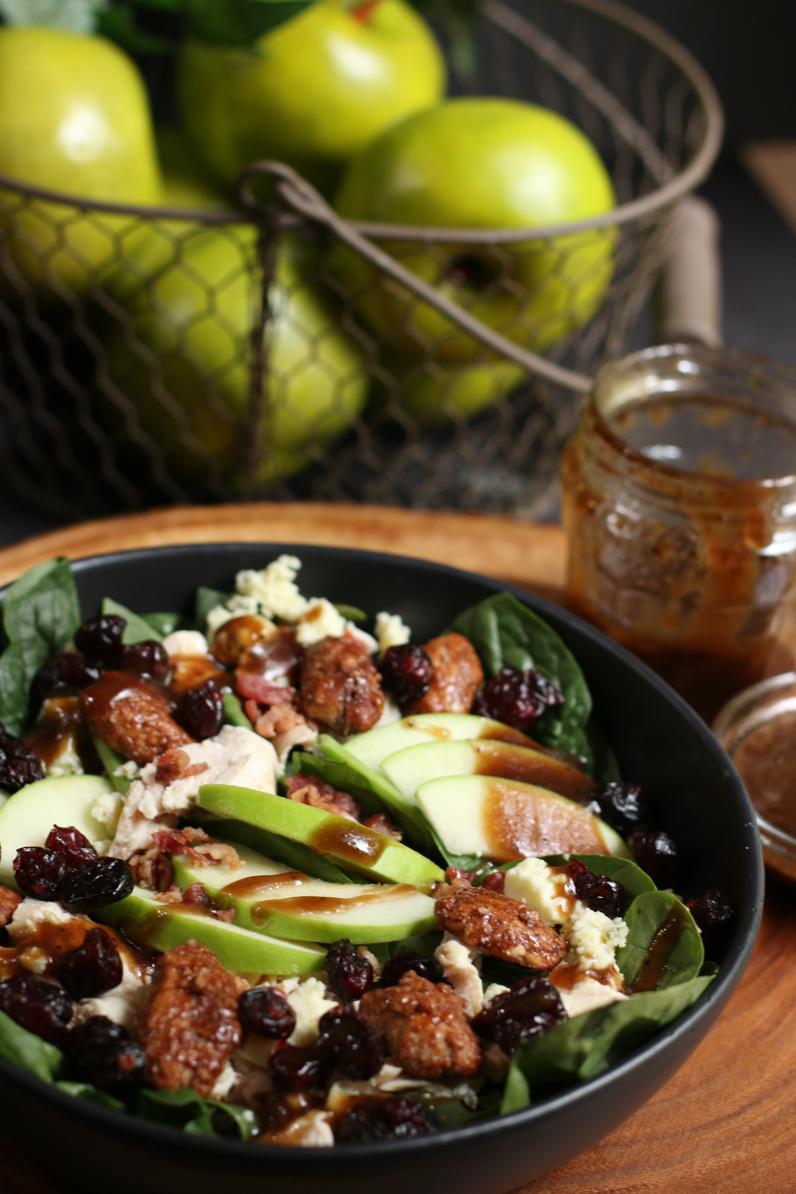

*Chicken Pecan & Apple Salad with Sweet Balsamic Dressing is loaded with fresh greens, tender chicken, crispy bacon, apple slices and sprinkled with glazed pecans and gorgonzola cheese. The Sweet Balsamic Dressing is perfect drizzled on top – so many layers of flavors!*

***SALAD*:**

6 cups spring salad mix, romaine or baby spinach

4 slices hickory smoked bacon (cooked and crumbled)

1/2 cup dried cranberries or cherries

1 large granny smith apple (chopped or sliced)

1/2 cup glazed pecans

5 oz. Gorgonzola or blue cheese (crumbled)

2 chicken breasts (grilled and chopped) or 2 cups rotisserie chicken (shredded)

***SWEET BALSAMIC DRESSING***:

1/2 cup vegetable oil or canola

1/3 cup sugar

3 tablespoons good balsamic vinegar or balsamic glaze

1/8 teaspoon dry mustard or one teaspoon Dijon mustard

Fresh cracked pepper

**HOW I MAKE THIS**:

1. Bake bacon until crisp (375 degree oven for about 10 minutes); cool & crumble.
2. Wash salad mix and drain well.
3. In a large bowl, mix all salad ingredients.
4. **PREPARE SWEET BALSAMIC DRESSING**: Combine salad dressing ingredients together in a small glass jar (with lid) or small bowl. Shake or whisk together, until sugar and oil are blended. It takes a few minutes for the oil and sugar to blend.
5. Slowly pour desired amount of dressing over salad and serve.

**SERVINGS**: 2 generous servings

*Originally posted March 2016; revised and reposted September 2020.*

*©* ***SnowflakesandCoffeecakes****. All images, attachments & content are copyright protected. All rights reserved. Please do not use my images without prior permission. If you want to republish this recipe, please re-write the recipe in your own words, or link back to* [*www.snowflakesandcoffeecakes.com*](http://www.snowflakesandcoffeecakes.com) *for the recipe.*