CHICKEN CHOPPED SALAD WITH GARLIC BALSAMIC DRESSING

[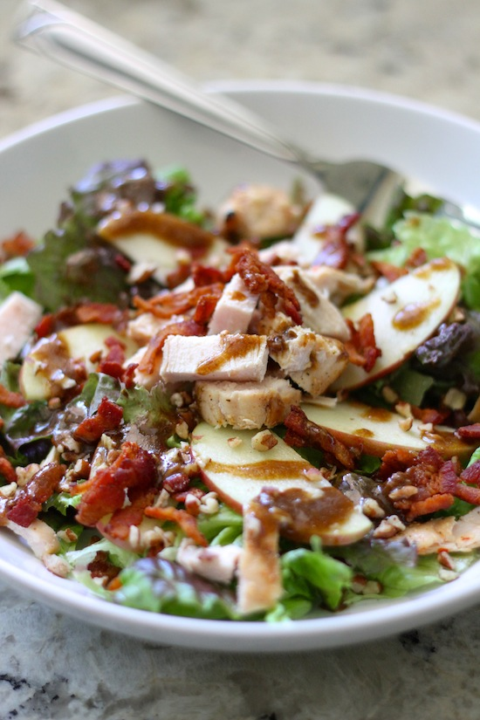](http://www.laurenslatest.com/wp-content/uploads/2013/07/IMG_0040.jpg)

*Generally Grandma Petska’s Buttermilk Pancakes are our go-to recipe, but for something special, these blueberry pancakes are a personal favorite!*

**INGREDIENTS:**

1 3/4 cups all purpose flour

2 tablespoons sugar

1 teaspoon baking powder

1/2 teaspoon baking soda

1/2 teaspoon salt

2 large eggs

1 cup milk, plus more if needed

1 cup sour cream

1 stick butter, melted

1/2 teaspoon vanilla

1 1/2 cups fresh or frozen blueberries

Maple syrup or Blueberry Syrup (warm)

**DIRECTIONS**:

## Apple, Bacon & Pecan Salad with Garlic Balsamic Dressing

Hear ye, hear ye!! This is my new favorite salad.

That is all.

……

Ya, like I could leave it at that! PSYCH! I am a girl after all! Soooooo, my days have become a little more entertaining with no husband BECAUSE……drum roll please……I’m making little daily videos of what we have been up to every day. That way when my husband gets home from Army training, he can see everything we did while he was gone :)Plus, I suck at writing in a journal. This way, it’s like a video journal! Much easier! I’m posting them all on my [youtube channel](http://www.youtube.com/laurenslatest). Be sure to watch [Day 1](http://www.youtube.com/watch?v=-v2HuYhPpVs), [Day 2](http://www.youtube.com/watch?v=oDCjFRtsm70), [Day 3](http://www.youtube.com/watch?v=x8J4kDW9o64) and [Day 4](http://www.youtube.com/watch?v=FTPAyeIGXgE). He’s been gone longer then just 4 days  but I only got the idea 5 days ago. Oopsie. *The last minute of Day 3 is my favorite. Make sure to turn up the volume!

Now, about this salad. It is gooooooooood.

Apples + Bacon + Pecans + leftover BBQ chicken + Garlicky Balsamic goodness = one heck of a party in your mouth.

I happened to have some leftover bacon I had precooked in my fridge along with some grilled chicken from a few days ago. That really made this salad come together in a cinch!  If you don’t have chicken readily available, it’s really no big deal. Just make sure you don’t forget the bacon. That is important.

And now for something equally as important….or not: I just finished watching Monday’s Bachelorette episode…..she’s already in love with Brooks?! And ABC didn’t edit her out saying that? Whaaa? I think she picks Brooks in the end since she just FREAKING told everyone that she can see him proposing to her. My mind is blown. But then, why is she crying in the previews saying she wants to go home? Ahhh!! I don’t understand!!!! And while I’m on this subject, I really think Sean and Catherine are a weird couple. I don’t know why, they just are.

This stuff really consumes my life when my husband is not around to make fun of this show.

[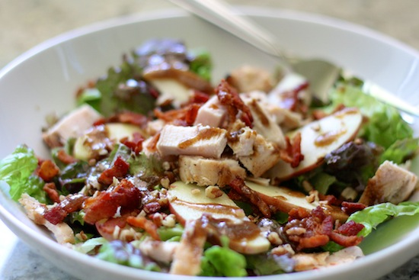](http://www.laurenslatest.com/wp-content/uploads/2013/07/IMG_0044.jpg)

Gotta love reality TV!! Haha…..anyways, check out my youtube channel, the Bachelorette and make this salad :)LOL!

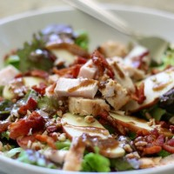[[Print](http://www.laurenslatest.com/apple-bacon-pecan-salad-with-garlic-balsamic-dressing/print/)Print](http://www.laurenslatest.com/apple-bacon-pecan-salad-with-garlic-balsamic-dressing/print/) [[Save](javascript:void(0);)Save](javascript:void(0);)

## Apple, Bacon & Pecan Salad with Garlic Balsamic Dressing

A yummy way to eat those greens! Add in a little smokey bacon, some sweet crisp apple and a yummy dressing!

Yield: 2 servings

Prep Time: 10 minutes

Cook Time: 0 minutes

Total Time: 10 minutes

### Ingredients:

6 cups red leaf lettuce, washed and torn  
1 fuji apple, washed and diced  
4 slices hickory smoked bacon, cooked and crumbled  
4 tablespoons toasted and chopped pecans  
1 small grilled chicken breast {leftovers!}

for the dressing-  
1 clove garlic, grated  
2 teaspoons dijon mustard  
2 tablespoons balsamic vinegar  
3-4 tablespoons olive oil  
salt & pepper, to taste

### Directions:

Place all salad ingredients into a large bowl. Whisk all ingredients for dressing together. Toss dressing with salad and serve.