cheddar ranch florentine chicken burgers
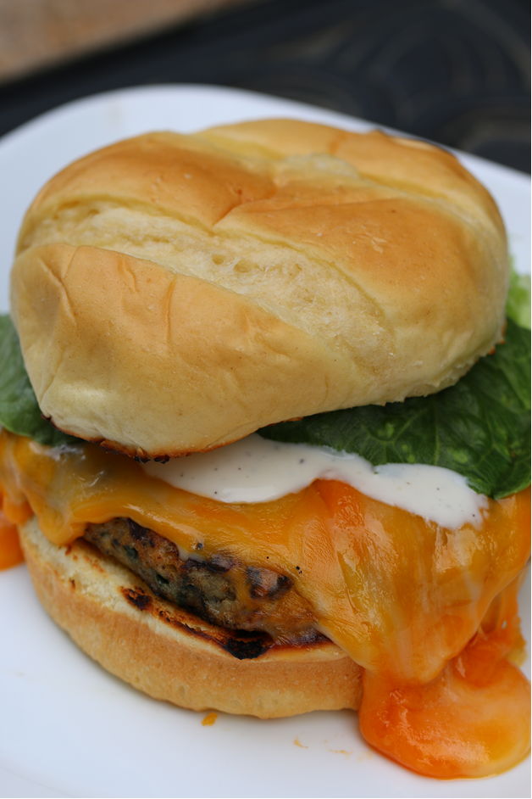

These flavorful and moist burgers are a wonderful alternative for those that don’t care for beef burgers. You can use either ground chicken or turkey.

INGREDIENTS:
1 pound ground chicken or turkey
1/2 cup Panko bread crumbs
1/4 cup Italian bread crumbs
1/3 cup fresh spinach, torn into small pieces
½ cup shredded Fontina cheese
1 tablespoon finely chopped fresh onion
1 teaspoon seasoned salt
1 teaspoon garlic powder
1 Tablespoon dry Ranch dressing mix
4 slices cheddar cheese
2 tablespoons butter
4 hamburger buns
Lettuce
Ranch Dressing

HOW I MAKE THESE:
- Preheat your grill to medium high.
- In a large bowl mix together the chicken, Panko crumbs, bread crumbs, onion, spinach, Fontina cheese, seasoned salt, garlic powder and dry ranch dressing.
- Form chicken mixture into 4 patties. Place on oiled grill.
- Grill/broil for 4-6 minutes on each side or until internal temp reaches 160 degrees. For the last minute of cooking, place a slice of cheese on each burger to melt. Remove from grill.
- Spread butter on the inside of the buns. Place on grill for a couple of minutes. Put chicken burger on bun and top with prepared ranch dressing and fresh lettuce.



