carrot cake WITH CREAM CHEESE FROSTING
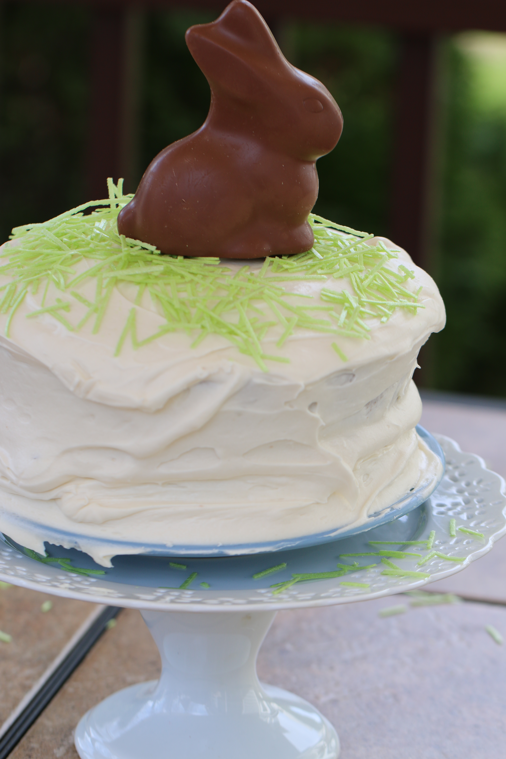

This is our favorite carrot cake – very simple, very moist! Carrot cake is very much a personal preference – some like it with pineapple, raisins and nuts. For us, simple is better!
This is a great cake for Easter- it always tastes more flavorable and moist a day after baking.

INGREDIENTS:
Cake:
1 cup oil
2 cups white sugar
3 large eggs, beaten well
2 cups carrots, peeled and grated fine
1 (8 ounce) can crushed pineapple, undrained
2 teaspoons vanilla
2 cups all purpose flour
1 cup whole wheat flour
1 teaspoon salt
1 teaspoon baking soda
1 teaspoon cinnamon
1 cup chopped pecans
Optional: Chopped Pecans, Coconut or Easter Decorations (for decoration)

Cream Cheese Frosting:
1/2 cup unsalted butter, softened to room temperature
8 ounces cream cheese, softened to room temperature
2 teaspoon vanilla
4 cups powdered sugar
HOW I MAKE THIS:
- Preheat oven to 350 degrees.
- Grease 2 or 3 round (8-inch or 9-inch) cake pans and line with parchment paper.
- Mix oil, sugar, eggs, carrots, pineapple and vanilla until combined.
- Mix dry ingredients in a bowl, combining gently with a whisk.
- Slowly add the wet ingredients to the dry mixture.
- Bake for 35-40 minutes or until toothpick inserted in the center comes out clean.
- Remove from oven and cool in pan for 10 minutes. Invert cakes into a cooling rack.
- When cake has cooled, frost with cream cheese frosting.
- For the Cream Cheese Frosting: Beat butter and cream cheese until light and fluffy. Add vanilla and then powdered sugar one cup at a time, scraping the bowl often. Beat until light and fluffy – at least 3 minutes.
- When cake has cooled complete, frost with cream cheese frosting.
- Cool for at least 24 hours before serving.
- If you’d like, you can top with chopped pecans or shredded coconut.
- For Easter, I like to decorate with edible Easter grass and a beautiful chocolate bunny!
YIELD: 12-16 servings
© SnowflakesandCoffeecakes. All images, attachments & content are copyright protected unless otherwise indicated. All rights reserved. Please do not use my images without prior permission. If you want to republish this recipe, please re-write the recipe in your own words, or link back to www.snowflakesandcoffeecakes.com for the recipe.



