BROWN SUGAR & apple cider glazed HAM with escalloped apples
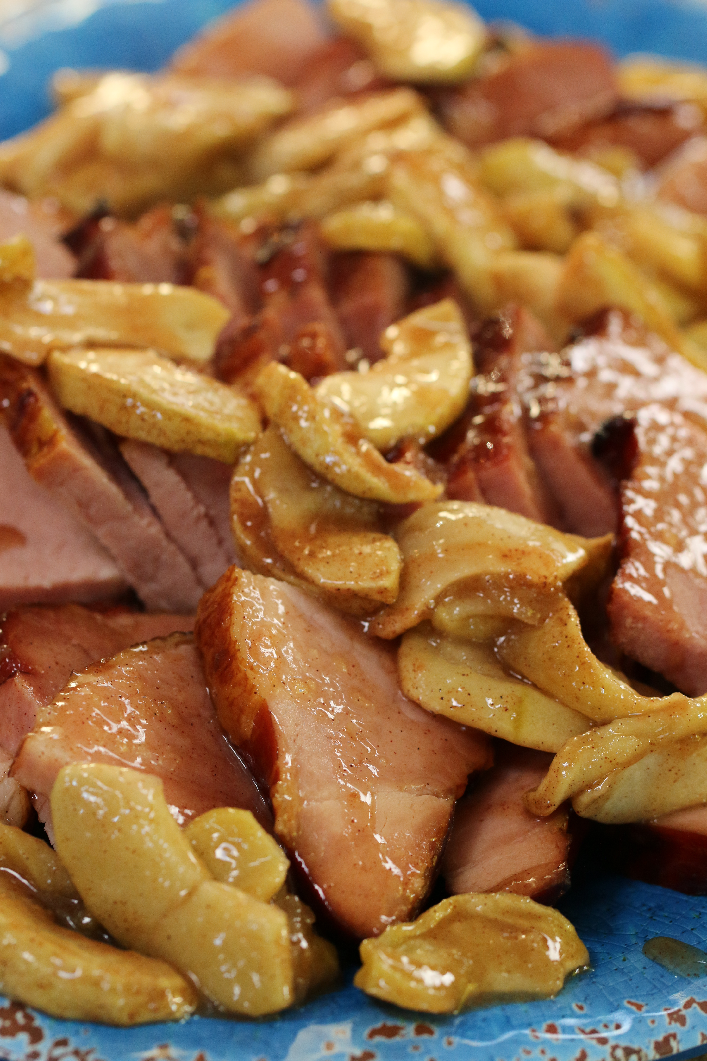

This delicious ham cooks quickly and easily in your slow cooker – perfect for an Autumn day! Savory brown sugar, apple cider and Dijon mustard melt into an AMAZING glaze, topped with tender cinnamon infused escalloped apples. You can only imagine how wonderful the house smells when I make this!

INGREDIENTS:
4 lb. ham (fully cooked, plain or smoked)
1 cup fresh apple cider
1 cup packed brown sugar
1 tablespoon Dijon mustard
Escalloped Apples (see my recipe at SNOWFLAKESandCOFFEECAKES.com)

HOW I MAKE THIS:
- Remove ham from packaging and discard any flavoring packet. If using a bone-in ham, check end of bone for a plastic cap and discard.
- Pour apple cider into the bottom of a large (6 or 7-quart) oval slow cooker.
- RUB: In a medium bowl, mix brown sugar and Dijon mustard into a paste. Spread brown sugar mixture all over ham and place, flat side down, in slow cooker.
- Cover slow cooker with lid and set to low. Cook ham for 2 hours (high heat) to 4 hours (low heat) or until meat is tender and internal temperature reaches 140 degrees. If desired, flip and baste ham halfway through cooking time and again about 30 minutes before ham is done.
- Once ham is done, remove from slow cooker and place on a sided baking pan, covering with foil to keep warm.
- Warm up already prepared Escalloped Apples (or time them so that they are finished baking when you are ready to serve your ham).
- Slice and serve ham warm with Escalloped Apples on the top or served on the side.

YIELD: Approximately 8 to 10 Servings

© SnowflakesandCoffeecakes. All images, attachments & content are copyright protected unless otherwise indicated. All rights reserved. Please do not use my images without prior permission. If you want to republish this recipe, please re-write the recipe in your own words, or link back to www.snowflakesandcoffeecakes.com for the recipe.

