BLUEBERRY GALETTES

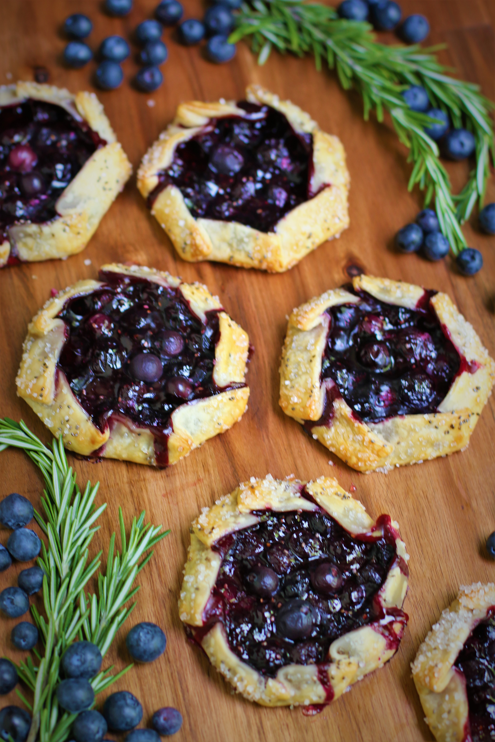

*These are the BEST fresh* ***Blueberry Galettes****, one of my favorite things to make with the abundance of gorgeous blueberries in the summer! Fresh sweet blueberries are baked in an easy, flaky homemade crust – uncomplicated and perfect – and sure to be the most irresistible fruit galettes you’ve ever had! A touch of fresh rosemary adds a gourmet flavor to the sweet and tangy blueberry filling, and the tender crust is sprinkled with sparkling sugar and chia seeds for a sweet crunch. So fast and easy to make, these tiny treats are perfect served warm with ice cream or sweetened whipped cream - the perfect rustic dessert for barbecues and picnics, garden teas, or a special after dinner treat!*

**INGREDIENTS:**

**PASTRY CRUST**: *(or use one package of pre-made refrigerated pie crusts)*  
1 cup (2 sticks or 226g) unsalted butter (cold and cut into cubes)

2-1/2 cups (310g) all-purpose flour

1 tablespoon granulated sugar

1 teaspoon salt

½ cup + 1 tablespoon cold buttermilk

**BLUEBERRY FILLING**:

2 cups (1 pint or 510g) fresh blueberries

1/3 cup (60g) granulated sugar

2 tablespoons (20g) Clearjel, quick tapioca or cornstarch

1 tablespoon fresh lemon juice

1 teaspoon finely grated lemon zest

Fresh rosemary leaves

**FOR THE GALETTES**

1 large egg (room temperature)

1 tablespoon water

2 tablespoons Turbinado sugar or sparkling sugar

1 tablespoon chia seeds (optional)

### **HOW I MAKE THESE**:

1. **PREPARE CRUST**: In a large bowl, whisk together the flour, sugar and salt. Add the cold butter cubes and toss to coat the butter evenly.
2. On a well-floured surface, dump flour mixture. With a well-floured rolling pin, roll the mixture together, flattening the butter into the flour. Use a bench scraper to bring the mixture back together again as needed.
3. When the butter is in long streaks and evenly distributed through the flour, return the mixture to the bowl and create a well in the center with your fingers.
4. Add the buttermilk and stir to combine and make a shaggy dough. If necessary, add more buttermilk, a tablespoon at a time, but the mixture should stay a little on the dry side.
5. Divide the dough into 2 and flatten slightly into disk shapes. Wrap each in plastic wrap and chill in the fridge for at least 2 hours or overnight.
6. Line two large baking sheets with parchment paper or silicone baking mats. Make sure you have enough room in your refrigerator or freezer for these baking sheets, as the galettes will need to chill before baking.
7. **PREPARE BLUEBERRY FILLING**: Clean blueberries, rinse in cool water and drain well. In a medium bowl, gently stir or toss the blueberries, clearjel (or tapioca or cornstarch), sugar, lemon zest and fresh lemon juice until evenly combined. Place in the refrigerator to chill.
8. **SHAPE THE CRUSTS**: Working with 1 chilled pie dough at a time, place the dough onto a floured work surface. Roll into a large 12-inch circle, using your warm hands to mold any cracking edges back together.
9. From the circle, cut 3 rounds using a 5-1/2 or 6-inch cookie cutter (you can also use a pan lid to cut if you have one the right size!) Work quickly, as the dough becomes more delicate the longer it’s at room temperature. Repeat with the second chilled pie dough for a total of 6 crusts.
10. **FILL GALETTES**: Arrange dough rounds on prepared baking sheets. Remove filling from the refrigerator and spoon about ¼ cup into the center of each, leaving any excess juice behind in the bowl.
11. Gently and tightly fold and pleat the edges up and over the filling, leaving the very center exposed. Pinch the pleats and folds to help keep them tight and compact so that they don’t unfold or lose shape while baking.
12. Add a few fresh rosemary leaves on the top of each galette.
13. Beat the egg and water together and using a pastry brush, brush pastry edges with egg wash. Sprinkle generously with Turbinado sugar or sparkling sugar and chia seeds for a sweet crunch.
14. Chill or freeze the shaped galettes for at least 30 minutes and up to 4 hours. **DO NOT SKIP THIS STEP!** The galettes will lose their shape if they are not chilled well.
15. Preheat oven to 375 degrees.
16. Bake chilled galettes for 25-28 minutes or until the edges are golden brown and the blueberry filling is bubbling.
17. Remove from oven and cool for at least 10 minutes before serving to allow the filling to thicken slightly as it cools. These are wonderful warm or at room temperature!
18. Perfect by themselves or serve with a scoop of vanilla ice cream or sweetened whipped cream.
19. Cover leftover galettes and store in the refrigerator for up to 3 days.

**YIELD**: 6 servings

**NUTRITION INFORMATION:**

Sodium: 425mg Calcium: 49mg  Vitamin C: 7mg  Vitamin A: 1059IU   Sugar: 22g Fiber: 3g   Potassium: 160mg  Cholesterol: 111mg  Calories: 588kcal Saturated Fat: 20g  Fat: 33g  Protein: 8g  Carbohydrates: 67g Iron: 3mg

**RECIPE NOTES**:

* **CAN I USE FROZEN BLUEBERRIES?** The beauty of using frozen blueberries in baking is that they can almost always be subbed for fresh blueberries. Just take the blueberries out of the freezer a few minutes before you assemble your filling.
* **WHAT IS THE BEST WAY TO THICKEN A FRUIT PIE FILLING**? You can use cornstarch, clearjel or quick cooking or "minute" tapioca to thicken the filling for this recipe. Clearjel is my favorite for fresh fruit galettes. Quick cooking tapioca has good jelling power and does an excellent job of absorbing the juice from even the juiciest fruit so that you can still get a fairly clean slice. Tapioca also works best if you allow it to sit with the fruit for a few minutes to soften and begin absorbing juices before filling the pie or baking, which is why I recommend letting the blueberry filling sit and chill before filling the galettes. We want that beautiful violet hue from the blueberries to shine thru!
* **SUBSTITUTIONS FOR TAPIOCA**? You can typically use clearjel, tapioca and cornstarch for this recipe in the same amount, but if you are using other fruits, you may need to make adjustments on the thickener you use. Check out [*this guide for fruit to cornstarch ratios*](https://www.kingarthurbaking.com/learn/guides/pie-thickener) for more information on clearjel, cornstarch and tapioca.
* **SUBSTITUTIONS FOR FRESH ROSEMARY**? Fresh rosemary and blueberries are fabulous together, but you could also use fresh thyme, fresh mint or fresh basil to create a galette that is something special!
* **WHAT IS TURBINADO SUGAR?** Turbinado sugar is partially refined sugar that retains some of the original molasses, giving it a subtle caramel flavor and color, and produces a nice sweet little crust when baked on top of cookies, cakes or pastries. Sparkling sugar also works well when sprinkled on pastries and pies if you don’t want the golden color and caramel flavor.
* **DO I HAVE TO CHILL THE DOUGH?** Chilling the dough helps hydrate the flour and ensures the pie crust will hold its shape when baked! Chilling the dough also makes it much easier to work with and roll out! Before baking, it is imperative that you chill the galettes before baking, which will help prevent the crusts from opening up during baking and your fruit filling to spill out.
* **RECIPE VARIATONS: CAN I USE A DIFFERENT FRUIT?** Besides being ridiculously easy to make, you can use your favorite fruits to make sweet galettes for any season of the year! You may want to substitute pure vanilla extract for the fresh lemon juice and zest, depending on the flavor profile of the seasonal fruit you are using! Any berries can be substituted in the same quantities but other fruits might require a slightly different amount of clearjel or cornstarch - check out [*this guide for fruit to cornstarch ratios*](https://www.kingarthurbaking.com/learn/guides/pie-thickener) for more information. These fruits all work well in galettes – have fun and experiment with your favorites:
* Raspberries
* Strawberries
* Blackberries
* Mixed Berries
* Rhubarb
* Summer Peaches
* Apples
* Plums
* Pears
* Pear & Apple Gingersnap
* Apricots
* Cherries
* Figs
* Cranberry Walnut
* Fruits of the Forest
* Add cream cheese for a rich cheesecake flavor
* Add custard for a fruit & custard galette
* **TELL ME MORE ABOUT SAVORY GALETTE VARIATIONS:** Galettes are simply delightful, whether you make sweet or savory variations.  Besides being so easy to make, savory galettes really let you explore so many different options, including seasonal vegetables, meats, savory herbs and cheese. Here are some yummy variations::
* Caramelized Onion
* Heirloom Tomato Caprese
* Mushroom & Goat Cheese
* Zucchini & Ricotta
* Potato Galette, topped with Lox and Crème Fraiche
* Summer Vegetable
* Savory Potato & Leek
* Potato, Onion & Gruyere
* Garden Carrot, Butternut Squash, Garlic, Fresh Rosemary & Thyme & Goat Cheese
* Butternut Squash and Caramelized Onion
* Broccoli & Cheese Galette made with shortcrust pastry
* Savory Zucchini with cheese baked into the crust for even more flavor!
* Spinach & Feta Galette - all the best parts of Spanakopita in a no-fuss pastry!
* Roasted Vegetable Galette with Butternut Squash, Carrots, Beets and Sweet Potatoes with Blue Cheese & Onion
* Sourdough Galette with Delicata Squash or Butternut Squash

*Original recipe created by Snowflakes & Coffeecakes; published May 2022.*

*© SnowflakesandCoffeecakes. All images, attachments & content are copyright protected. All rights reserved. Please do not use my images without prior permission. If you want to republish this recipe, please re-write the recipe in your own words, or link back to* [*www.snowflakesandcoffeecakes.com*](http://www.snowflakesandcoffeecakes.com) *for the recipe.*

*Love this recipe? Snap a picture and share it on Instagram  and mention* [*@SnowflakesandCoffeecakes*](https://www.instagram.com/snowflakesandcoffeecakes/)*and tag*[*#SnowflakesandCoffeecakes*](https://www.instagram.com/snowflakesandcoffeecakes/)*.*