easy blackberry sauce & syrup
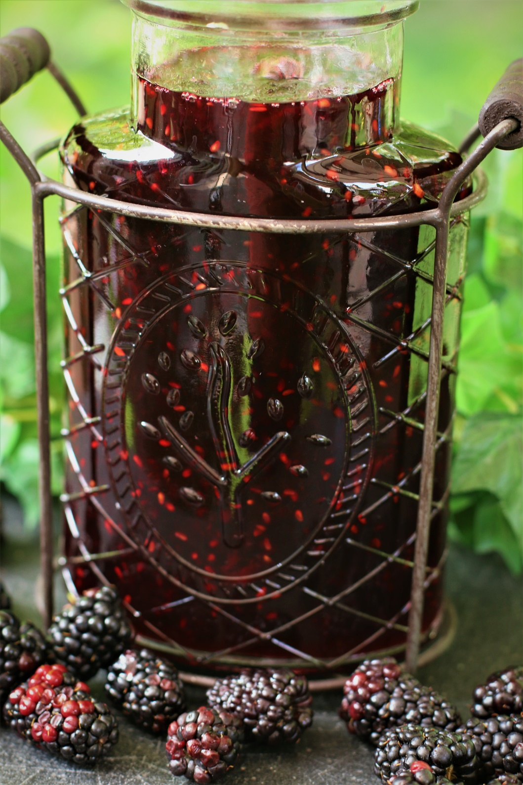

If you're a fan of blackberries and looking for a versatile and mouthwatering sauce and syrup recipe, this is the recipe you've been looking for! This fresh and easy Blackberry Sauce & Syrup is the perfect addition to your breakfast, desserts, and even savory dishes. Whether you're drizzling it over pancakes, swirling it into yogurt, drizzling on cheesecake or using as a glaze for grilled meats, this homemade blackberry sauce and syrup is sure to elevate your culinary creations! No need to go to trendy breakfast restaurants when you can make easy and even more delicious brunch recipes at home!
INGREDIENTS:
4 cups blackberries (fresh or frozen)
1 cup (200g) granulated sugar
1 tablespoon fresh lemon juice
1 tablespoon cornstarch

HOW I MAKE THIS:
- In a medium heavy saucepan, combine the blackberries and sugar.
- Cook over medium heat, stirring frequently until the sugar mixes with blackberry juice and dissolves completely, about 2-3 minutes.
- In a small bowl combine lemon juice and cornstarch. Slowly drizzle into the saucepan with the blackberries, stirring constantly.
- Bring the sauce to a boil and allow it to cook for another 2-4 minutes or until the sauce has thickened.
- Remove from heat and allow to cool. The sauce will continue to thicken as it cools.
- Transfer to an air-tight container and store in the fridge for up to a week. You can also freeze this tasty sauce in an airtight container for up 6 months. When you’re ready to use it, defrost in the fridge overnight.
YIELD: 2 cups
RECIPE NOTES:
- FRESH OR FROZEN BERRIES? I prefer to use fresh blackberries when they are in season, but frozen will also work just when blackberries aren’t in season.
- SEEDLESS BLACKBERRY SAUCE & SYRUP: If you don’t want seeds in your blackberry sauce, run the cooked sauce through a fine mesh sieve, pressing the berries with the back of a spoon or spatula to release all the juices.
- BLACKBERRY SYRUP: For a thinner syrup, cook the berries only until they are starting to thicken. The Blackberry Syrup will continue to thicken as it cools.
- SERVE warm or cold – whichever you prefer!

BLACKBERRY SAUCE & SYRUP SERVING SUGGESTIONS:
- Pancakes, Waffles & French Toast: Pour fresh Blackberry Sauce & Syrup generously over a stack of warm and fluffy pancakes or crispy waffles. The syrup will soak into the warm breakfast treats, creating a delightful flavor combination.
- Yogurt Parfait: Layer your favorite yogurt with fresh fruits, granola and a drizzle of blackberry sauce. The tanginess of the yogurt pairs perfectly with the sweetness of the sauce, creating a refreshing and indulgent parfait.
- Crepes & Cheese Blintzes: One word - DIVINE!
- Ice Cream Sundae: Transform a simple scoop of vanilla ice cream into a decadent dessert by topping it with blackberry sauce, topped with sweetened whipped cream for an extra special treat.
- Cheesecake, Angel Food or Pound Cake Topping: Spoon the blackberry sauce over a slice of creamy cheesecake, angel food cake, or a moist pound cake. The sauce adds a burst of fruity flavor and a beautiful presentation. I also like using this Blackberry Sauce in layer cakes - SO GOOD!
- Toast or Croissant Spread: Enhance your morning toast or flaky croissant by spreading a layer of blackberry sauce. The tangy sweetness of the sauce will take your breakfast to the next level.
- Savory Glaze: Use the blackberry sauce as a glaze for grilled or roasted meats. Brush it onto chicken, turkey breast, pork, or even salmon before cooking for a unique and flavorful twist.
- Salad Dressing: Mix a tablespoon or two of blackberry sauce with your favorite vinaigrette or creamy dressing to create a fruity and tangy salad dressing. Drizzle it over a fresh green salad with goat cheese, candied pecans, and fresh berries.
- Mixed Berry Compote: Combine the blackberry sauce with other fresh berries like strawberries, raspberries, and blueberries to create a mixed berry compote. Serve it warm over pancakes, crepes, or oatmeal for a delightful breakfast treat.
- Baked Brie with Blackberry Compote: This is another favorite recipe variation for entertaining at our house! Simply slice the rind off the top of brie and place on a parchment-lined baking sheet and bake for 12 to 15 minutes in a 350 degree oven, or until the cheese is beginning to melt. Place the melting brie on a serving platter and top with the blackberry compote. Serve with your favorite crackers or baguette slices.
- Blackberry Mimosas: Pour into the bottom of chilled glasses and add your favorite chilled champagne or sparkling wine – stir gently and enjoy!

RECIPE VARIATIONS:
LEMON BLUEBERRY SAUCE: Add a refreshing twist to your blackberry sauce by incorporating the zest and juice of a lemon. The citrusy flavor will complement the sweetness of the blackberries and add a bright, tangy note.
VANILLA BEAN BLACKBERRY SAUCE: Enhance the flavor profile of your blackberry sauce by infusing it with vanilla. Split a vanilla bean and scrape out the seeds, then add them to the saucepan along with the blackberries. Simmer together to infuse the sauce with a subtle vanilla essence.
SPICED BLACKBERRY SAUCE: Add warmth and depth to your blackberry sauce by incorporating spices such as cinnamon, nutmeg, or cloves. You can either add these spices directly to the saucepan or create a spice bag by tying the spices in a cheesecloth and simmering them with the blackberries.
MINT BLACKBERRY SAUCE: For a refreshing and herbaceous twist, add a handful of fresh mint leaves to the blackberry sauce while it simmers. The mint will infuse its aroma and flavor, elevating the sauce to a whole new level.
BLACKBERRY GINGER SYRUP: Infuse your blackberry sauce with a kick of ginger by adding freshly grated ginger. The combination of sweet blackberries and spicy ginger creates a unique and tantalizing flavor profile.
BERRY MEDLEY SAUCE: Instead of using only blackberries, mix different types of berries like fresh strawberries, raspberries, and blueberries to create a mixed berry sauce. The combination of flavors and colors will make your sauce even more vibrant and delicious.
BLACKBERRY BALSAMIC REDUCTION: Add a touch of sophistication to your fresh blackberry sauce by incorporating balsamic vinegar. Simmer the blackberries with a splash of balsamic vinegar until it reduces and thickens into a rich and tangy reduction.

Original recipe posted July 2012 by Snowflakes & Coffeecakes; revised & reposted July 2023.
© SnowflakesandCoffeecakes. All images, attachments & content are copyright protected. All rights reserved. Please do not use my images without prior permission. If you want to republish this recipe, please re-write the recipe in your own words, or link back to www.snowflakesandcoffeecakes.com for the recipe.

Tried it and loved it? Snap a picture and share it with me on Instagram @SnowflakesandCoffeecakes and by using the hashtag #SnowflakesandCoffeecakes.

