beefy wild rice bake
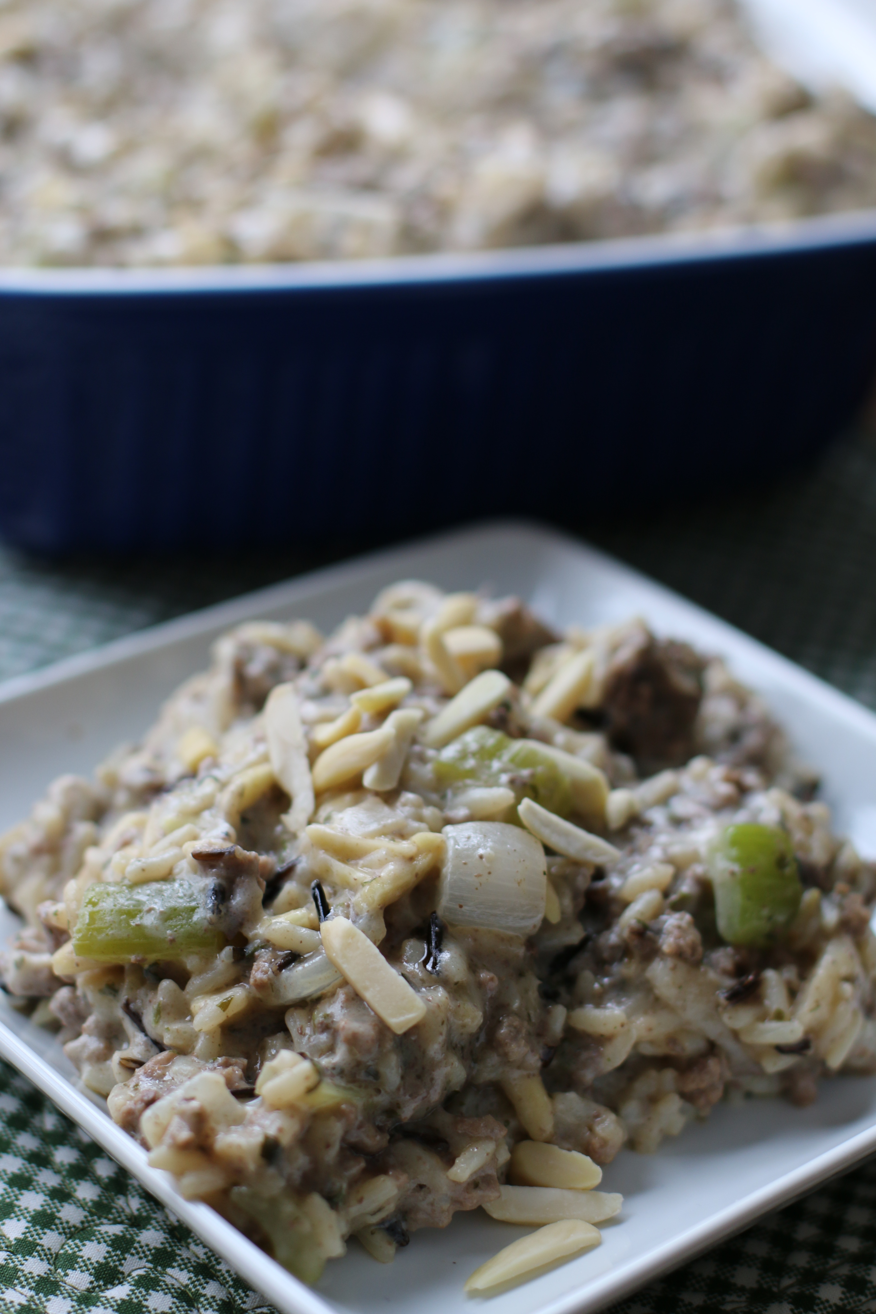

This dish has a wonderful combination of white and wild rice…great for a Sunday night dinner or potluck! I always make a double batch of this…everyone always wants to take leftovers home and we always want some leftover at home too!

INGREDIENTS:
1 C. uncooked white rice 1 can cream of celery soup
1 C. uncooked wild rice 1 tsp. salt
2 lbs. lean ground beef ¼ tsp. pepper
½ C. butter or margarine 1 (8 oz.) can sliced water chestnuts, drained
1 lb. (6 C.) fresh mushrooms, sliced 1 (2-1/2 oz.) pkg. slivered almonds
1 C. chopped celery
1 C. chopped onion
¼ C. soy sauce
1 can beefy mushroom soup
1 (8 oz.) carton dairy sour cream

DIRECTIONS:
Cook white rice following package directions for 10 minutes only; drain. Cook wild rice and drain.
Brown ground beef; set aside. Melt butter in skillet; sauté mushrooms, celery and onion until tender, about 5 minutes. Combine soy sauce, water, sour cream, soup, salt and pepper in large bowl. Stir in rice, ground beef, mushrooms, celery, onion, water chestnuts and half of almonds. Pour mixture into greased 3-quart casserole; sprinkle with remaining almonds. Refrigerate up to 4 hours. Bake, covered, in a 350 degree oven for 45 minutes; cover and bake until heated through, about 15 to 20 minutes longer. Makes 10 to 12 servings.

[NOTE: Uncle Ben’s Long Grain & Wild Rice (6.2 oz. pkg) makes 3 cups cooked rice.]

