banana bread cookies
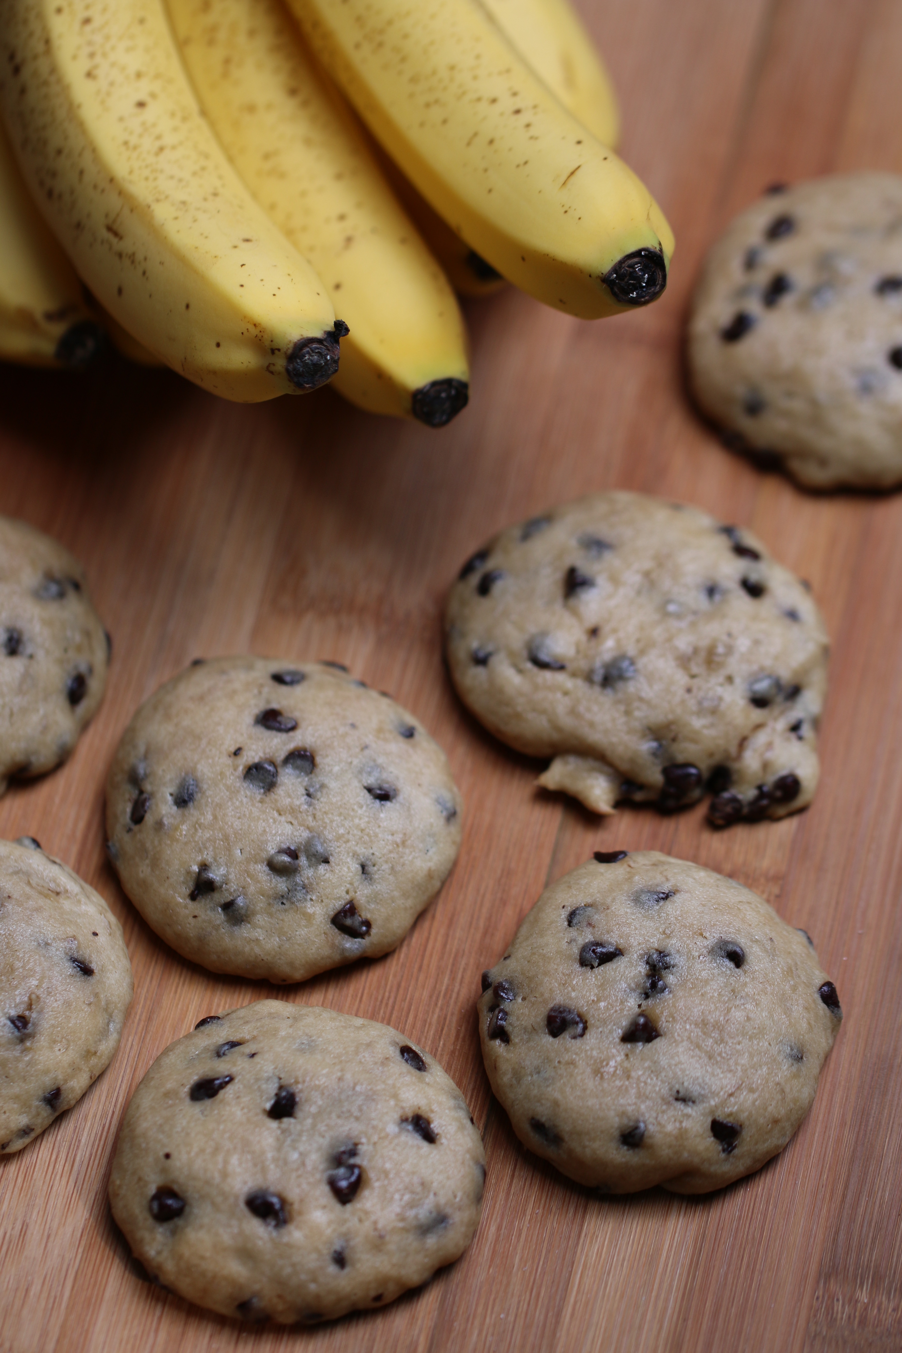

We can’t decide if these are more like Banana Bread Cookies or Banana Bread Muffin Tops. So soft and moist, and loaded with banana flavor and mini-chocolate chips. What’s not to love?!

INGREDIENTS:
1/2 cup butter (softened to room temperature)
1/2 cup sugar
1/2 cup brown sugar
1 egg (room temperature)
2 teaspoons vanilla extract
3/4 cup mashed bananas (about 2 large bananas or 3 small bananas)
1/2 cup sour cream or vanilla Greek Yogurt
2 1/2 cups flour
3/4 teaspoon baking soda
1/2 teaspoon baking powder
1/2 teaspoon salt
1/2 cup mini chocolate chips
1/2 cup pecans, chopped (optional)

HOW I MAKE THESE:
- In a medium bowl, mix the butter and sugars with a hand mixer until light and fluffy.
- Add the egg and vanilla, mixing well. Mix in mashed banana and sour cream.
- In separate bowl, combine flour, baking soda, baking powder and salt and whisk gently.
- Fold flour mixture into banana mixture, stirring just until blended.
- Fold in the chocolate chips and nuts. The cookie dough will be very moist.
- Refrigerate dough for at least one hour.
- Preheat oven to 350 degrees. Line cookie sheets with silicone baking sheets or parchment paper.
- Using a medium cookie scoop (1-1/2”) drop a scoop of dough onto cookie sheets, about two inches apart.
- Bake at 350 degrees for 12 minutes or until edges are just starting to turn golden. Do not overbake these! Remove cookies from oven and allow to sit on pan for five minutes before removing to cool. Cookies will get more moist as they sit.
- For something fun – make Banana Bread Cookie Moon Pies – use your favorite buttercream or cream cheese frosting to stick two cookies together, roll edge in mini-chocolate chips and serve.
- Store in a covered container in a cool location.
Yield: about 3 dozen
All writing, images, attachments and photography is Copyrighted 2010 by Snowflakes & Coffeecakes Cooking School - www.snowflakesandcoffeecakes.com - unless otherwise indicated. All rights reserved.

