bacon & vidalia onion quiche

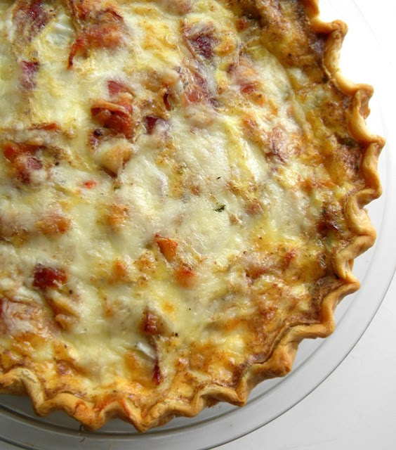

*This flavorful quiche is perfect for a brunch or to serve with a beef dinner!*

**INGREDIENTS:**

1 pie shell (homemade, frozen, or pre-made)  
6 slices Smoke Bacon, cooked crisp   
2 teaspoons olive oil   
1/2 large Vidalia Onion, sliced thinly   
3 green onions (scallions), chopped   
1/2 to 1 teaspoon white pepper   
4-6 ounces shredded Fontina cheese  
1/4 cup arugula leaves, finely chopped   
1 cup whipping cream   
4 extra large eggs   
1/2 teaspoon cinnamon   
1/2 teaspoon salt   
1/4 teaspoon ground pepper

**SERVINGS: 6**

**HOW WE MAKE THIS**:  
  
(1) Sauté bacon until crisp. Remove from heat and cool on paper towels. Break into thirds.   
  
(2) Sauté Vidalia onions and green onions in olive oil at medium heat until they turn limp and slightly brown/caramelized. Remove from heat and drain on paper towels.   
  
(3) Sprinkle (1/2 to 1) teaspoon of white pepper and 2 oz. shredded cheese on pie crust. Layer with finely chopped arugula.

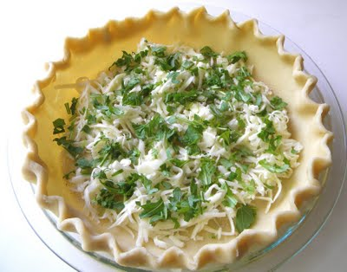

(4) Lay onions on top of arugula. Lay bacon on top of onions.

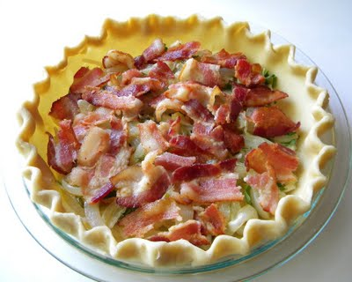

(5) Mix milk, eggs, and seasonings together. Pour into pie crust. Sprinkle egg mixture with remaining cheese.

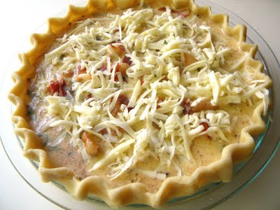

(6) Bake 35-40 minutes at 375 degrees F. until quiche is firm and lightly brown on top and crust.

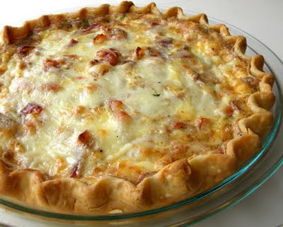

Allow to cool for a few minutes   
before cutting into slices and...

