avalanche bark
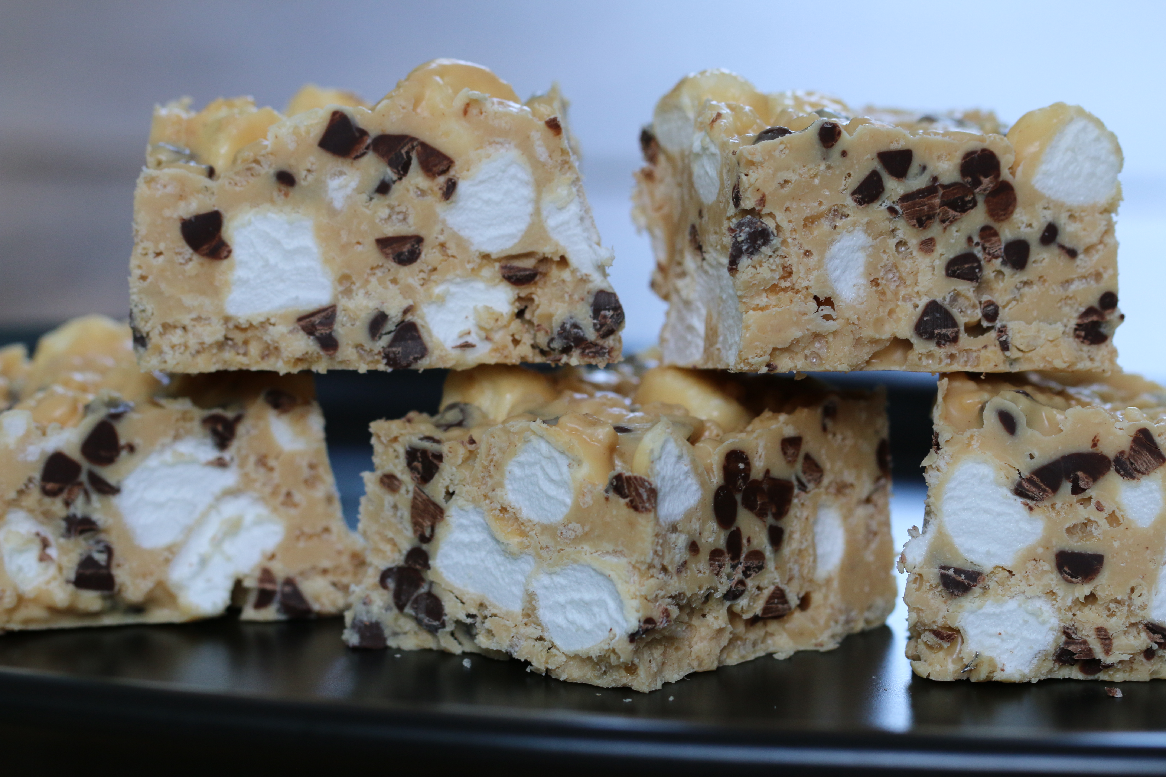

Re-creation of the treat made famous by Rocky Mountain Chocolate Factory – these are very similar to the White Chocolate Peanut Candies that are a family favorite!

INGREDIENTS:
12 ounces white chocolate, finely chopped
½ cup peanut butter
1½ cups Rice Krispies
1½ cups miniature marshmallows
½ cup miniature chocolate chips

DIRECTIONS:
- Line an 8-inch square pan with parchment paper or foil; set aside. Place the miniature chocolate chips on a plate and place in the freezer until ready to use.
- Combine the white chocolate and peanut butter in a mixing bowl and microwave on 50% power in one minute increments, stirring after each minute until completely melted and smooth.
- Remove from microwave and stir in Rice Krispies. Let the mixture sit and cool until it reaches room temperature, stirring occasionally, about 10 to 20 minutes.
- Gently stir in the miniature marshmallows, then the miniature chocolate chips.
- Place the mixture into the prepared pan and press into an even layer. Refrigerate until set, about 15 minutes.
- Remove from the pan and cut into squares. To store, keep in refrigerator in an airtight container.
Servings: 9 bars

All recipes, writing, images, attachments and photography is Copyrighted 2010-2014 by Snowflakes & Coffeecakes Cooking School - www.snowflakesandcoffeecakes.com - unless otherwise indicated. All rights reserved.

