TEXAS SHEET CAKE
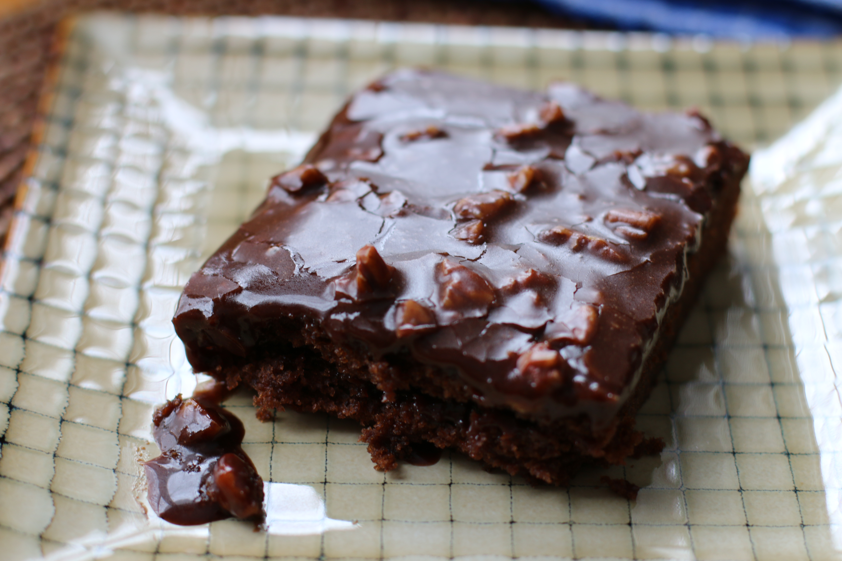

This is the best chocolate sheet cake ever!
For a change, substitute hot strong coffee for the hot water in the cake, and replace 2 tablespoons of the milk in the frosting with strong coffee that has been cooled down to room temperature.

Cake:
2 cups Flour
2 cups Sugar
1/4 teaspoon Salt
4 Tablespoons (heaping) Cocoa
2 sticks Butter
1 cup Boiling Water
1/2 cup Buttermilk
2 whole Beaten Eggs
1 teaspoon Baking Soda
1 teaspoon Vanilla

Frosting:
1/2 cup finely Chopped Pecans
1-3/4 stick Butter
4 Tablespoons (heaping) Cocoa
6 Tablespoons Milk
1 teaspoon Vanilla
1 pound (minus 1/2 Cup) Powdered Sugar

Instructions:
- In a mixing bowl, combine flour, sugar, and salt.
- In a saucepan, melt butter. Add cocoa. Stir together.
- Add boiling water, allow mixture to boil for 30 seconds, then turn off heat. Pour over flour mixture, and stir lightly to cool.
- In a measuring cup, pour the buttermilk and add beaten eggs, baking soda, and vanilla. Stir buttermilk mixture into butter/chocolate mixture.
- Pour into 18x13 jelly roll pan and bake at 350-degrees for 20 minutes.
- While cake is baking, make the icing. Chop pecans finely. Melt butter in a saucepan. Add cocoa, stir to combine, then turn off heat. Add the milk, vanilla, and powdered sugar. Stir together. Add the pecans, stir together, and pour over warm cake.
- Cut into squares, eat, and totally wig out over the fact that you’ve just made the best chocolate sheet cake. Ever.

Servings: 24

