Dijon Glazed Salmon
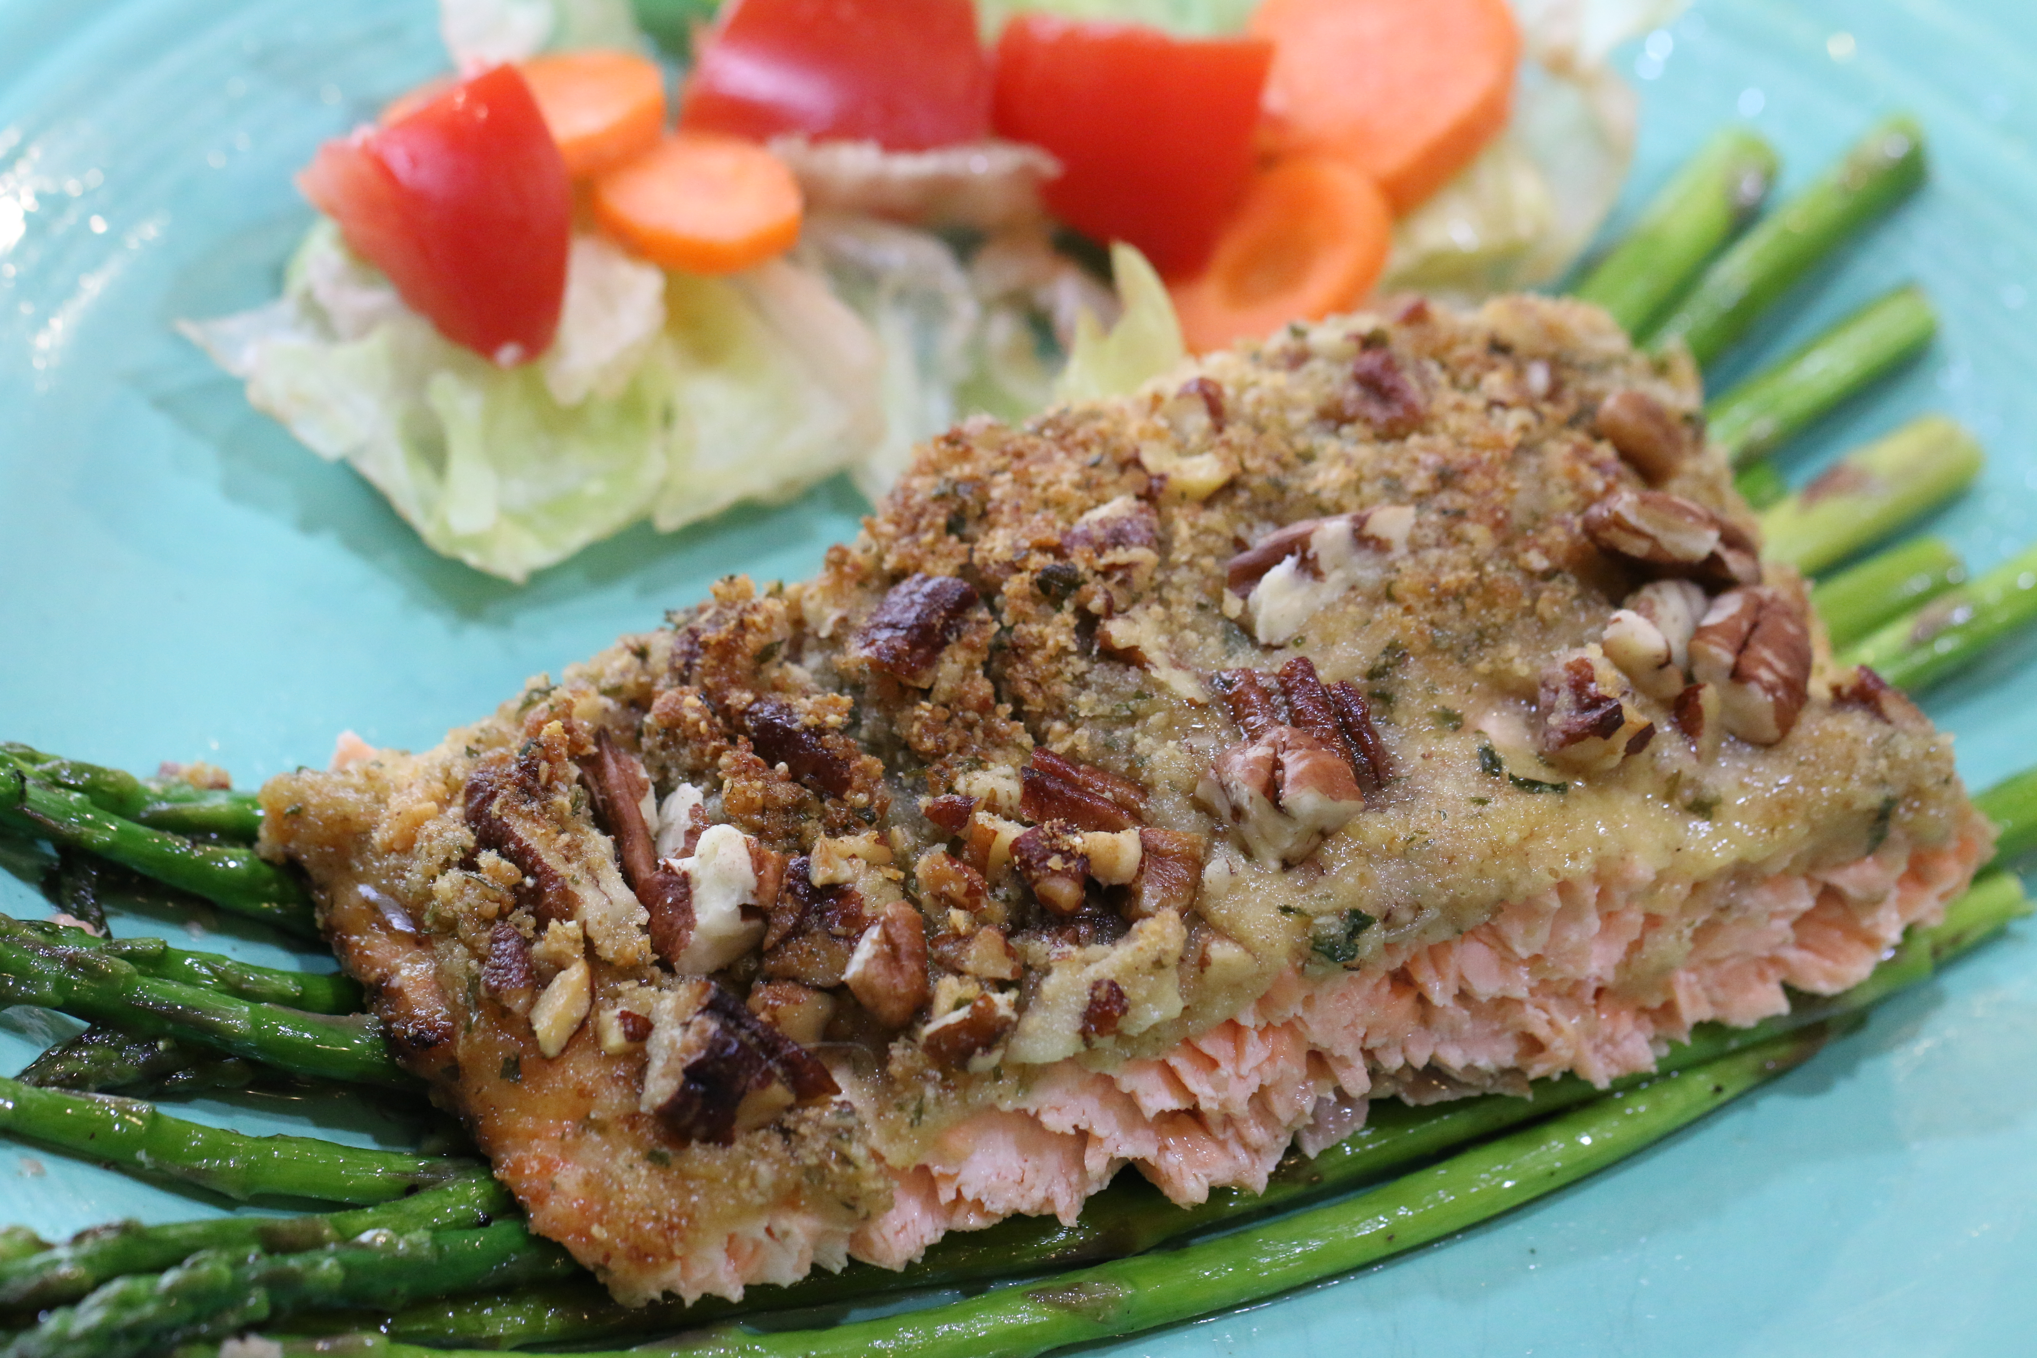

This is one of my favorite dishes from the Roadhouse Inn!

INGREDIENTS:
1/4 cup butter, melted
3 tablespoons Dijon mustard
1 1/2 tablespoons honey
1/4 cup dry bread crumbs (panko)
1/4 cup very finely chopped pecans
4 teaspoons chopped fresh parsley
4 (4 ounce) fresh salmon fillets
salt and pepper to taste
1 lemon
HOW I MAKE THIS:
- Preheat oven to 400 degrees.
- In a small bowl, stir together butter, mustard, and honey. Set aside. In another bowl, mix together bread crumbs, pecans, and parsley.
- Brush each salmon fillet lightly with honey mustard mixture. Sprinkle with salt and pepper. Next, sprinkle the tops of the fillets with the bread crumb mixture.
- Bake salmon 12 to 15 minutes in the preheated oven, or until it flakes easily with a fork. If your fillet is thick you may need to cook a few minutes longer.
- Drizzle with any leftover sauce and garnish with a wedge of lemon.

Servings: 4 filet

All writing, images, attachments and photography is Copyrighted 2010-2015 by Snowflakes & Coffeecakes Cooking School - www.snowflakesandcoffeecakes.com - unless otherwise indicated. All rights reserved.

