lactation COOKIES
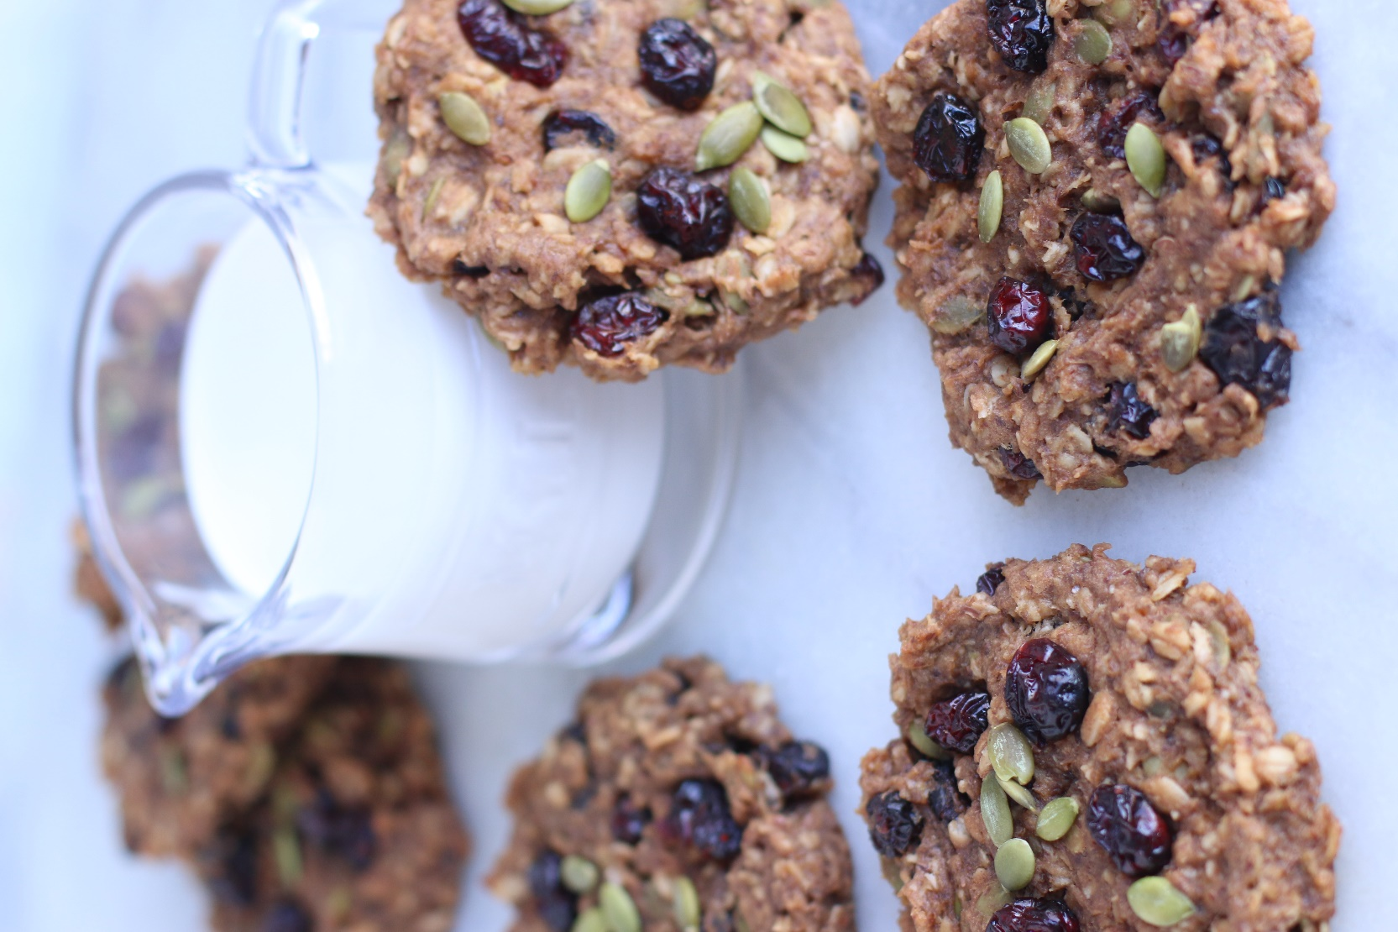

These healthy Lactation Cookies are so simple to throw together and new moms love them! Filled with wonderful natural ingredients and they taste amazing, too! They’re whole grain, all-natural, gluten-free, and vegan. Made without refined sugar, oil, or butter, these cookies are thick and chewy, and filled with flavor. Even non-nursing moms love these for quick and lasting energy.
INGREDIENTS:
2 cups (160g) old-fashioned whole oats
1/2 teaspoon salt
1 teaspoon ground cinnamon
1 cup (250g) peanut butter, almond butter, cashew butter or sunflower seed butter
1/4 cup (60ml) pure maple syrup (NOT pancake syrup) or honey
1/3 cup (60g) natural unsweetened apple sauce or apple butter
1 large ripe banana, mashed (about 1/2 cup)
1/3 cup (75g) raisins or chopped dates
1/3 cup (75g) dried cranberries or dried cherries
1/3 cup dark chocolate chips
1/3 cup (70g) pepitas (pumpkin seeds)
1/4 cup (28g) ground flax
3 Tablespoons brewers yeast
2 Tablespoons milk

HOW I MAKE THESE:
- Preheat oven to 325°F. Line 2 large baking sheets with parchment paper or silicone baking mats; set aside.
- In the bowl of a stand mixer, combine all of the ingredients (or use a hand mixer).
- Mix until all of the ingredients are combined. The dough will be thick and heavy.
- Using a 1/4 cup measuring cup, portion 1/4 cup mounds of cookie dough onto prepared cookie sheet.
- Use the back of a spoon or your fingers to slightly flatten out into a cookie shape. (These cookies will not spread in the oven.)
- Bake for 15-18 minutes or until the edges are slightly brown. Because of different ingredients you may use and different ovens, use your eyes – when the edges are lightly browned, they’re done!
- Remove from oven and cool cookies on the baking sheets for 10 minutes, then transfer to a wire rack to cool completely.
- Wrap cookies individually and store at room temperature for up to 5 days, in the refrigerator for up to 10 days, or freeze for up to 3 months.
YIELD: Makes 12 cookies.
RECIPE NOTES:
- Breakfast Cookies: Because toddlers and everyone else seems to love these cookies too, you can leave out the brewer’s yeast and milk and call them “Breakfast Cookies” – a great way to start the day with a quick and easy, on-the-go breakfast!
- Oatmeal: For best results, use whole oats (old-fashioned oats) for this recipe. Quick oats or instant oatmeal will not give you the same chewy texture and will result in a dryer cookie.
- Apple Butter: I love using apple butter in these breakfast cookies, but 1/3 cup of unsweetened applesauce works in its place.
- Nut Butter: Peanut Butter, Almond Butter, Cashew Butter or Sunflower Seed Butter
- Fruit Butter: Apple Butter, Pumpkin Butter or Unsweetened Applesauce are wonderful choices!
- Cookie Add-Ins: These cookies are easily customizable to your favorite cookie add-ins. For the perfect consistency and to hold their shape, keep add-ins to no more than 1-1/2 cups total.
- Dried Fruit: Raisins, Craisins or chopped Dates are all wonderful. I recommend dried fruit, rather than dehydrated or freeze-dried fruit for this recipe. Dried apples, strawberries and apricots are also tasty options.
- Nuts & Seeds: Pepitas (pumpkin seeds), sesame seeds, sunflower seeds, honey-roasted nuts, peanuts, pecans, or sunflower seeds all add nice crunch.
- Dark Chocolate Chips: Probably my most-requested add-in!
- Double Batch: The recipe can easily be doubled to make a bigger batch.
- Gluten Free: Use certified GF oats for gluten free cookies.
- Vegan: Use pure maple syrup (NOT pancake syrup) rather than honey to keep these cookies vegan.
- Freezing Instructions: I wrap each of these cookies individually before freezing. Cookies can be frozen up to 3 months. Thaw on the counter or in the refrigerator. Enjoy these cookies chilled, or bring to room temperature, or warm in the microwave for a few seconds before eating.

Originally published September 2019, revised & reposted January 2021.
© SnowflakesandCoffeecakes. All images, attachments & content are copyright protected. All rights reserved. Please do not use my images without prior permission. If you want to republish this recipe, please re-write the recipe in your own words, or link back to www.snowflakesandcoffeecakes.com for the recipe.

