MINT CHOCOLATE CHIP ICE CREAM BROWNIE COOKIES
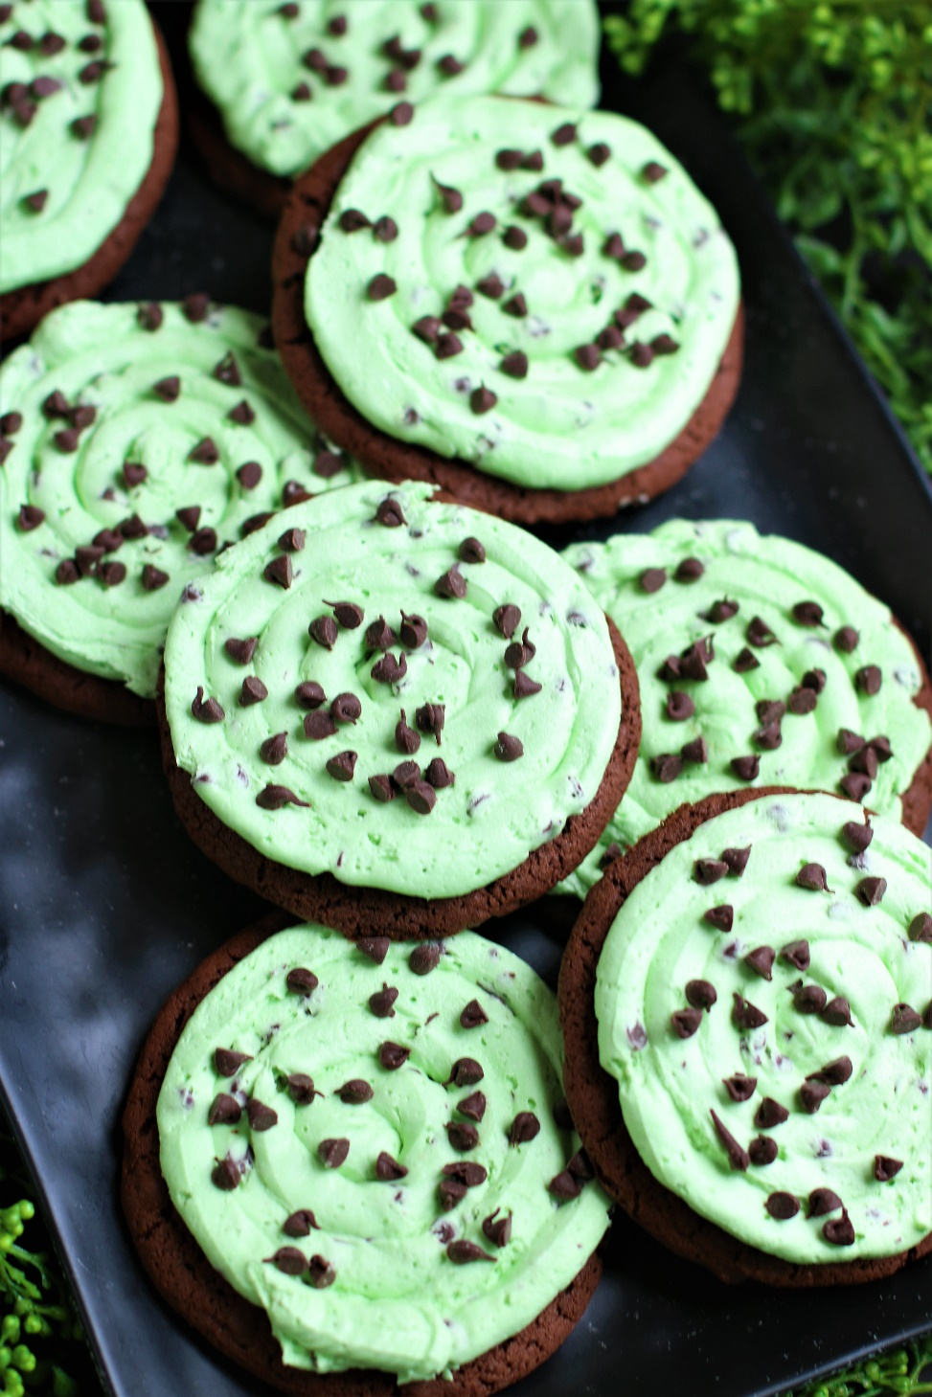

Mint Chocolate Chip Ice Cream Brownie Cookies are a fresh take on your favorite brownie cookies! With a thick chocolate cookie base and topped with a cool and refreshing mint ice cream buttercream frosting, you won’t be able to stop yourself from enjoying these! Inspired by Crumbl, these gourmet cookies are an indulgent treat that combines the classic flavors of chocolate and mint in a deliciously unique way. These cookies are perfect for anyone who loves the cool and refreshing taste of mint ice cream paired with rich, decadent chocolate - soft and chewy, with just the right amount of sweetness! So fast and easy to make, with a no-chill dough, it’s easy to see why these are always a favorite for special occasions and everyday treats!
INGREDIENTS:
CHOCOLATE COOKIE BASE:
1-1/2 cups (3 sticks) unsalted butter (softened)
3 large eggs (room temperature)
3-3/4 cups (450g) all-purpose flour
1 cup (100g) Dutch processed cocoa powder
2 tablespoons (15g) cornstarch
1 tablespoon (5g) milk powder
2 teaspoons baking soda
1 teaspoon salt
1-1/2 cups (319g) brown sugar (light or dark)
1/2 cup (100g) granulated sugar
1 teaspoon espresso powder
2 tablespoons corn syrup
1 tablespoon pure vanilla extract
1-1/2 cups semi sweet chocolate chips (or Andes Mint Chips)

MINT CHIP “ICE CREAM” BUTTERCREAM FROSTING:
12 tablespoons (6 ounces) unsalted butter (softened)
2 ½ cups (300g) powdered sugar
1-2 tablespoons heavy cream or half & half
¼ teaspoon pure peppermint extract
Mint green food coloring (gel style)
pinch salt
1 cup mini chocolate chips or Andes Mint Chips (divided)

HOW I MAKE THESE:
- Set eggs and butter out to come to room temperature (this helps them incorporate into the cookie dough better).
- Preheat oven to 350 degrees. Line baking sheets with parchment paper; set aside.
- PREPARE COOKIE BASE: In a medium bowl, whisk together the flour, cocoa powder, cornstarch, milk powder, baking powder and salt until well combined; set aside.
- In a large bowl using a hand-held mixer or stand mixer fitted with a paddle attachment, beat the butter, both sugars and espresso powder on medium speed until completely creamy and fluffy (about 3-4 minutes).
- Scrape down the sides and add in the eggs one at a time, beating well between until each is fully mixed in.
- Add corn syrup and vanilla extract; beat until well blended.
- Scrape down the sides and add in the flour mixture, ½ at a time, mixing just until blended; add remaining flour mixture and again mix just until blended.
- Fold in the chocolate chips and stir until evenly mixed. This cookie dough will be really soft and creamy!
- Using a large cookie scoop (3 Tablespoon size), scoop out cookie dough and roll into a ball with your hands. Repeat with remaining dough.
- Place six cookie dough balls on each baking sheet, leaving room between each cookie as the cookies will spread when they bake.
- Flatten the cookie dough balls by pressing gently with your hand to about ¾-inch thickness.
- Bake for 12-14 minutes or until the centers of the cookies have puffed up and are no longer glossy. Every oven is a little bit different, so watch your first batch when baking and time accordingly. DO NOT OVERBAKE, as these will lose their softness.
- Remove from oven and allow cookies to cool on the baking sheets.
- PREPARE MINT CHIP ICE CREAM BUTTERCREAM FROSTING: In the bowl of a stand mixer fitted with a paddle attachment, add softened butter, beating until light and fluffy.
- Add powdered sugar and slowly mix until well blended. Add peppermint extract and half & heavy cream (or half & half) and beat on medium until light, fluffy and well combined, scraping down the sides of the bowl as necessary.
- Add additional half & half or heavy cream, 1 tablespoon at a time, until frosting is piping consistency. If your frosting is too thin, add a little bit of powdered sugar and beat until light and fluffy. Stir in ½ cup of mini chocolate chips (or Andes Mint Bits).
- FROST & DECORATE: Spoon frosting into a large piping bag fitted with a large round tip.
- Once cookies have reached room temperature, pipe the frosting onto cookies, starting in the center of the cooking and piping in a circular motion until the cookie is covered evenly.
- Sprinkle remaining mini chocolate chips (or Andes Mint Chips) on top of frosting.
- Once the cookies have completely cooled, chill in the fridge until ready to serve. Allow decorated cookies to set completely before storing – keep parchment paper between each layer or place cookies in individual self-sealing bags for easy freezing and serving.
- These cookies are best served slightly chilled. Remove from the fridge 10-15 minutes before serving so that the buttercream has a few minutes to soften to the perfect texture. You can also serve these directly from the refrigerator if you prefer chilled cookies.
YIELD: Makes 30 (four-inch) cookies
RECIPE NOTES:
WEIGH INGREDIENTS CAREFULLY FOR BEST RESULTS: If I can only share one baking secret with you, always use a DIGITAL KITCHEN SCALE. You can use measuring cups and spoons for most recipes, but using a digital scale makes for the more consistent and efficient baking. Take this from someone that bakes A LOT!
PURE MINT EXTRACT: I recommend using pure “peppermint” extract throughout the recipe because “mint” extract has a tendency to taste like spearmint toothpaste. Taste and add additional extract until you reach the flavor profile you want!
TO KEEP THESE COOKIES SOFT: These cookies will stay soft and fresh for up to 5 days in an air-tight container kept in the refrigerator.
MAKE AHEAD TIP: Baked and frosted cookies freeze well for up to 1 months. You can also bake the cookies and freeze UNFROSTED for up to 2 months – simply defrost and then frost before you plan on serving.
BEFORE FREEZING: With frosted cookies, it’s important to freeze the cookie prior to placing them into a container so that the frosting remains intact. Place all frosted cookies on a parchment paper lined baking sheet and pop it in the freezer. Once the icing is set and hard (usually an hour) or the cookies are frozen solid, the cookies can be frozen in containers with parchment paper between layers.
HOW TO THAW FROSTED COOKIES: For frosted cookies or “served chilled” cookies, thaw them in the fridge and NOT at room temp. For chilled cookies, you need to maintain refrigeration throughout the thawing process up until the time you eat the cookie for food safety. To keep your cookies from getting soggy and frosting from losing its shape and texture, remove from the freezer and place the unopened container in the refrigerator overnight to thaw. Cookies that are not frosted can thaw overnight UNOPENED on your kitchen countertop.
FOR PARTIES: I package cookies individually in self-sealing clear cellophane cello bags (Pack It Chic are my favorite brand). Make sure cookies are completely set after decorating before packaging. To make ahead, place individually wrapped and sealed cookies in a larger airtight container and refrigerate or freeze. Thaw frozen cookies unopened in the refrigerator - you are trying to minimize moisture during defrosting, which can cause your frosting to soften too much and loose detail.
Original recipe created by Snowflakes & Coffeecakes; published April 2023.
© SnowflakesandCoffeecakes. All images, attachments & content are copyright protected. All rights reserved. Please do not use my images without prior permission. If you want to republish this recipe, please re-write the recipe in your own words, or link back to www.snowflakesandcoffeecakes.com for the recipe.

Tried it and loved it? Snap a picture and share it with me on Instagram @SnowflakesandCoffeecakes and by using the hashtag #SnowflakesandCoffeecakes.

