crumbl banana cream pie cookies
(COPYCAT RECIPE)
\
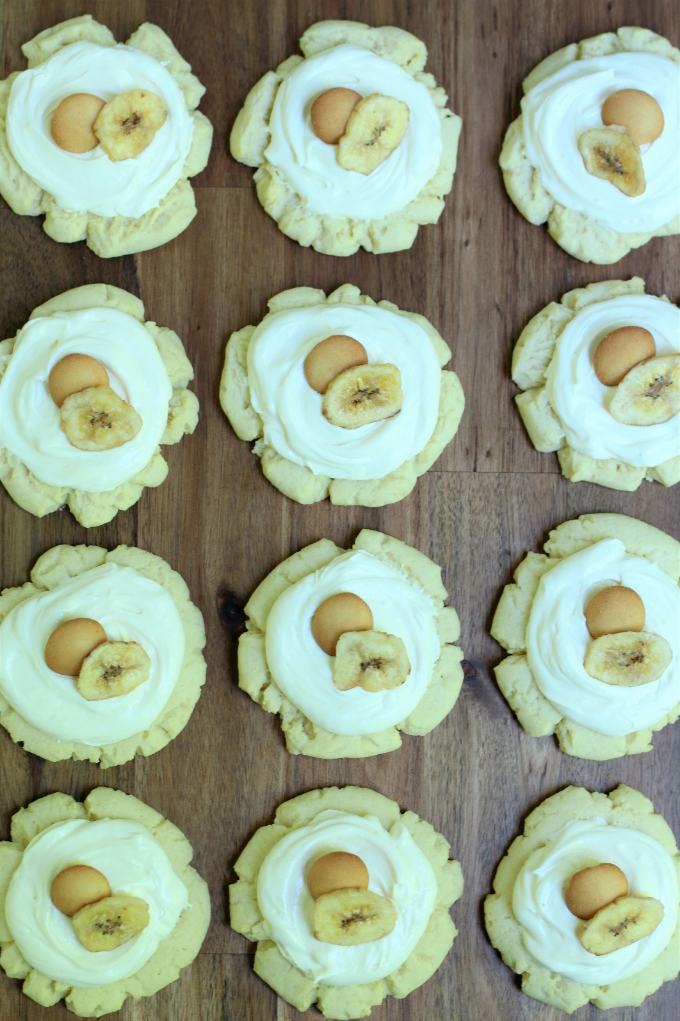

If you are a lover of southern Banana Cream Pudding or Crumbl cookies, these Crumbl Banana Cream Pie Cookies are for you! Start with a soft and tender sugar cookie, fill with a thick swirl of silky rich banana cream pie filling, and top with tiny vanilla wafer cookies and a slice of sweet banana. If that description doesn’t convince you to make these cookies, I don’t know what will!
Super soft, chewy and buttery, the cookie is amazing all by itself, but the banana cream pie filling is truly better than any banana cream pudding you’ve ever had - you may be tempted to eat it with a spoon! I get so many requests to create Crumbl copycat cookies – but this flavor is one of the most requested, and after one bite you’ll understand why! The flavors in this cookie are amazing and work so well together – overall this is simply a fantastic cookie!
INGREDIENTS:
SUGAR COOKIE BASE:
1 cup (260g) unsalted butter (softened)
2 large eggs (room temperature)
2/3 cup (150g) vegetable or canola oil
1 cup (200g) granulated sugar
½ cup (60g) powdered sugar
2 teaspoons pure vanilla extract
2 teaspoons butter vanilla emulsion
4-2/3 cups(550g) all-purpose flour
2 tablespoons cornstarch
1 tablespoon milk powder
2 teaspoons baking powder
½ teaspoon salt

BANANA CREAM PIE FILLING:
8 oz. full fat cream cheese (room temperature)
1 package instant banana cream pudding mix
1 can (14 oz.) sweetened condensed milk
1 teaspoon pure vanilla extract
8 oz. Cool Whip (refrigerator temperature)

GARNISH:
Nabisco Nilla Wafers (regular size or miniature)
Fresh banana slices (if serving immediately) or
Banana Chips or Freeze-Dried Bananas (if serving later)

HOW I MAKE THESE:
- Set eggs, butter and cream cheese out to come to room temperature.
- Preheat oven to 350 degrees. Line baking sheets with parchment paper; set aside.
- PREPARE COOKIES: In a medium bowl, whisk together the flour, cornstarch, milk powder and salt; set aside.
- In a large bowl using a hand-held mixer or stand mixer fitted with a paddle attachment, beat the butter, oil, and both sugars on medium speed until completely creamy and fluffy (about 3 minutes).
- Scrape down the sides and add in the eggs one at a time, beating well between each is fully mixed in and incorporated.
- Add vanilla extract and butter vanilla emulsion; beat until well blended.
- Scrape down the sides and add in the flour mixture, ½ at a time, mixing just until blended; add remaining flour mixture and again mix just until blended. This cookie dough will be really soft and creamy!
- Using a large cookie scoop (3 Tablespoon size), scoop out cookie dough and roll into a ball with your hands. Repeat with remaining dough.
- Place six cookie dough balls on each baking sheet, leaving room between each cookie as the cookies will spread when they bake.
- Flatten the cookie dough by gently pressing the bottom of a drinking glass or measuring cup into the center of each, and press down gently to create a small indentation. To keep your glass from sticking to the cookie dough, it works best to dip the bottom in flour before pressing each cookie. Any flour left behind will “melt” into the cookie as it bakes – not to worry!
- Bake for 11-13 minutes or until the centers of the cookies have puffed up and are no longer glossy. Every oven is a little bit different, so watch your first batch when baking and time accordingly. DO NOT OVERBAKE, as these will lose their softness.
- Remove from oven and allow cookies to cool on the baking sheets.
- PREPARE BANANA CREAM PIE FILLING: In the bowl of a stand mixer fitted with a paddle attachment, add room temperature cream cheese, banana pudding mix and beat on medium speed until light and fluffy.
- Add sweetened condensed milk and vanilla extract and continue beating until fluffy and well blended.
- Remove Cool Whip from the refrigerator and gently fold into the filling just until well blended, scraping down the sides and bottom of the bowl as necessary – DO NOT OVERMIX! Cover and refrigerate until ready to assemble cookies.
- FROST & DECORATE: Once cookies have cooled to room temperature, spread the Banana Cream Pie Filling on the cookies and swirl the top slightly with the bottom of a spoon to give it a nice, smooth finished look.
- Right before serving, top each cookie with nilla wafers (regular size or miniature) sprinkle with nilla wafer cookie crumbs. I like to add a slice of fresh banana if serving right away, or if preparing ahead of time you can top with Banana Chips or Freeze-Dried Bananas. You can typically find these at your local market, or order from https://www.nuts.com.
- These cookies are best served chilled – cover and store in the refrigerator until ready to serve. Banana Cream Pie Cookies can be stored in an air-tight container in the refrigerator for up to 4 days.
YIELD: Makes 24 (four-inch) cookies
RECIPE NOTES:
HOW TO STORE THESE COOKIES: The filling for these cookies has cream cheese in it, so keep all extra cookies in the fridge! Store them in a sealable container, and they’ll stay fresh and good in the fridge for up to4 days - if they even last that long!
TO KEEP THESE COOKIES SOFT: These cookies will stay soft and fresh in an air-tight container refrigerated for up to 4 days.
MAKE AHEAD TIP: Baked and frosted cookies freeze well for up to 1 month. Thaw overnight UNOPENED in your refrigerator. Garnish with vanilla wafers and banana slices right before serving.
Original recipe created by Snowflakes & Coffeecakes; published June 2022.
© SnowflakesandCoffeecakes. All images, attachments & content are copyright protected. All rights reserved. Please do not use my images without prior permission. If you want to republish this recipe, please re-write the recipe in your own words, or link back to www.snowflakesandcoffeecakes.com for the recipe.

Tried it and loved it? Snap a picture and share it with me on Instagram @SnowflakesandCoffeecakes and by using the hashtag #SnowflakesandCoffeecakes.

