LOBSTER RAVIOLI
WITH CRAB ALFREDO SAUCE
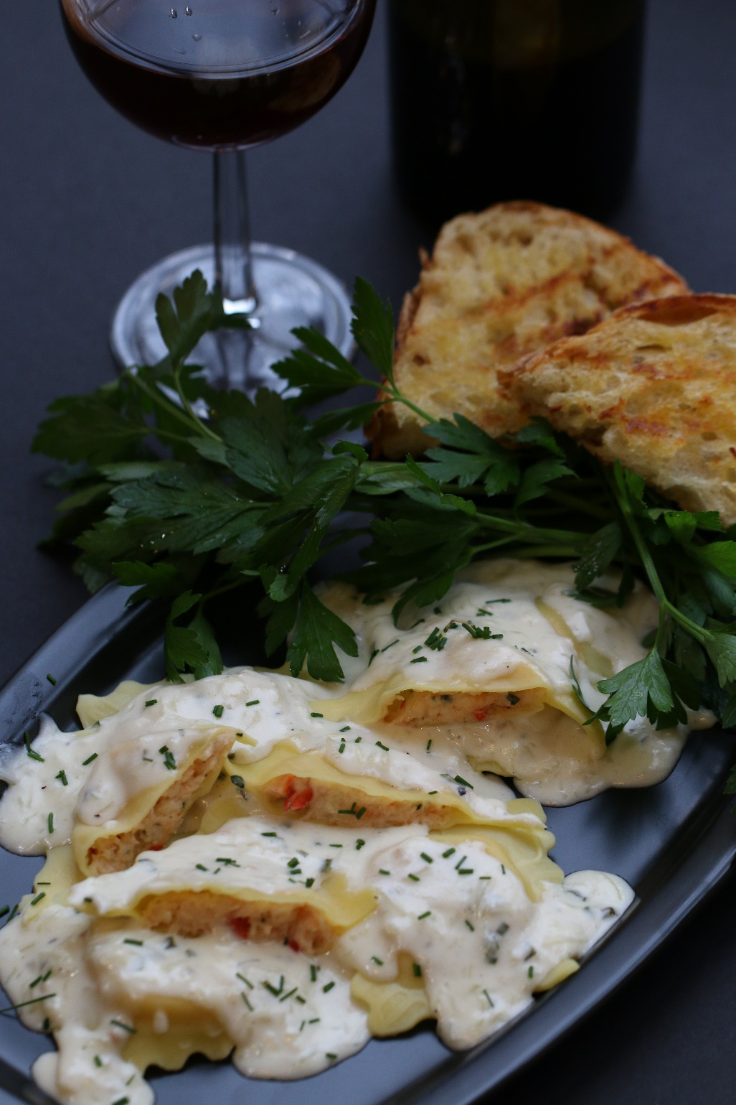

For a REALLY special dinner, Lobster Ravioli with creamy Crab Alfredo Sauce is the way to go! My family will do just about anything for this fabulous dinner – often requested for birthday celebrations and special events.
INGREDIENTS:
Lobster Filling:
1 tablespoon olive oil
1 tablespoon butter
1-2 shallots, chopped
2 tablespoons cognac
¼ cup white wine (Sauvignon Blanc)
1 pound cooked lobster meat (chopped)
2 tablespoons chopped fresh chives, basil or parsley
¼ cup finely grated Parmigiano-Reggiano cheese
1 pound mascarpone or ricotta cheese
1 large egg (beaten)
Pinch of fresh grated nutmeg
Salt & Pepper to taste

Ravioli Pasta:
1 cup semolina flour
2 cups all purpose flour
4 large eggs (room temperature)
1 tablespoon Extra Virgin Olive Oil

Sauce:
1 stick (8 oz.) unsalted butter
2 cups heavy cream
2 Tablespoons cream cheese
1 tsp minced garlic in olive oil
¼ tsp fresh black pepper
1-1/4 cup freshly grated Parmesan cheese
1 cup finely chopped crab meat
For Garnish: Fresh grated Parmesan Cheese and fresh Chives

HOW I MAKE THIS:
- Prepare Lobster Filling: In a large saute pan, heat butter and olive oil. Add shallots and cook until soft and translucent, about 3 minutes.Add cognac and white wine, cook until reduced to a syrup-like consistency. Remove pan from heat and allow mixture to cool.
- Once cooled, in a medium bowl combine the mascarpone (or ricotta) and beaten egg. Stir in the lobster meat, chives, parmesan cheese and nutmeg, and season with salt and pepper. Taste and adjust seasoning if necessary.
- Prepare Pasta Dough: Sift flours. Combine flour and salt, and mound on a work surface. Make a well in the center and add the eggs and olive oil. Carefully, beat the eggs with a fork until well mixed. Gradually begin incorporating the flour into the egg mixture with the fork. When enough of the flour has been incorporated so that the dough can be worked by hand, begin kneading the dough, adding more flour to prevent the dough from becoming too sticky. Knead vigorously for about 10 minutes, or until the dough is smooth and satiny to the touch, and when cut in half, is completely smooth, with no air holes or gluten strands visible. Wrap the dough in plastic and allow to rest at room temperature for 30 minutes in order to relax the gluten.
- To roll homemade pasta sheets: using a wooden rolling pin or pasta roller, roll out pasta into thin sheets (about 1/8”-inch thick). Make sure to flour your counter or rolling surface.
- Lay one pasta sheet out on floured counter. Add about a tablespoon and a half of filling a couple of inches apart. Using a pastry brush, wet the area around the filling with egg wash (1 egg and 1 tablespoon water). Top off with another pasta sheet. Around each mound of filling, press out on the wet area, making sure there are no air pockets in the filling. Cut each ravioli out with a pizza or pie crust roller. Make sure that the edges of each ravioli are completely sealed (use additional egg wash if necessary to make them stick together). Lay the completed ravioli on a parchment-lined baking sheet and continue making ravioli until you’ve used all the lobster filling. Make sure to cover the raviolis as you work. At this point you can freeze the raviolis for later use, if you are making these in advance
- Prepare sauce: In a large shallow saucepan, combine the butter and garlic, saute for 2 minutes. Add the heavy cream and cream cheese. Simmer until melted and just beginning to thicken, stirring constantly. Stir in the crab meat. Remove from heat and stir in grated cheese and fresh black pepper.
- Meanwhile, in a large shallow pot of boiling water, carefully slide in the raviolis. Cook the raviolis just until they float up to the to (al dente) – about 8 to 10 minutes if using fresh ravioli, 12 minutes if using refrigerated and 15 minutes for frozen. Remove raviolis with a slotted spoon and lay on paper towels to absorb excess water. Place cooked raviolis on a dinner plate, spoon sauce over top and garnish with additional grated Parmesan cheese and fresh snipped chive. Serve immediately!
YIELD: about 24 ravioli
NOTE: You can substitute wonton wrappers (1 pkg) for the pasta dough if you are in a hurry! To prepare this way, clear some counter space and layout the wonton wrappers. Brush with egg wash, and then place a heaping teaspoon of the lobster filling in the middle of half of the wontons. Next, cover with another wonton wrapper, and seal by wetting your fingertips with water, rubbing the edges of the wontons and pressing them together. While doing this, make sure to press out any air bubbles. Repeat until you have used all the wontons. You will have leftover filling. When ready to eat, boil the ravioli in salted water until they float to the top.

© SnowflakesandCoffeecakes. All images, attachments & content are copyright protected unless otherwise indicated. All rights reserved. Please do not use my images without prior permission. If you want to republish this recipe, please re-write the recipe in your own words, or link back to www.snowflakesandcoffeecakes.com for the recipe.
