make-ahead turkey gravy
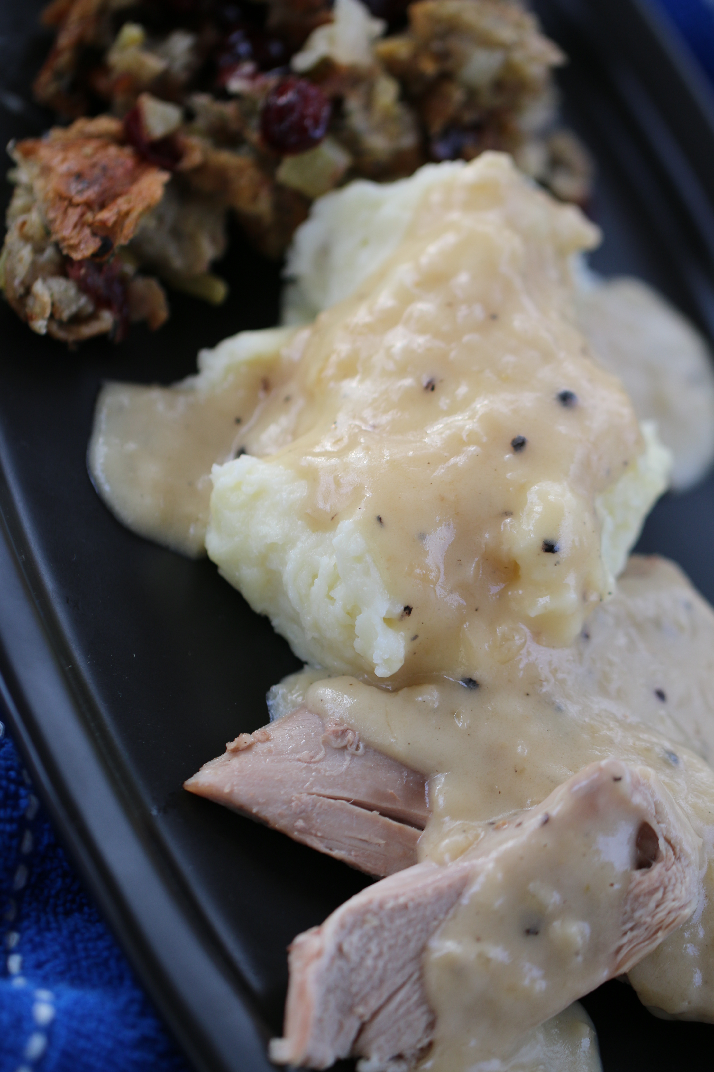

This is a fabulous and savory homemade turkey gravy – a creamy and flavorful gravy that is so easy to make ahead of time – and eliminate the last minute craziness when you preparing to serve a homemade and HOT turkey dinner and you don’t want to be slaving over the stove at the very last minute straining and whisking lumps out of turkey drippings!

INGREDIENTS:
½ cup unsalted butter
1-1/2 cups finely chopped yellow onion
¼ cup all-purpose flour
1 teaspoon kosher salt
½ tsp. black pepper (freshly ground)
2 cups turkey or chicken stock, heated
2 tsp. Better Than Bouillon Turkey or Chicken Base
1 tablespoon Cognac, Brandy or cooking sherry (optional)
1 tablespoon heavy cream

HOW I MAKE THIS:
- In a large saute pan (10 to 12 inch), melt butter over medium-low heat. Add onions and cook for 12 to 15 minutes, until the onions are lightly browned.
- Sprinkle the flour evenly over top of sautéed onions, whisk in, and then add salt and pepper. Cook for 2 to 3 minutes.
- Slowly whisk in the hot turkey/chicken stock, bouillon and cognac.
- Cook uncovered for 4 to 5 minutes, whisking gently until thickened. Add the cream and whisk well.
- You can either serve warm, or store in refrigerator overnight. Warm over low heat, whisking gently. If you need to thin before serving, stir in a splash or two of turkey/chicken stock.
© SnowflakesandCoffeecakes. All images, attachments & content are copyright protected unless otherwise indicated. All rights reserved. Please do not use my images without prior permission. If you want to republish this recipe, please re-write the recipe in your own words, or link back to www.snowflakesandcoffeecakes.com for the recipe.


