scalloped potatoes & ham
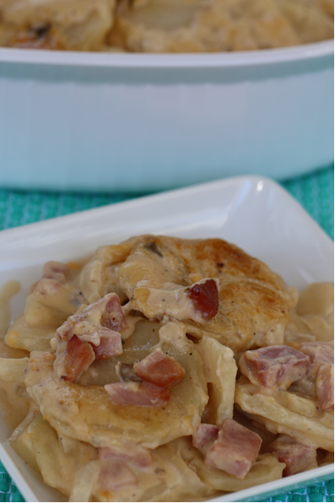
This wonderful dinner is not just for Easter leftovers!
Wonderful comfort food on a cold winter evening.

INGREDIENTS:
5-6 large Russet or Yukon Gold Potatoes (peeled)
2 Tablespoons Butter
1 large sweet onion, sliced
3 cups Diced Ham
2 Tablespoons Butter
¼ cup flour
2 cups Half-and-half
1-1/2 cup Heavy Cream
1 can Cream of Mushroom Soup
Black Pepper
1 cup Grated Cheddar Cheese
1 cup Grated Monterey Jack Cheese
Chopped Parsley (optional)

DIRECTIONS:
- Preheat oven to 350 degrees. Spray a large casserole dish with non-stick spray.
- Using a mandoline or slicer, slice potatoes and onions into 1/8-inch slices (very thin.)
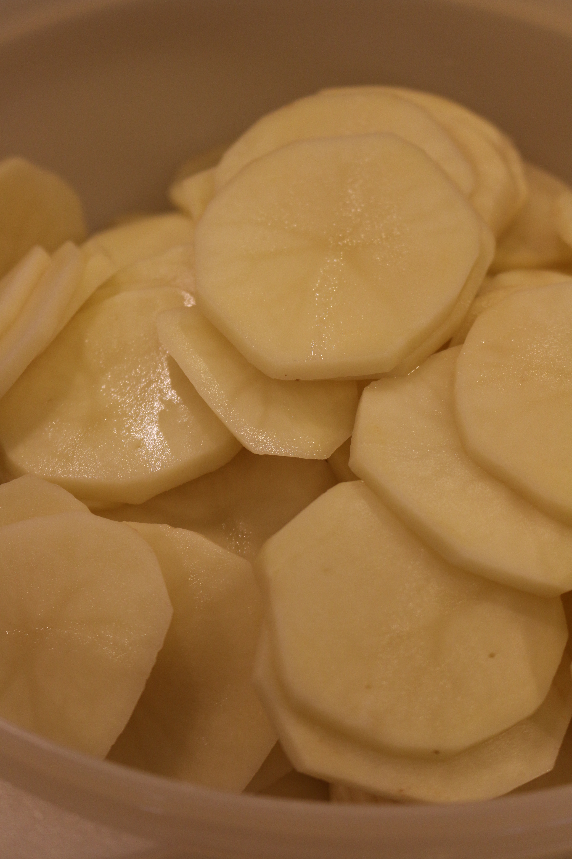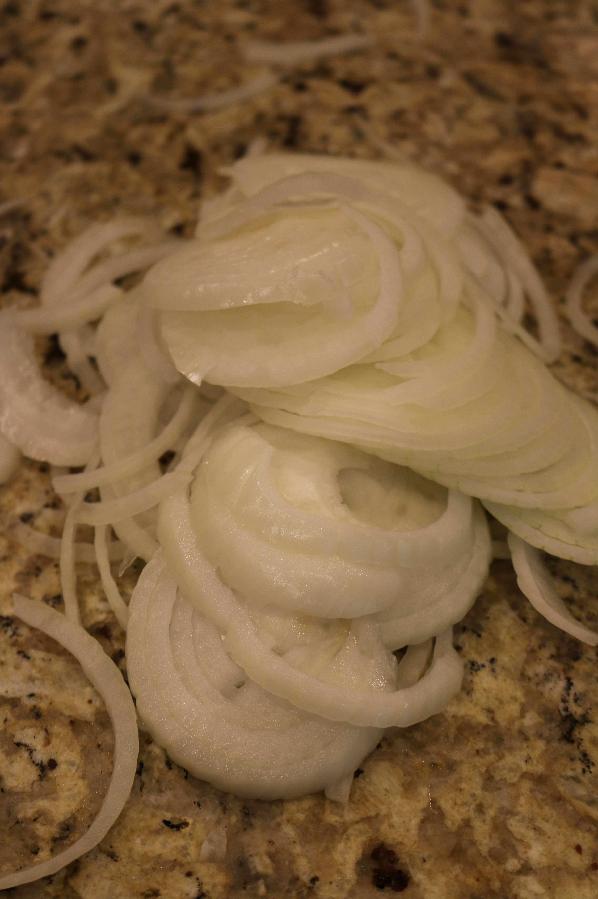

- Dice ham; set aside.
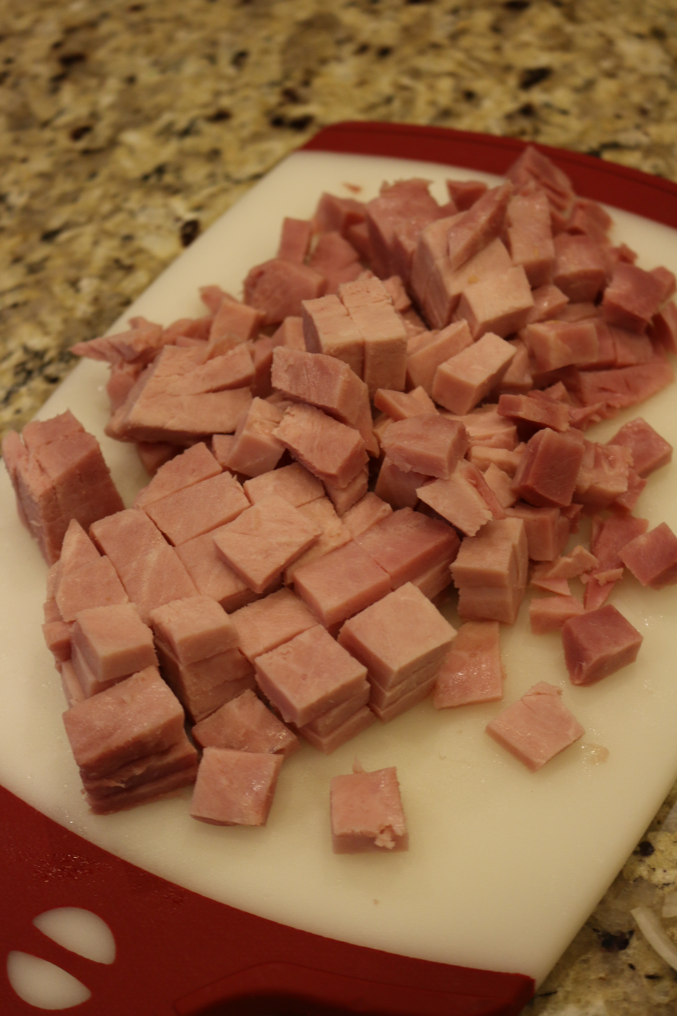
- Heat butter in a large skillet. Add onions and cook for 1 to 2 minutes, or until they start to turn translucent. Add ham and cook for 3 to 4 minutes until thoroughly heated. Remove from heat and set aside.
- In a heavy saucepan, melt 2 tablespoons of butter; whisk in ¼ cup flour, stirring constantly for one minute. Slowly whisk in half-and-half, cream, mushroom soup and black pepper until totally combined. Heat until mixture just begins to simmer and thicken. Remove from heat and stir in cheese, stirring until melted and well blended.
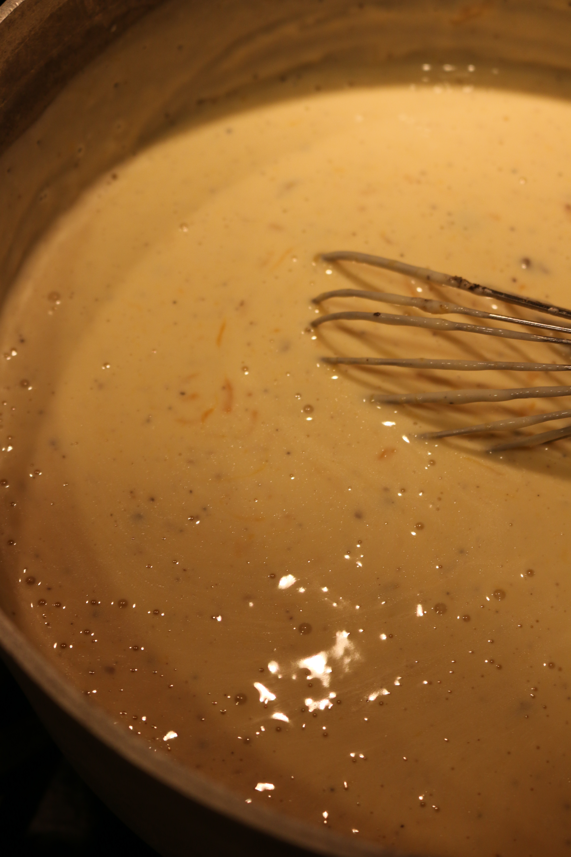
- Place a thin layer of sauce on bottom of casserole. Layer 1/3 of the potato slices in the buttered casserole dish. Sprinkle on 1/3 of the ham/onion mixture, then ¼ of the sauce mixture.
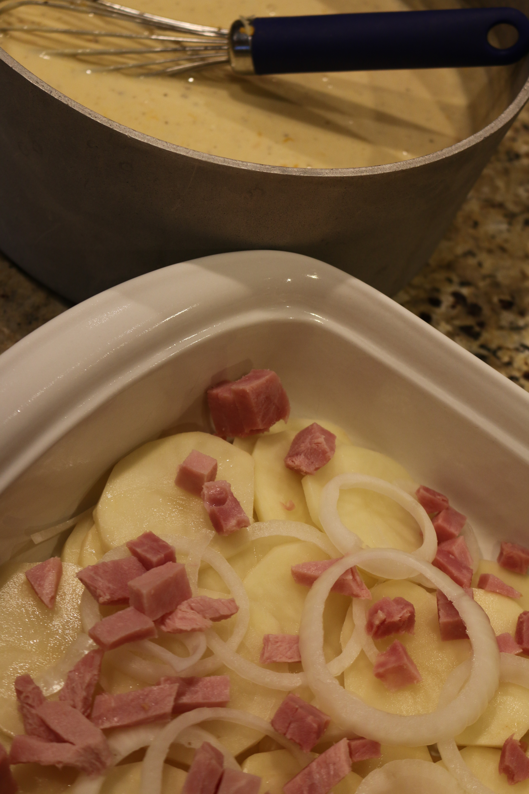
- Repeat this twice more, ending with the rest of the cream mixture. Cover dish with foil and bake for 60 minutes. Remove the foil and bake for an additional 30 minutes at least, or until bubbly and hot.
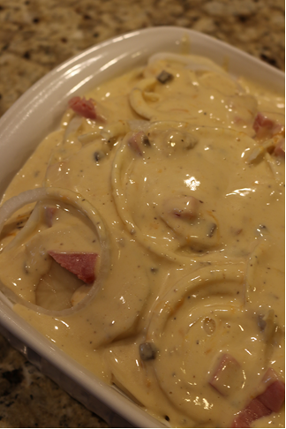

- Sprinkle on chopped parsley before serving. Cut into squares and serve.
Yield: 12 Servings


