salted caramel apple pie
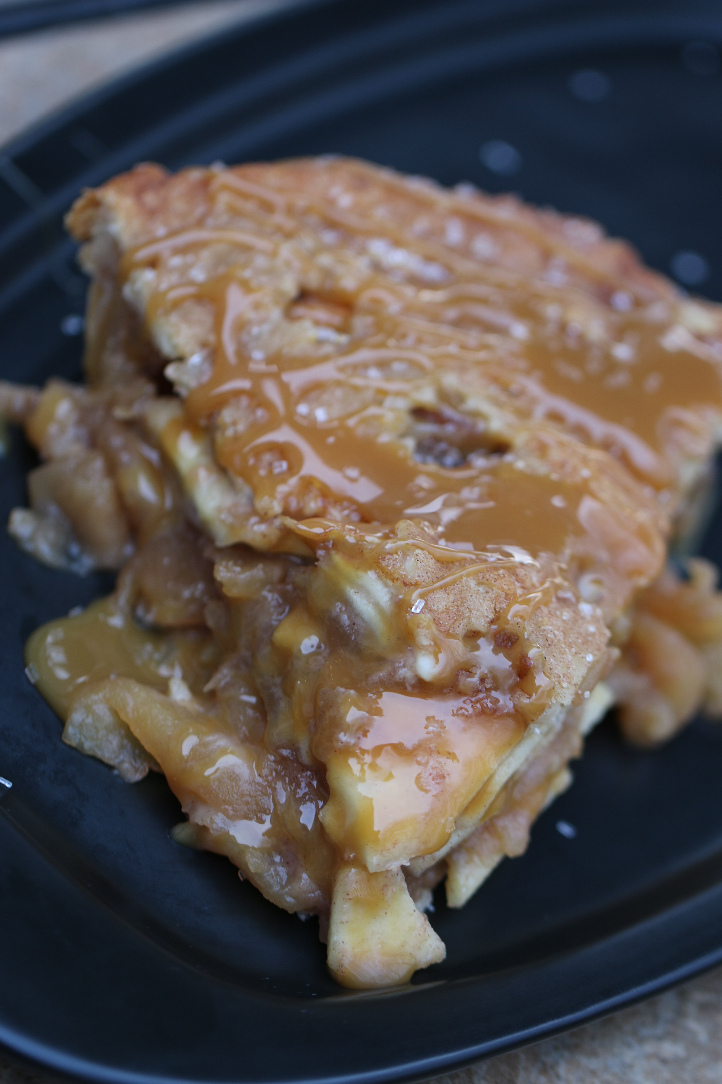

This is a classic deep dish lattice-topped all American apple pie – bubbling with salted caramel and tender, cinnamon apples! Perfect by itself, or topped with vanilla bean ice cream and drizzled with more Salted Caramel Sauce!

INGREDIENTS:
Pie Crust:
1-1/4 cups (6-1/4 oz) all-purpose flour
1 tablespoon granulated sugar
½ tsp salt
6 tablespoons COLD unsalted butter (cut into ¼ inch pieces and chilled)
4 tablespoons Crisco vegetable shortening (cut in half and chilled)
2 tablespoons vodka (chilled)
2 tablespoons ice water

Filling:
2 teaspoons fresh lemon zest
1/4 cup fresh lemon juice
2-1/2 lbs Granny Smith apples (cored, peeled & thinly sliced – about 5 cups)
2-1/2 lbs Bradburn or Honey Crisp apples (cored, peeled & thinly sliced – about 5 cups)
¼ tsp salt
1/8 teaspoon ground cloves
1/8 teaspoon ground nutmeg
1 - 1/2 teaspoons ground cinnamon
1/2 cup granulated sugar
14 cup light brown sugar (packed)
½ tsp grated lemon zest plus 1 tablespoon lemon juice
1/4 cup all-purpose flour
1/2 cup Homemade Salted Caramel Sauce
1 large egg white (room temperature) beaten
Sprinkling or coarse sugar for topping
½ cup Homemade Salted Caramel Sauce (garnish)

HOW I MAKE THIS:
- IF USING A READY-MADE PIE CRUST, SKIP TO STEP 6.
- MAKE PIE CRUST: Process ¾ cup flour, sugar and salt in food processor until combined, about 5 seconds. Sprinkle butter and shortening on top and continue processing until mixture begins to form uneven clumps with no remaining floury bits (about 10 seconds).
- Scrape down sides of bowl and redistribute dough around blade. Sprinkle remaining ½ cup flour over dough and pulse until mixture is evenly distributed into pieces around bowl (4 to 6 pulses).
- Transfer mixture to medium bowl. Sprinkle vodka and ice water over mixture. Using stiff silicone spatula, stir and press down until it sticks together.
- Turn pie dough onto sheet of plastic wrap and shape into round 4-inch shape. Wrap tightly in plastic and refrigerate for at least 1 hour or up to 2 days.
- Remove dough from refrigerator and allow to soften slightly (about 10 minutes) before rolling.
- Roll dough into a 12-inch circle on floured counter.
- Sprinkle flour into bottom of glass or ceramic deep dish pie plate (this will keep your crust from sticking to the bottom of the pie plate).
- Roll dough loosely around your rolling pin and unroll into the pie plate, leaving at least a 1-inch overhand on each side. Working in a circular motion, ease dough into place by gently lifting edge of dough with one hand while pressing into plate bottom with the other hand. Cover with plastic wrap and refrigerate until ready to fill pie.
- MAKE PIE FILLING: Toss apples, ½ cup granulated sugar, brown sugar, lemon zest, salt and spices together in Dutch oven. Cover and cook over medium heat, stirring gently and often, until apples are tender when poked with fork but still hold their shape (about 15 to 20 minutes). Sprinkle with flour, stir in gently; remove from heat.
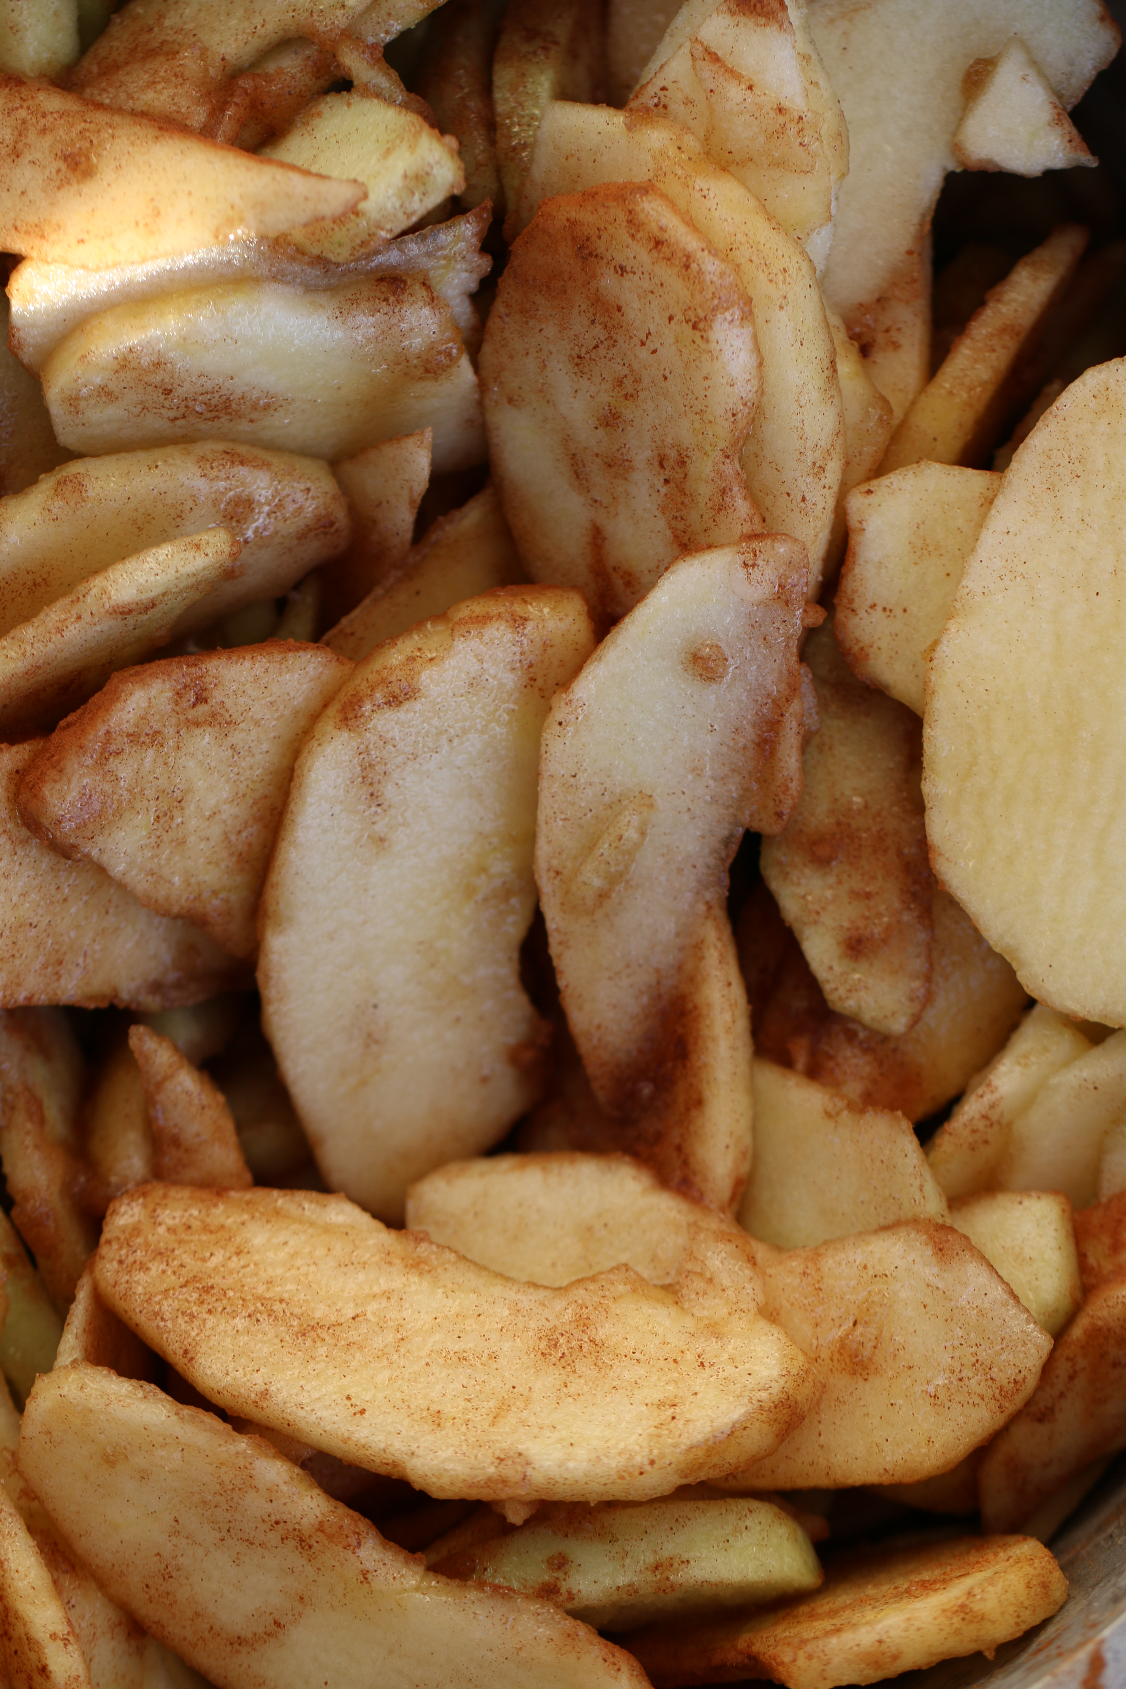
- Transfer apples and the juices to a rimmed baking sheet and let cool completely (about 30 minutes).
- Drain cooled apples thoroughly in colander, reserving ¼ cup of juice. Stir lemon juice into reserved apple juice.
- Adjust oven rack to lowest position and heat oven to 425 degrees.
- Spread apples into dough-lined plate, mounding them slightly in middle, and drizzle with lemon juice mixture. Drizzle with ½ cup Homemade Salted Caramel Sauce.
- MAKE LATTICE CRUST: Remove the remaining chilled pie dough from the refrigerator. Roll the dough out, 12 inches diameter. Using a pastry wheel, cut 16 strips 1/2 inch wide. Carefully weave the strips into a lattice over top of pie. Using a small knife, trim the extra overhang. Crimp edges of the dough with your fingers.
- Brush the lattice top with the beaten egg white and sprinkle with coarse sugar.
- Place the pie onto a large baking sheet and bake for 20 minutes. After 20 minutes, place pie-edger around top of pie crust to keep it from browning too much. Keeping the pie in the oven, turn the temperature down to 375°F and bake for an additional 40-50 minutes. If the top of your pie is getting too brown, cover loosely with aluminum foil. The pie will be done when the caramel begins to bubble up. A small knife inserted inside should come out relatively clean.
- Allow the pie to cool for at least 4 hours before serving. Drizzle the pie with the extra caramel sauce to serve. This apple pie is best served on the same day, but it can be covered tightly and stored in the refrigerator.
YIELD: One 9-inch pie
© SnowflakesandCoffeecakes. All images, attachments & content are copyright protected unless otherwise indicated. All rights reserved. Please do not use my images without prior permission. If you want to republish this recipe, please re-write the recipe in your own words, or link back to www.snowflakesandcoffeecakes.com for the recipe.


