raspberry buttermilk pancakes
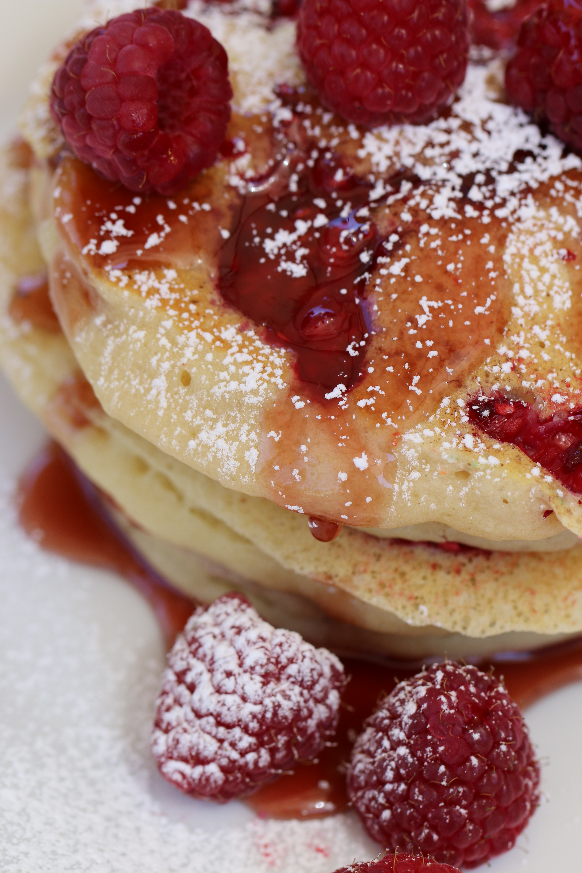

Generally Grandma Petska’s Buttermilk Pancakes are our go-to recipe, but for something special, these raspberry pancakes are a personal favorite! Buttermilk creates soft, tender and fluffy pancakes. Raspberries are one of our favorite fruits, and make even warm, buttery pancakes, dripping in syrup and loaded with raspberries, taste just that much better!

INGREDIENTS:
1 cup all-purpose flour
2 tablespoons granulated sugar
1 teaspoon baking powder
1/2 teaspoon baking soda
¼ teaspoon salt
1 cup buttermilk
1 large egg (room temperature)
2 tablespoons melted butter
1/2 teaspoon vanilla extract
1 cup roughly chopped raspberries

HOW I MAKE THESE:
- In a medium mixing bowl, add flour, sugar, baking powder, baking soda, salt, and whisk to combine; set bowl aside.
- In a large measuring cup, melt butter. Add 1 cup buttermilk, egg, oil, vanilla, and whisk to combine.
- Pour wet ingredients over dry, and mix until just moistened. Don't overmix! Lumpy batter is what you're looking for and it'll be quite thick. If it seems too thick for your liking, add an additional splash of buttermilk.
- Spray a large, non-stick griddle with cooking spray, and heat over medium-low to medium heat. Once skillet it hot, using a one-quarter cup measure, scoop batter into skillet. Sprinkle raspberry pieces to each pancake.
- Cook first side for about 3 minutes, or until underneath is golden and set - don’t wait to see any bubbles.
- Flip carefully and cook second side until done and golden, about 3 minutes. Repeat process with remaining batter.
- Serve pancakes immediately with butter, jam, syrup, powdered sugar, or your favorite pancake topping.

SERVINGS: Makes 6 pancakes



