raspberry BUTTERCREAM CAKE
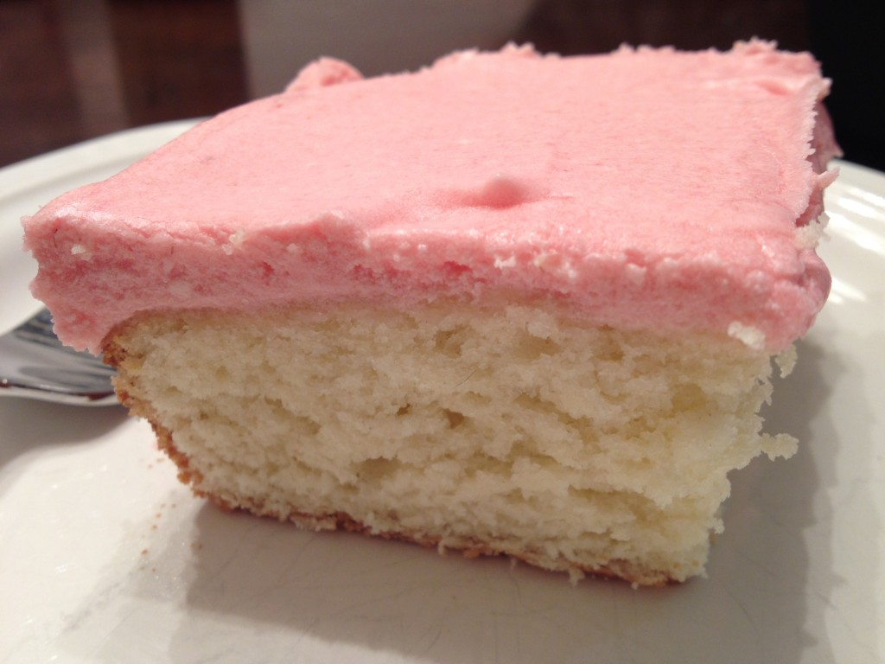

This cake is fabulously moist, and the fresh raspberry frosting is to die for!
Perfect for a Spring celebration or birthday.

CAKE:
12 tbs unsalted butter, at room temperature
2 ¾ cups all-purpose flour
¼ cup cornstarch
1 ¼ tsp baking powder
½ tsp baking soda
¾ tsp salt
1 ½ cups granulated sugar
1 ½ tsp vanilla extract
3 large eggs
1 ½ cups buttermilk, well-shaken
RASPBERRY BUTTERCREAM FROSTING:
1 cup fresh raspberries
16 tbs unsalted butter, at room temperature
4 cups (1 lb.) confectioners’ sugar

INSTRUCTIONS:
Preheat your oven to 350 F. Grease a 9×13” cake pan.
In a medium bowl, whisk together the flour, cornstarch, baking powder, baking soda, and salt. In a large bowl, beat the butter and sugar with an electric mixer at medium speed until the mixture is pale and fluffy. Beat in the vanilla, then the eggs one at a time. Beat well and scrape down the bowl after each addition. On low speed, beat in the buttermilk until just combined (it’s okay if the mixture looks curdled). Add the flour mixture in three batches, blending until each addition is just incorporated into the batter.
Spread the batter evenly in the prepared baking pan. Bake until golden and a cake tester inserted into the center comes out clean, 30 to 40 minutes. Remove from the oven and cool the cake in the pan for 10 minutes. Then run a knife around the edges of the cake and let it cool the rest of the way. Cool completely before frosting, at least 1 hour.
For the frosting: Puree the berries in the food processor until they are as smooth as possible. Press the puree through a sieve or other fine-mesh strainer. Discard the solids and seeds. You are looking for about 1/3 to a scant ½ a cup of puree. Set aside.
In a large clean bowl, beat the butter until light and fluffy. Beat in the sugar, 1 cup at a time, beating well after each addition. Add ¼ cup puree and beat until the color is fully incorporated. Add more if desired, but beware: more will intensify the color, which looks beautiful, but it will make the frosting not as stiff. Refrigerate the cake until ready to serve.


